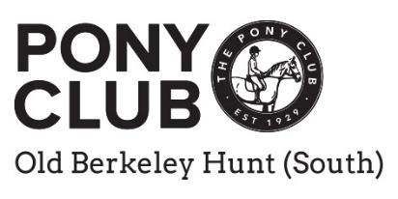
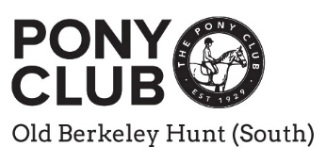
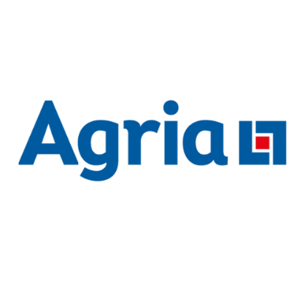

Pony Club Area 12 Dressage Show
Sunday, 28th June 2026
Berkshire College of Agriculture
Hall Place
Burchetts Green
Berkshire
SL6 6QR
Organised by the Old Berkeley Hunt South Branch of the Pony Club
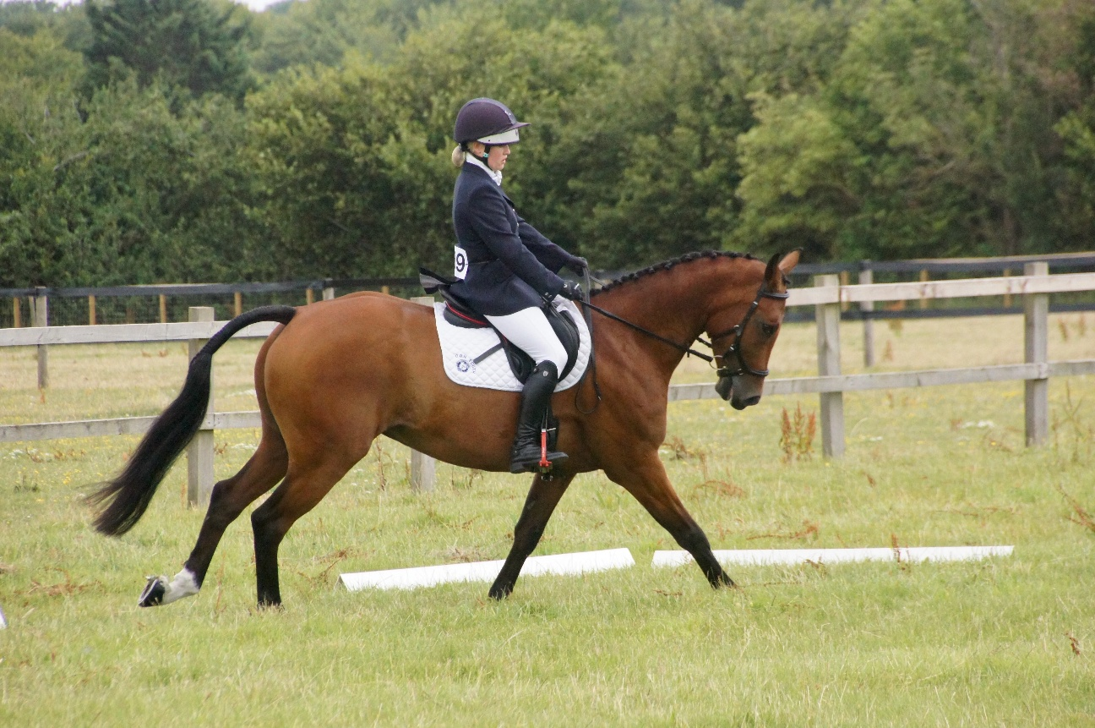
Organiser & contact on the day: Anne Sandford 07770 476773
For entry information contact: info@horse-events.co.uk 07962 251696 (before 19.00hrs)
Entries Close: Thursday, 18th June 2026

Late entries will NOT be accepted

Classes
Class 1: Prix Caprilli
TEST: https://branches.pcuk.org/area12/wp-content/uploads/sites/604/2026/04/Prix-Caprilli-Test-9.jpeg
May be commanded in line with Area 12 Prix Caprilli Rules
Class 2: PC70
TEST: Foundation PC70 Dressage Test 2026
May be commanded in line with Area Dressage Rules 2026 – Page 38
Class 3: PC70+
TEST: Foundation PC70 Dressage Test 2026
May be commanded in line with Area Dressage Rules 2026 – Page 38
Class 4: PC80
TEST: Grassroots PC80 Dressage Test 2026
May be commanded in line with Area Dressage Rules 2026 – Page 38
Classes 2, 3 & 4 - Qualifiers for the East Midlands & East Anglia Regional Grassroots Championships
29th – 30th August 2026, Aston le Walls, Northamptonshire
Class 5: Novice
TEST: Novice PC90 Dressage Test 2026
Cannot be commanded in line with Area Dressage Rules 2026 – Page 39
Class 6: Intermediate
TEST: Intermediate PC100 Dressage Test 2026
Cannot be commanded in line with Area Dressage Rules 2026 – Page 39
Class 7: Open
Test: Open PC110 Dressage Test 2026
Cannot be commanded in line with Area Dressage Rules 2026 – Page 39
Classes 5, 6 & 7 - Qualifiers for the Pony Club National Championships
18th – 22nd August 2026, Offchurch Bury, Warwickshire
Eligibility

For general eligibility rules, please refer to the Pony Club Dressage Rulebook 2026 Pages 7 – 10.

For the Individual, Team and Area Team rules, please refer to the Pony Club Dressage Rulebook 2026 Page 10.

Entries
Open to all eligible Area 12 Pony Club Branch and Centre members.
Entries should be made by your Dressage Team Manager and with the approval of the District Commissioner of your Pony Club Branch.
Bookings are direct via the Horse Events website - Horse Events
Fees per Class
Class 1 £25 including paramedic fee
Classes 2 - 7 £30 including paramedic fee
Booking fees are payable direct to Horse Events when placing your entry and are nonrefundable and on a per class basis.
To edit your horse or rider details before the closing date of the event, please log in to your Horse Events account and edit your booking under the ‘MY BOOKING’ tab.
To change the class please email info@horse-events.co.uk and if there is space available they will do this for you.
For all horse and rider substitutions after the closing date there is a £5 charge. To make any such changes, please complete the online form: https://www.horse-events.co.uk/rider-horse-substitutions-form/
Team Entries. Please indicate Team Name when entering. There is no separate team entry fee. We will endeavour to create Area teams with individuals where possible.
Ages
Ages as at 1st January 2026 (indicate on entry where applicable).
Rosettes
Class 1 Individuals to 10th place for all sections
Classes 2 - 7 Individuals to 6th place all classes/sections
Teams To 6th place
Prizes
Additional prizes may also be presented at the Presentation Ceremony following each class. Please encourage all competitors to attend prize giving IN CORRECT RIDING DRESS. Times of the Presentations will be updated on Pony Club Results throughout the day.
Protests and Objections
Apart from the Official Steward, the Area Representative and officials of the competition, only District Commissioners or their Appointed Representatives are entitled to lodge protests or objections, which must be made in writing and addressed to the Organiser of the Area Competition, or Secretary of the Championships. They must be accompanied by a deposit of £50 at either Area or Championships, which is forfeited unless the Jury of Appeal decides that there were good and reasonable grounds for them.
Protests or objections must be made not later than half an hour after the scores have been published. The Official Steward/Organiser shall give their decision in the first instance. If this is not accepted, the Jury of Appeal shall give their decision after investigation and this decision is final.
Winter League Dressage
Presentations to the winners will be made during the luncheon interval. Again, timing will be indicated on Pony Club Results.
Dressage Instructions
Times will be available from Wednesday 24th June 2026 after 19.00 hrs on Pony Club Results.
RESPONSIBLILY FOR CORRECT TACK AND DRESS remains the responsibility of the Member and DC. There will be a SAFETY Tack and Turnout inspection for each competitor before they compete.
REASONABLE ADJUSTMENT The Pony Club is committed to ensuring that, wherever possible, members are able to access all aspects of the Branch and Centre activities we offer.
Adjustments are any reasonable actions that help to reduce the effect of a disability or difficulty.
In order for such requests to be accommodated, any requests for reasonable adjustment must be made by Friday, 19th June, by e-mail to: Anne Sandford, aesandford@yahoo.co.uk.
Conditions of Entry
- Legal Liability: Save for the death or personal injury caused by the negligence of the organisers, or anyone for whom they are in law responsible, neither the organisers of this event or The Pony Club nor any agent, employee or representative of these bodies, nor the landlord or his tenant, accepts any liability for any accident, loss, damage, injury or illness to horses, owners, riders, spectators, land, cars, their contents and accessories, or any other person or property whatsoever. Entries are only accepted on this basis.
- Health & Safety: Organisers of this event have taken reasonable precautions to ensure the health and safety of everyone present. For these measures to be effective, everyone must take all reasonable precautions to avoid and prevent accidents occurring and must obey the instructions of the organisers and all the officials and stewards
- Reasonable Adjustment: Any requests for Reasonable Adjustment must be made by Friday, 19th June 2026.
- Rules: The event will be run under Pony Club Dressage Rules 2026 and it is the responsibility of the competitors to make sure that they understand and adhere to the rules.
- Vaccination: The event venue stipulates all horses/ponies entering the event site must comply with 2026 Pony Club vaccination rules - passports must accompany all horses/ponies and spot checks may be undertaken
- Hat- Tagging: Please ensure that the riding hat is tagged in line with the Pony Club rules - pink tags. Yellow hat tags are required if wearing spurs.
- Reservation of Rights: The organisers reserve the right to alter, amend or cancel any class/ amalgamate sections where there are insufficient entries or split classes if oversubscribed and reserve the right to disqualify anyone for misuse of the whip or spurs, dangerous riding or any horse/pony in poor lame condition, and to refuse any entry for any reason at their sole discretion.
- Withdrawal and Abandonment: The event will follow 2026 Withdrawal and Abandonment criteria – Pony Club Dressage Rulebook 2026, page 11. If a Member, Branch or Centre withdraws a team or individual prior to the closing date for a competition, a full refund of entry will be made, less an administration charge of £5. Withdrawals after the closing date for a competition will not be refunded. In the event of a competition being abandoned, for whatever reason, a refund of 50% of the entry fee will be given.
- Tests: Copies of dressage tests may be downloaded from the Pony Club website. The Prix Caprilli test is downloadable from the Area 12 website.
- Time & Results: Please refer to Pony Club Results for times and results.
- Lunging: No Lunging will be allowed on the day.

Photographer is Charlotte Bury Photography – https://www.charlotteburyphotography.co.uk/
Other than parents and guardians photographing their own children, no other photography/photographers will be permitted on site.
Photographic rights: Participants and their parents/guardians give permission for any photographs taken by the designated photographer at the event to be developed for sale and published on the internet only for the purposes of resale or for Old Berkeley Hunt South Branch of the Pony Club for publicity purposes.
With many thanks to our Sponsors:
The Journeyman
Kimble Solar
The Eleventh Hour
Soho Equestrian
Equine Essentials

The vet on call on will be Elite Equine Clinic

