

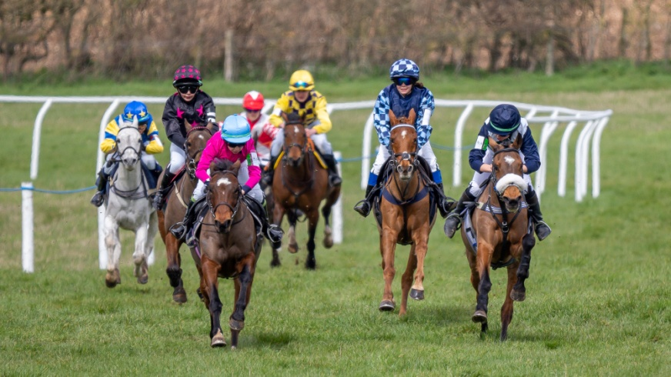

**SOUTH DORSET & AREA 14 OF THE PONY CLUB**

**Pony Club Pony Racing Day**

**(Part of the Pony Club Racecourse Series)**

**at**

**THE SOUTH DORSET POINT TO POINT COURSE**

**MILBORNE ST ANDREW, NEAR BLANDFORD, DORSET BH20 7JF**

**By kind permisson of Mr M Miller**

**Saturday 15th February 2025**

**First Race 12pm (Noon)**

All riders must walk the Course with the nominated Officials **and** must attend the briefing at the start of the day. Members should meet at the **Paddock at 10am.** Non attendance will result in not being allowed to ride.

All entries via Horse-Events.co.uk.

The day will be run under Pony Club Pony Racing Rules 2025

Entry fee. £30.00 per race.

Catering, Doctor, First Aid, Vet and Photographer all on site.

For More information contact Louly Thornycroft on [area14@pcuk.org](mailto:area14@pcuk.org) 01258 860614/07887841480

All ponies attending MUST be compliant with the current Pony Club minimum vaccination requirements and must be accompanied by their passport.

**SCHEDULE**

**Entries Close 8th February 2025**

All dogs must be kept on short leads at all times.

**Beginners Races: 1,4,8**

**For riders who have not taken part in Pony Racing before, except for Beginners.**

**Riders who have won one Beginner race or have completed three Beginner Races at a Pony Club Raceday, must step up to the next level.**

**Ponies are not to have been placed in Open Pony Club or Pony Racing Authority Races in the last two years.**

**No minimum Weight. Combination MUST have met the qualification criteria as per Pony Club Pony Racing Rule Book 2025**

**Novice Riders Races: 2,5,9**

**For riders who have not been placed 1st in a Novice Pony Club or a Pony Racing Authority Point-to-Point Pony Race before, or taken part in the PRA Racecourse Series, who must be on a pony who has not won an Open Pony Club or Pony Racing Authority Point-to-Point Pony Race in the last 3 calendar years with another jockey or taken part in any Pony Racing Authority Racecourse Series Race.**

**No minimum weight.** Combination MUST have met the qualification criteria as per Pony Club Pony Racing Rule Book 2025

**Intermediate Races: 3,6,10**

**For Riders who may have won a Novice Race before but not won an Intermediate or an Open Pony Club or Pony Racing Authority Point to Point Pony or Racecourse Series Race before. No restrictions on Ponies.**

**No minimum weight. Combinations MUST have met the qualification criteria as per the Pony Club racing rule book 2025.**

**Open Pony Races: 7,11**

**Combination of riders and ponies who have been placed in a Pony Club or Pony Racing Authority Race Day**

**Riders to carry minimum weight as stated and to provide their own WEIGHT cloth and LEAD.**

**Combinations MUST have met the qualification criteria as per the Pony Club racing rule book 2025.**

**RACES**

1. NOON Beginners: For Ponies not exceeding 128cms

2. Novice: For Ponies not exceeding 128cms

3. Intermediate: For Ponies not exceeding 128cms

Distance Approx 4 furlongs

**If insufficient entries, races will be amalgamated as appropriate.**

4. Beginners: For Ponies not exceeding 138cms

Distance Approx 4 furlongs

5. Novice: For Ponies not exceeding 138 cms

6. Intermediate: For Ponies not exceeding 138 cms

7. Open: For Ponies not exceeding 138cms

**Minimum Weight 7st 10lbs.**

8. Beginners: For Ponies not exceeding 148 cms

9. Novice: For Ponies not exceeding 148 cms

Distance Approx 6 furlongs

**If insufficient entries, races will be amalgamated as appropriate.**

**10. Intermediate: For Ponies not exceeding 148cms**

**11. Open: For Ponies not exceeding 148 cms**

**Minimum Weight 9st.**

**Distance Approx 9 furlongs**

**If insufficient entries, races will be amalgamated as appropriate.**

**First race is at noon. Further race times will be advertised after close of entries. All competitors must be ready to race at least half an hour before the advertised start time.**

.**Conditions of Entry and General Information**

The Event will run under Pony Club Racing Rules 2025. These are available to download from THE PONY CLUB WEBSITE or buy from Amazon UK.

The organisers reserve the right to cancel the event or any race, to alter the advertised times, to divide any race and to refuse entry with or without stating a reason. The decision of the Chief Steward will be final and binding.

**Health & Safety**

Organisers of this event have taken reasonable precautions to ensure the health and safety of everyone present. For these measures to be effective, everyone must take all reasonable precautions to avoid and prevent accidents occurring and must obey the instructions of the organisers and all the officials and stewards.

**Legal Liability**

Save for the death or personal injury caused by the negligence of the organisers, or anyone for whom they are in law responsible, neither the organisers of this event or The Pony Club nor any agent, employee or representative of these bodies, nor the landlord or his tenant, accepts any liability for any accident, loss, damage, injury or illness to horses, owners, riders, spectators, land, cars, their contents and accessories, or any other person or property whatsoever. Entries are only accepted on this basis.

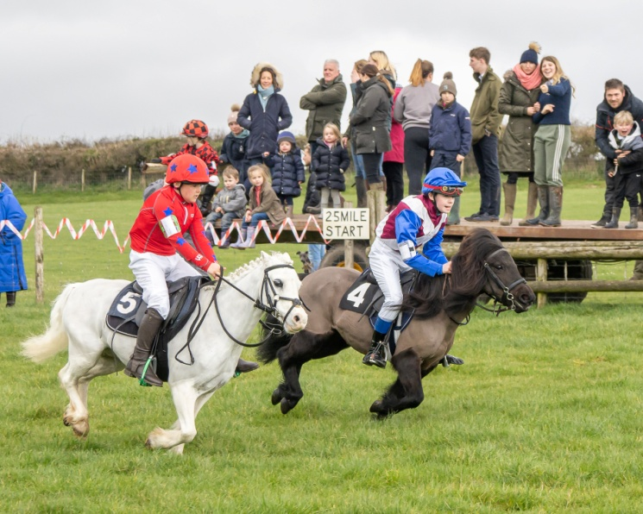

Photographs of the course at Milborne courtesy of Nigel Gidney Photography