**BARRIER ANIMAL HEALTH SPRING FESTIVAL 2025**

**AREA SHOWJUMPING QUALIFIERS**

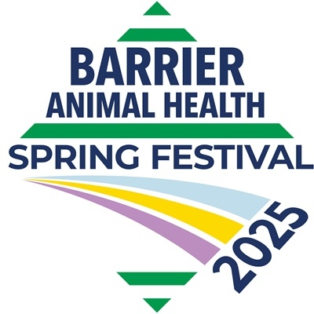

**Saturday 18th January 2025**

HOSTED BY SRC and WEST WARWICKSHIRE BRANCH OF THE PONY CLUB

Online entries only on the Solihull Riding Club website: [www.solihullridingclub.co.uk](http://www.solihullridingclub.co.uk)

**Team and Individual competition**

**Showjumping Qualifiers:**

**Class 1: PC80**

**PC80 – A combination of horse/pony and rider are NOT eligible if they have:**

**• Completed any competition with a starting height of 100cm or above in the previous**

**calendar year**

**Class 2: PC90**

**PC90 – A combination of horse/pony and rider are NOT eligible if they have:**

**• Completed any competition with a starting height of 110cm or above in the previous**

**calendar year**

**Class 3: PC100**

**PC100 – A combination of horse/pony and rider are NOT eligible if they have:**

**• Previously ever finished 1st to 3rd as an individual at the Summer Championships at**

**PC100 level or above on two or more occasions in the last five years.**

**Class 4: PC110**

**PC110 GRAND PRIX – Riders CANNOT compete in the Open Grand Prix Area Competition if**

**they have ridden in the PC80 Spring Festival Area Competition in the same year.**

**The competition comprises:**

**The individual competition** – the scores for all competitors in the competition

automatically count for this competition. It is also open to all competitors in the team

competition (below).

**The team competition** – open to teams that must consist of three members from each

Branch/Centre with all three scores to count.

Numbers to qualify – please see below. In the event of a competitor being placed in a

qualifying position when they are not able to attend the final, the place may pass down the

line.

**Teams**

The top Branch/Centre team from each Area at each height will qualify. Where a qualifying

individual is a member of a qualifying team, the qualifying individual place should be passed

down the line.

**Entry Fees:** All classes – £18 per individual

**Close of Entries:** 9am on Tuesday 14th January – No entries will be taken on the day

**Start Times:** Times will be uploaded on the SRC website: [www.solihullridingclub.co.uk/times](http://www.solihullridingclub.co.uk/times) from 4pm onwards on Thursday 16th January

**Withdrawals:** In the unfortunate event of a withdrawal please alert the secretary by 9am on Tuesday 14th January 2025 – we regret no refunds or transfers will be made after the close of entries, this rule will be strictly adhered to.

**Rosettes:** 1st – 8th in all classes

**Rules:**

**Area Competitions –** will be run in accordance with The Pony Club Show Jumping Rule Book and The Pony Club Spring Festival Show Jumping 2025 Rules.

**Whip Use –** in all Pony Club Show Jumping, excessive use of the whip, including repeated slapping down the shoulder, is prohibited. The rules state that the whip may be used a **maximum of three times** during any round. Use of the whip will be monitored, especially at the Championships, and excessive use may result in elimination at the discretion of the judges.

**Use of Spurs** – the use of spurs must be in accordance with the pony club spurs rules.

**Saddlery & Dress –** at Area Competitions and the Finals, The Pony Club Saddlery and Dress Rules Apply.

**The competition comprises:**

• **The individual competition** – the scores for all competitors in the competition

automatically count for this competition. It is also open to all competitors in the team

competition (below).

• **The team competition** – open to teams that must consist of three members from each

Branch/Centre with all three scores to count.

Numbers to qualify – please see below. In the event of a competitor being placed in a

qualifying position when they are not able to attend the final, the place may pass down the

line.

**Teams**

The top Branch/Centre team from each Area at each height will qualify. Where a qualifying

individual is a member of a qualifying team, the qualifying individual place should be passed

down the line.

ENTRIES accepted at rider’s risk. SRC reserve the right to refuse an entry at their discretion, cancel, amend or amalgamate any class for any reason whatsoever. The Judge’s decision is final.

INSURANCE Each competitor must carry their own liability insurance whether Riding Club, Pony Club, BHS, BS, BD, BE or independent cover.

HEALTH & SAFETY The organisers of this event have taken reasonable precautions to ensure the health and safety of everyone present. For these measures to be effective everyone must take all reasonable precautions to avoid and prevent accidents occurring and must obey the instructions of the organisers and all the officials and stewards. Those attending this event must report any accidents to the secretary or organizer of the event.

Please do not leave unattended horses tied to lorries and no hay nets to be tied to the outside of lorries or trailers.

Solihull Riding Club welcomes responsible dog owners. Dogs must be kept on a lead at all times.

DISCLAIMER OF LIABILITY save for the death or injury caused by the negligence of the organisers of the event, no liability is accepted for any accident, loss or damage, injury or illness to horses, ponies, owners, riders, spectators, vehicles their contents and accessories, or any other person or property whatsoever, whether caused by their negligence, breach of contract or in any way whatsoever.

Please ENTER ONLINE: [www.solihullridingclub.co.uk/events](http://www.solihullridingclub.co.uk/events)