The current Welfare issues related to the use of horses for recreational and sport purposes

-Welfare issues relating to modern horse use for sport and recreational purposes are the single biggest threat to our sport, pulling all equestrian disciplines into the public eye, going as far as the discussion of being equestrianism being banned altogether.
-With more and more horses being used for sport/recreational purposes in the West, many people ask – ‘what give us the right to ride a horse?’.
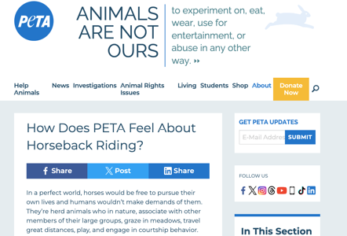

As we all know most horses enjoy their lives under the saddle and in human care but only under the right circumstances.
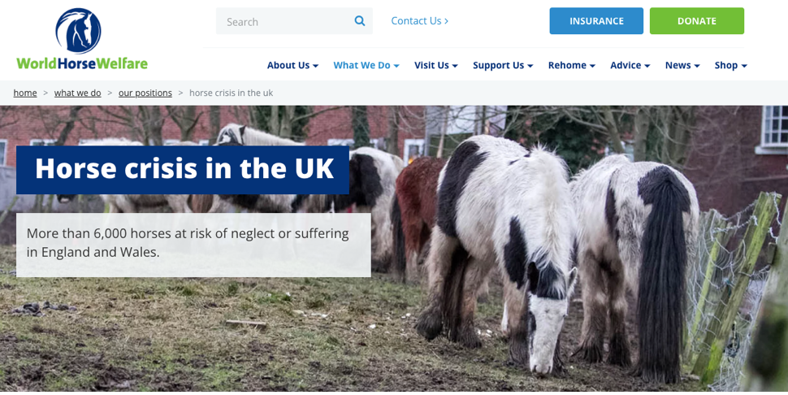

I have outlined in this handout just some of the recent research into issues that are seen as most pressing by the horse community and public as compromising to a horses welfare.

- The five freedom’s

-The five freedoms are the five tangible factors that determine whether an animal is in a state of good welfare or not and are extremely important to acknowledge when keeping animals in any respect.
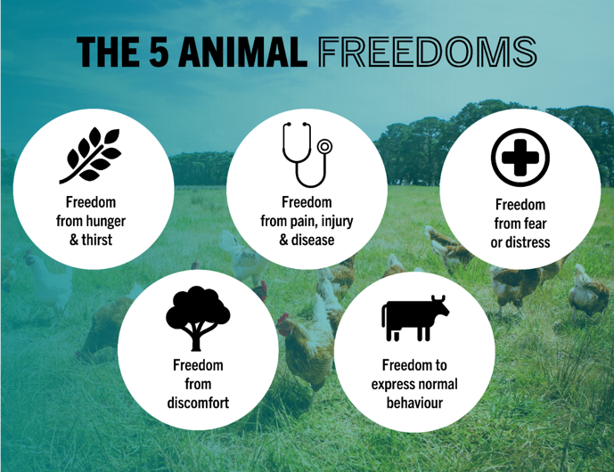
-If even one of the 5 freedoms are compromised then one could consider the animal to have a poor state of welfare.

-These points are what the animal welfare act 2006 is based off – this act legally places a duty of care on people to ensure that they take reasonable steps in all circumstances to meet the welfare needs of their animals to the extent required by good practice

- Overleaf is a short summary of the 5 five freedoms and just some of the common welfare issues that regularly compromise them – these suggestions are from the referenced published papers.

-Before you turn over think as think of as many potential issues that you have seen or think of…

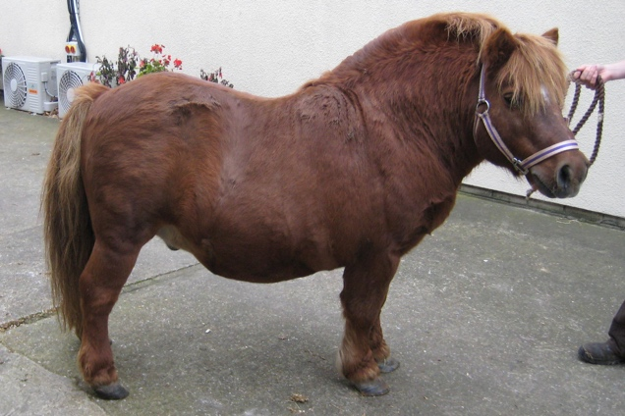
- Hunger and thirst

-Empty haynet overnight.
-Starvation paddocks.

- Discomfort

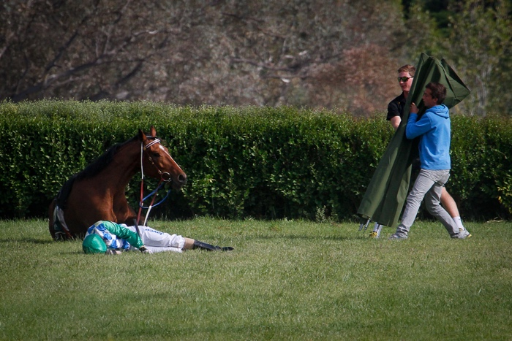
-Ill fitting tack
-Misuse/Overuse of aids – SPURS and WHIPS, bits, draw reins.
-Poor rider balance or too heavy for horse

- Pain, injury and disease

-Obesity
-Sporting injuries
-Un-vaccinated animals
-Human induces disease – Arthritis, Laminitis, EMS/Cushings
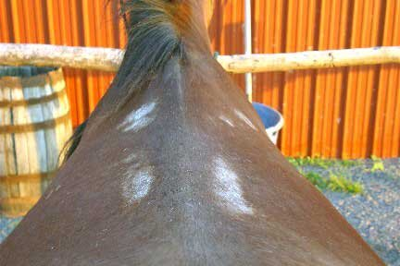
-poor farriery
-unjustified/poor veterinary and dentistry work

-lack of funds for farriery, veterinary, dental work

- To express normal behaviours

-STABLING
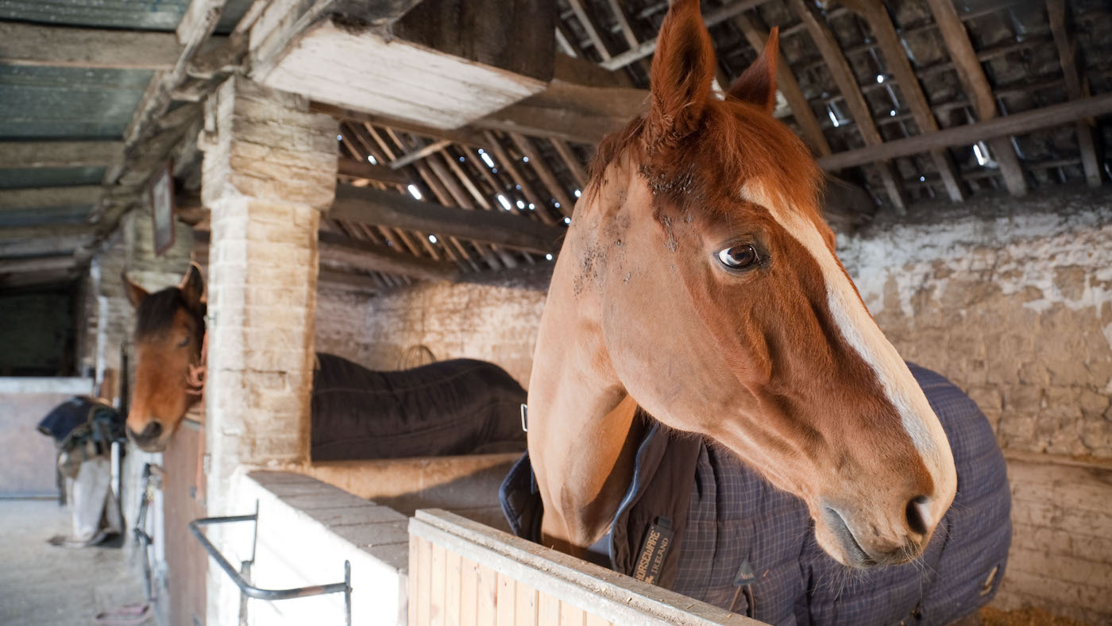
-social isolation

- From fear or distress

-over training
-punishment
-TRANSPORT
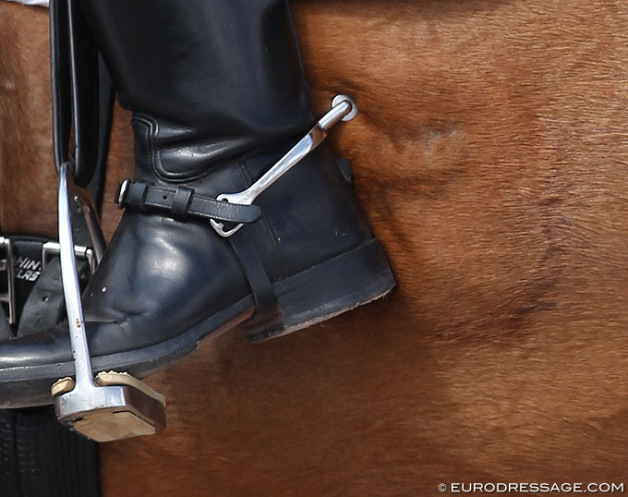

References-
-Minero, M. and Canali, E., 2009. Welfare issues of horses: an overview and practical recommendations. Italian Journal of Animal Science, 8(sup1), pp.219-230.
-Horseman, S.V., Buller, H., Mullan, S. and Whay, H.R., 2016. Current welfare problems facing horses in Great Britain as identified by equine stakeholders. PLoS One, 11(8), p.e0160269.
-Harewood, E.J. and McGowan, C.M., 2005. Behavioral and physiological responses to stabling in naive horses. Journal of Equine Veterinary Science, 25(4), pp.164-170.
-Schwean, K., 2005. The welfare of horses: Review of recent literature.
-DuBois, C., Nakonechny, L., Derisoud, E. and Merkies, K., 2018. Examining Canadian equine industry participants’ perceptions of horses and their welfare. Animals, 8(11), p.201.
-Weeks, C.A., McGreevy, P. and Waran, N.K., 2012. Welfare issues related to transport and handling of both trained and unhandled horses and ponies. Equine Veterinary Education, 24(8), pp.423-430.
-Arthur, R.M., 2011. Welfare issues in horse racing. Equine welfare, pp.229-224.

-IMAGES – google images

