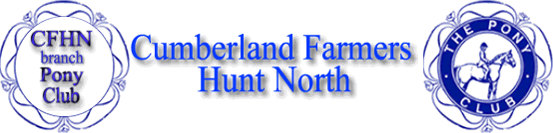
PONY CLUB SENIOR CAMP FORM 2024

To be held at: Emma Carmichaels @ The Birks stables, Longhorsley, NE65 8RD

Senior Camp 30th – 31st July

____________________________________________________________________________

CHILDS NAME …………………………………………………………………………………………………………

ADDRESS………………………..……………………………………………………………………………………..

……………………………………………………………………………………………………………………………

AGE ………………..………………………………… EMAIL ………………………………………………………..

TEL ……………………………..……………………. MOBILE .……………………………………………………..

EMERGENCY CONTACT …………………………………………………………………………………………….

_____________________________________________________________________________

HEIGHT OF JUMPS YOU ARE COMFORTABLE JUMPING .......................................................................

TESTS ALREADY PASSED ...........................................................................................................................

_____________________________________________________________________________

NAME OF PONY/HORSE ………………..………………..................................................................................

AGE OF PONY/HORSE .................... HEIGHT OF PONY/HORSE ………….………………………………….

Please Provide your own horse feed for the 2 days.

Hay/Haylage will be provided.

_____________________________________________________________________________

Pony Club will provide lunch and dinner on Tuesday 30th and lunch on Wednesday 31st.
If arriving Monday 29th evening, please provide your own dinner. All breakfasts must be organised yourself.
Please advise if your child has any dietary requirements.

………………………………………………………………………………………………………………..

_____________________________________________________________________________

ADULT REQUIREMENTS:
Adult meals must be booked and paid for in advance, Cost is £40 for lunch both days and dinner on the 30th, including teas and coffees across the 2 days.

DIETERY REQUIREMENTS …………………………………………………………………………………………

_______________________________________________________________________________________

All forms to be posted to:
Anna Couper
Barn Owl Steading
Chapelknowe
Canonbie
Dumfriesshire
DG14 0XT
Tel: 07921507451
Please Pay full balance through horse events
Please print forms and send to the above address

To secure your place please forward the following,
- Application form
- Medical form

