FLINT & DENBIGH HUNT BRANCH

Of the

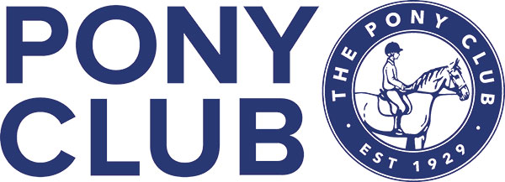

Winter League Team & Individual Dressage Competition

Sun 2nd November 2025

At

The Equine Unit,

Coleg Cambria, Northop.

CH7 6AA

Entries Close Sunday 26th October 2025

Enquiries:

Ruth James 07796698497

email: Comp.entries@fndponyclub.org.uk

Times Tuesday 28th October 2025

Will be posted on www.ponyclubresults.co.uk

FLINT & DENBIGH HUNT BRANCH OF THE PONY CLUB

Winter League Team & Individual

DRESSAGE COMPETITION

At

The Equine Unit,

Coleg Cambria, Northop.

CH7 6AA

Sun 2nd November 2025

Entries Close Sunday 26th October 2025

Entry Fee £16 Walk Trot £12

Dressage Tests:

Class 1 Walk Trot Test - Walk Trot Test 2022 (lead rein permitted)

Class 2 Grassroots - Grassroots Test 2018

Class 3 Novice - Novice Test 2020

Class 4 Intermediate - Intermediate Test 2024

Class 5 Open - Open Test 2020

Please enter online, using Entrymaster [Entrymaster - Home page](https://fndpc.entrymaster.online/index.php?id=1).

Rules:

1. All classes will be run according to Pony Club Area 5 Winter League Dressage rules 2024 [Microsoft Word - WL Dressage Rules 2022 2023 27.9.22 Final](https://branches-old.pcuk.org/area5/files/2022/10/WL-Dressage-Rules-2022-2023-27.9.22-Final.pdf) and Pony Club Dressage Rules at the commencement of the Winter League season 2025/26
2. Points will be awarded individually and for Teams as per Area 5 Winter League Dressage rules.
3. Members will be required to print their own numbers and use number bibs/bridle numbers.
4. All accidents should be reported to the show secretary for inclusion in the accident book
5. If any horse/pony has been in contact with strangles or any other infectious disease, it should not attend the competition. All horses/ponies vaccinations must comply with Pony Club Equine Influenza Vaccine Rule. Details can be found on [The-Pony-Club-Equine-Influenza-VACCINATION-RULE-.pdf](https://resources.pcuk.org/wp-content/uploads/2024/08/The-Pony-Club-Equine-Influenza-VACCINATION-RULE-.pdf)
6. Please ensure you have your horse/pony passport with you.
7. In the event of cancellation, refunds will be made, minus any expenses/admin incurred by the hosting branch. This amount will be checked and approved by an Area 5 representative before refund is made.
8. Health & Safety The organisers of this event have taken reasonable precautions to ensure the health and safety of everyone present. For these measures to be effective, everyone must take all reasonable precautions to avoid and prevent accidents occurring and must obey the instructions of the organisers and all the officials and stewards.

Disclaimer of Legal Liability Save for the death or personal injury caused by the negligence of the organisers, or anyone for whom they are in law responsible, neither the organisers of this event or The Pony Club nor any agent, employee or representative of these bodies, nor the landlord or his tenant, accepts any liability for any accident, loss, damage, injury or illness to horses, owners, riders, spectators, land, cars, their contents and accessories, or any other person or property whatsoever.

Entries are only accepted on this basis.