Auction of promises to be held at The Fox & Hounds, Ainthorpe
Friday 28th November
Arrive from 6pm to start at 7pm
All proceeds to Glaisdale Pony Club
If you cannot attend the event but would like to put forward your ‘best bid’ on an item please send the item number and bid amount to Kathryn on 07921333964. Txt message is preferred.

Item 1 - A 30 minute riding lesson on your own horse/pony with Alison Wilson at Ugthorpe
Item 2 – Cream Tea for 2 at Ravenscar Tea rooms - donated by Lynne Butler
Item 3 – One 4ft round bale of hay donated by Kathryn Rollinson – Can be delivered in the Whitby area.
Item 4 – A Cherry Bakewell Made by Gill Halton
Item 5 – An evening’s baby sitting by Rebecca Weston (fully qualified in childcare, DBS checked & paediatric 1st aid level 3) within a 15 mile radius of Ugglebarnby
Item 6 – Personalised Browband covered in ribbon in 2 colours of your choice Made by Jenny Fowles
Item 7 – A homecooked main meal for 2 made by Paula Bean and delivered in Whitby area or collected from Newholm.
Item 8 – A Clip for a well behaved horse or pony in a 5 mile radius of Ugthorpe by Alison Wilson
Item 9 – A batch of jam tarts made by Harriet Billson-Hodges, to be collected from Ugglebarnby or any Glaisdale PC event.
Item 10 – 3 bags of meadow haylage to be collected from Alison Wilson’s at Ugthorpe. Donated by ‘The moor fire horse liveries’
item 11 – A Beauty Treatment of your choice by Becky Walker
Item 12 – Half a pig, butchered, vacuum packed and frozen, to be collected from Easington – donated by The Atkinson family
Item 13 – A Pole Clinic for 3 riders with Suzi Millward at Rascals equestrian, Irton, Scarborough, donated by Suzi Millward
Item 14 – 6 cheese scones made by Paula Bean
Item 15 – 5 Bales of Hawthorne shavings – donated by Chris and Wendy, to be collected from near Sleights
Item 16 – Private Hospitality box for 10 or 12 people to watch Darlington Mowden Park v Sheffield Tigers Rugby match on Saturday 31st January 2026. National League 2 North. Food and drink available at £10 per head pre ordered (not included In voucher). Retail price £450. Donated by Neil Young and Mowden Park Rugby Club.
Item 17 – A batch of homemade soup (tomato & basil, chicken & veg, or pea & mint), made by Laura Crookes and delivered within 10 mile radius of Whitby or collected from Sneaton
Item 18 – One hour Arena Hire at Richmond equestrian centre – Indoor or Outdoor arena, donated by Richmond Equestrian Centre

Item 19 – A homemade bag (pictured, 15” x 12” x 11”) made by Ruth Maltby
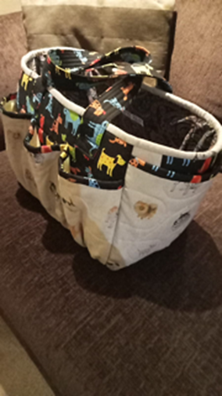
Item 20 – Parmo Night for 2 at The Fox, Roxby, donated by The Wilson family.
Item 21 – A large round bale of haylage, to be collected from Ugthorpe. Donated by Sam Mortimer.
Item 22 – A lemon, chocolate or Victoria sponge Birthday cake with a fondant pony topper - made by Anna Watson.
Item 23 – 1 place on a clinic with Lucy Wild ‘The wild equestrian’ for you and your horse. Helping negotiate obstacles in a safe environment. Donated by Lucy Wild.
Item 24 – Whitby distillery tour for 2 people – donated by The Whitby Distillery, contact Gemma Oliver
Item 25 – Cream tea for 2 at Ravenscar Tea Rooms - donated by Lynne Butler
Item 26 – A black Fleece rug in your choice of size – Donated by Millbry Hill
Item 27 – A batch of cookies made by Harriet Billson-Hodges, to be collected from Ugglebarnby or any Glaisdale PC event.
Item 28 – A Sketch of your pony drawn from a photo by Sophia Tokarski
Item 29 – 1 hour hire of the gallops for 2 ponies at Upsall Grange Equestrian, donated by Upsall Grange Equestrian
Item 30 – Ferrero Roche Cheesecake Made by Gill Halton
Item 31 – An evening’s baby sitting by Rebecca Weston (fully qualified in childcare, DBS checked & paediatric 1st aid level 3) within a 15 mile radius of Ugglebarnby
Item 32 – A One hour riding lesson on your own horse/pony with Beth Hodges at Ugglebarnby.
Item 33 – Ellers House Festive hamper donated by The Knight family
Item 34 – Baking hamper donated by Sam Shepherd

