# THE MID SURREY BRANCH OF THE PONY CLUB



## ANNUAL 12 YEARS AND UNDER OPEN SHOW

(Open to non-Pony Club members)

## The Pony Club Field, Hurst Road,

## Walton on the Hill, Surrey, KT20 5BN

**Sunday 8th June 2025**

**Including Showing Classes, Showjumping, Handy Pony, Clear Round and Fancy Dress**

**Challenge Cups to be won in each age group**

 **Sunshine Tour Qualifier 2025**

Secretary - Mrs Susan Arnold

🕿07720 399089

🖂the_arnolds@btinternet.com

**Online entries only via My Riding Life**

No entries on the day (except Handy Pony and Clear Round Jumping)

Entries close Thursday 5th June 2025

AVAILABLE ON THE DAY

**Photographer**

Photography by Equipassion uk [www.equipassionuk.com](http://www.equipassionuk.com)

Facebook Equipassion UK. Instagram @equipassion_uk

**Hot and Cold Food and Drinks**

|  |  |  |
| --- | --- | --- |
| Competition to be judged in four age groups, with a challenge cup presented to the rider and pony combination in each age group accumulating the most points  1st Place = 4 Points, 2nd Place = 3 Points, 3rd Place = 2 Points, 4th Place = 1 Point  Points accumulated for all Classes except Clear Round, Relay Jumping (C7) & Open Jumping (C8)  **POINTS MAY BE COLLECTED FOR ONE SECTION ONLY, WHICH MUST BE NOMINATED ON ENTRY.**  **PLEASE ENSURE YOU ENTER THE CORRECT SECTION FOR AGE & ABILITY.**  **POINTS ARE NOT TRANSFERABLE BETWEEN SECTIONS** | | |
| Section A | 7 Years and Under- **may be assisted** | The Littlewern Comador Cup |
| Section B | 8-10 Years - **Unled** | The Karen Skarvia Trophy |
| Section C | 11-12 Years – **Unled** | The Freedom Cup |
| Section D | 12 Years and Under- **must be led** | The Cobweb Cup |
|  | Best Mid Surrey Member Open Dressage | The Tarka Perpetual Cup |
|  | Best Endeavour Mid Surrey Member | The Sonia Sunshine Endeavour Cup |
|  | Best Mid Surrey Member  Condition and Turnout | Karen Johnson Memorial Trophy |
| **Riders may enter more than 1 pony, but points will be accumulated by each rider and pony combination, only 1 combination per child to count.** | | |

|  |  |
| --- | --- |
| ENTRIES | |
| All Classes (except classes mentioned below) | Non-members £9.00 per class  Mid Surrey Member £7.00 per class |
| Class 7 – Relay jumping | £16.00 per pair |
| Handy Pony & Clear Round Jumping | £5.00 per round - Enter on the day |
| First Aid | £5.00 |
| **ON-LINE ENTRIES ONLY - ENTRIES CLOSE THURSDAY 5 JUNE 2025**    **NO ENTRIES WILL BE ACCEPTED ON THE DAY** | |

|  |
| --- |
| **Terms and Conditions of Entry**  1) Save for the death or personal injury caused by the negligence of the organisers, or anyone for whom they are in law responsible, neither the organisers of this event nor The Pony Club nor any agent, employee or representative of these bodies, nor the landlord or his tenant, accepts any liability for any accident, loss, damage, injury or illness to horses, owners, riders, spectators, land, cars, their contents and accessories, or any other personal property whatsoever, whether caused by their negligence, breach of contract or in any other way whatsoever. Entries are only accepted on this basis. The organisers of this event have taken all reasonable precautions to ensure the health and safety of everyone present at this event. For these measures to be effective, everyone must take all reasonable precautions to avoid and prevent accidents. They must obey the instructions of the organisers and all officials and stewards. Competitors who are not members of The Pony Club are not covered by The Pony Club insurance and must have their own third party cover. The Mid Surrey  Branch of The Pony Club and the organisers of this event are not legally responsible for non-Members and their insurance will not cover you.  2). In the event of cancellation due to circumstances beyond our control £5 per competitor will be withheld for administration costs.  3). Entry fee refunded less £5 admin fee before entry closing date.  After closing date, entry fee less £5 admin fee only refunded on production of Vet or Doctor’s certificate.  4)Horses and ponies tied up to the outside of horseboxes or trailers must not be left unattended under any circumstances.  5) A Pony Club compliant hat with Pink hat tag must be worn at all times when mounted, including for Fancy Dress competition.  6) All dogs must be kept on a short lead. Please clear up any dog mess and take home with you.   * **REASONABLE ADJUSTMENT :** The Pony Club is committed to ensuring that, wherever possible, members are able to access all aspects of the Branch and Centre activities we offer. Reasonable Adjustments are any actions that help to reduce the effect of a disability or difficulty.  Any requests for **Reasonable Adjustment**must be made by 7th April 2024 Link to the Pony Club Reasonable Adjustment information: <https://pcuk.org/officials/equality-diversity/reasonable-adjustment/> * **PHOTOGRAPHIC RIGHTS: Competitors and their guardians give permission for any photographic and/or film or TV footage taken of persons taking part in Pony Club events to be used and published in any media whatsoever for editorial purposes, press information or advertising by or on behalf of The Pony Club and/or official sponsors of The Pony Club.** * **Notes on The Sunshine Tour Qualification**   This show is a qualifier for The Sunshine Tour Championships held at The All-England Showground, Hickstead from Thursday 11th – Sunday 14th September 2025.  The Championships are for unaffiliated and amateur competitors in Dressage from Intro to Elementary, Show Jumping from Lead Rein to 1.0m; Showing for lead rein, in-hand, ridden, working hunter, veterans, plus many more, Eventer’s Challenge from 50cm through to 90cm.  Qualification: Dressage & Show Jumping 1st – 3rd place; Showing & Eventers Challenge 1st – 3rd place. Qualification does not pass down the line.  Registration of qualification must be completed within 1 month of competition (sooner for late July shows).  Restrictions apply to both horse and competitor’s previous winnings and amateur status, please check the website for Terms & Conditions.  Visit www.sunshinetour.co.uk for more information, to register and submit evidence of results. |

|  |  |  |  |  |
| --- | --- | --- | --- | --- |
| **Approximate Time** | **SECTION A**  **7 yrs and under**  **May be assisted** | **SECTION B**  **8-10 yrs** | **SECTION C**  **11-12 yrs** | **SECTION D**  **12 & under**  **Must be Led** |
| From 09:30 | Clear Round Jumping  RING 2 | | | |
| C6 - Handy Pony All Sections  RING 8 | | | |
| 08:30 -10:30 | C1 - Condition and Turnout  RING 1 | C1 - Condition and Turnout  RING 1 | C1 - Condition and Turnout  RING 1 | C1 - Condition and Turnout  RING 1 |
| 09:00 | C13 - Working Hunter Pony  RING 5 | C21 - Best Rider  RING 7 | C17- Pony Club Pony  RING 6 | C11 – Walk & Trot (Must be led)  RING 4 |
| 09:45 | C10 - PC 70 Dressage (Not led)  RING 3  C11 – Walk & Trot (Must be led)  C12 – Walk & Trot (Unled)  RING 4 | C14 - Working Hunter Pony  RING 5 | C22 - Best Rider  RING 7 | C18 - Pony Club Pony  RING 6 |
| 10:30 | C19 - Pony Club Pony  RING 6 | C10 - PC 70 Dressage (Not led)  RING 3  C12 – Walk & Trot (Unled)  RING 4 | C15 - Working Hunter Pony  RING 5 | C23 - Best Rider  RING 7 |
| 11:15 | C24 - Best Rider  RING 7 | C20 - Pony Club Pony  RING 6 | C10 - PC 70 Dressage (Not led)  RING 3  C12 – Walk & Trot (Unled)  RING 4 | C16 - Working Hunter Pony  RING 5 |
| 12 :00 -14:30 |  |  |  | C2 - Showjumping  RING 1 |
| C3 - Showjumping  RING 1 |  |  |  |
|  | C4 - Showjumping  RING 1 |  |  |
|  |  | C5 - Showjumping  RING 1 |  |
| C7 - Relay Jumping All Sections – does not count towards Championship  RING 1 | | | |
| C8 - Open Jumping All Sections – does not count towards Championship  RING 1 | | | |
| 14:45 | C9 - THE GRAND FINALE - Fanny Memorial Fancy Dress – All Sections  RING 1 | | | |

|  |  |
| --- | --- |
| RING 1Condition & Turnout from 08:30Show Jumping from approximately 12:00Fancy Dress – on completion of ALL classes in ALL rings | |
|  **Condition & Turnout** CLASS 1 All Sections  08:30 to approx. 10.30  No allocated times | To be judged individually for all age groups  Overall winner will receive The Horse Plinth Trophy  Best Mid Surrey Member will receive the Karen Johnson Memorial Trophy |
| **SHOW JUMPING TO COMMENCE ON COMPLETION OF SHOWING CLASSES** | |
| A picture containing clipart  Description automatically generated  CLASS 2  Section D – **must be led**  Approximately 12:00 | White Owl Farm Stakes 12 Years & Under Jumping  Bottom Hole Jumping.  The White Owl Farm Stakes Trophy |
| A picture containing clipart  Description automatically generated  CLASS 3  Section A – **may be assisted** | The Cheltenham & Gloucester7 Years & under Jumping  Cross Pole Jumping Approx 30 cm  The C& G Building Society Challenge Cup |
| A picture containing clipart  Description automatically generated  CLASS 4  Section B - **unled** | The Cheltenham & Gloucester 8-10 Years Jumping Approx. 50cm. 2 Phase  The Cheltenham & Gloucester Building Society Challenge Cup |
| A picture containing clipart  Description automatically generated  CLASS 5  Section C – **unled** | The Philip Mitchell 11-12 years Jumping  Approx. 60cm. 2 Phase  The Philip Mitchell Challenge Trophy |
| CLASS 7Open to all age groups Points do not count toward Championship | Debbie Cookman Relay Jumping.Approx 50cm. 2 PhaseThe Debbie Cookman Challenge Cup. |
| CLASS 8 Open to all age groups Points do not count toward Championship | Dowding Shield Open Jumping  Approx 70cm 2 Phase.  The Dowding Open Challenge Shield |
| CLASS 9 -  All Sections - may be assisted  **To be held when ALL CLASSES IN ALL RINGS have completed (Approximately 14:45)** | Fanny Memorial Fancy Dress  The Fanny Memorial Trophy to the most original entry  The Paddy & Curly Bell Perpetual Memorial Rose Bowl to the best entry. |

|  |
| --- |
| RING 2CLASS 0Clear Round Jumping from 09:30 |
| Starting at bottom hole, open to all.  £5.00 per round. Entries taken on the day.  Enter as many times as you like.  No points towards Championship. |

|  |  |
| --- | --- |
| **RING 3**  **PC 70 Dressage from 09:45** | |
| CLASS 10  **All Sections except D**A picture containing clipart  Description automatically generated  Not led  From 09:45 Allocated start times | Dressage 12 Years & Under  Pony Club Preliminary PC70 Dressage Test 2022.  May be Called. May not be Led The Pippin Challenge Shield to overall winner.The Tarka Perpetual Memorial Trophy to best Mid Surrey member Prizes and points split into age group |
| Rider/Pony combination only permitted to enter one Dressage Class.  Please ensure you enter the appropriate class for age and ability. | |

|  |  |
| --- | --- |
| RING 4 **Walk and Trot Dressage from 09:00** | |
| A picture containing clipart  Description automatically generated  CLASS 11  From 09:00  Sections A & D - **must be led**  Allocated times | Walk and Trot Dressage - Lead Rein  To be led on loose rein.  Pony Club Walk & Trot Dressage Test 2022  The Tumber Livery Trophy to winner, prizes to 3rd, rosettes to 6th place |
| A picture containing clipart  Description automatically generated  CLASS 12  Section A from 09:45  Section B from 10:30  Sections C from 11:15  Sections A, B & C – **unled**  Allocated times | Walk and Trot Dressage - Unled  NOT to have been placed 1st – 3rd in an Intro Test or Higher  Pony Club Walk & Trot Dressage Test 2022  The Nick Wooley Trophy for overall winner. Prizes and points split into age group. |
| Rider/Pony combination only permitted to enter one Dressage Class.  Please ensure you enter the appropriate class for age and ability. | |

|  |  |
| --- | --- |
| **RING 5**  **Working Hunter Pony from 09:00** | |
| A picture containing clipart  Description automatically generated  CLASS 13 from 09:00  Section A – **may be assisted** | Blue Mist Working Hunter Pony 7 years & under Jumps approx.30cm  The Blue Mist Working Hunter Pony Trophy |
| A picture containing clipart  Description automatically generated  CLASS 14 from 09:45  Section B – **unled** | Blue Mist Working Hunter Pony 8 – 10 years  Jumps approx. 50 cm  The Blue Mist Working Hunter Pony Trophy |
| A picture containing clipart  Description automatically generated  CLASS 15 from 10:30  Section C – **unled** | Naylor Working Hunter Pony 11- 12 years Jumps approx. 60cm  The Naylor Working Hunter Pony |
| A picture containing clipart  Description automatically generated  CLASS 16 from 11:15  Section D – **must be led** | Just Chloe Working Hunter Pony 12 years & under  Lead Rein Jumps Bottom Hole  The Just Chloe Challenge Cup |

|  |  |
| --- | --- |
| **RING 6**  **Pony Club Pony from 09:00**  Only snaffle bridles will be permitted for all classes in this ring. | |
| A picture containing clipart  Description automatically generated  CLASS 17 from 09:00  Section C – **unled** | Parents Committee Pony Club Pony 11 - 12 Years  To be judged 50% conformation, 50% suitability for rider  Parents Committee Cup |
| A picture containing clipart  Description automatically generated  CLASS 18 from 09:45  Section D – **must be led** | Benfield Leading Rein Pony 12 Years & Under  To be judges 50% conformation, 50% suitability for rider The Benfield Shield to winner |
| A picture containing clipart  Description automatically generated  CLASS 19 from 10:30  Section A – **may be assisted** | Mickey Finn Pony Club Pony 7 Years & Under  To be judged 50% conformation, 50% suitability for rider  The Mickey Finn Cup |
| A picture containing clipart  Description automatically generated  CLASS 20 from 11:15  Section B - **unled** | Shannon Pony Club Pony 8 - 10 Years  To be judged 50% conformation, 50% suitability for rider The Shannon Trophy to winner |

|  |  |
| --- | --- |
| **RING 7**  **Best Rider from 09:00** Only snaffle bridles will be permitted for all classes in this ring | |
| A picture containing clipart  Description automatically generated  CLASS 21 from 09:00  Section B – **unled** | Linda Bagnall Best Rider 8 - 10 Years  The Linda Bagnall Challenge Cup |
| A picture containing clipart  Description automatically generated  CLASS 22 from 09:45  Section C – **unled** | Linda Bagnall Best Rider 11 - 12 Years  The Linda Bagnall Trophy |
| A picture containing clipart  Description automatically generated  CLASS 23 from 10:30  Section D - **must be led** | Mint Chip Best Led Rider 12 Years & Under  The Mint Chip Challenge Trophy |
| A picture containing clipart  Description automatically generated  CLASS 24 from 11:15  Section A - **may be assisted** | Linda Bagnall Best Rider 7 Years and Under The Linda Bagnall Trophy |

|  |  |
| --- | --- |
| RING 8Handy Pony from 09.30 | |
| CLASS 6All – Sections | All age groups complete the same course but will be judged separately.  Riders may enter as many times as you like but only the best time will count.  £5.00 per round. Entries taken on the day.  The Gleneagles Cup |

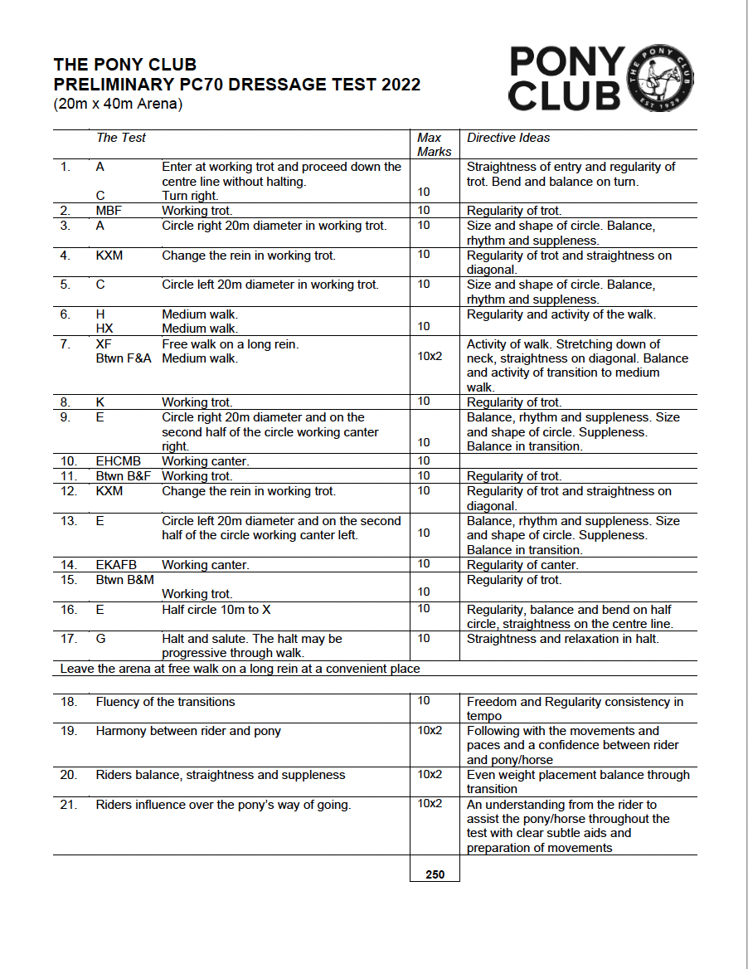

THE PONY CLUB

WALK & TROT DRESSAGE TEST 2022

(20m x 40m Arena)

|  |  |  |  |
| --- | --- | --- | --- |
| *The Test* | | *Max Marks* | *Directive Ideas* |
| 1. A  C | Enter at working trot and continue down the centre line.  Turn right in working trot. | 10 | Active walk. Straightness on the centre line. |
| 2. B  BF | Circle right 20m diameter in working trot. Working trot. | 10 | Good shaped circle with correct rhythm and bend. |
| 3. Btwn F&A | Transition to medium walk. | 10 | Balanced transition. |
| 4. AKE | Medium walk. | 10 | Correct walk rhythm and active steps. |
| 5. Btwn E&H | Transition to working trot | 10 | Balanced transition. |
| 6. MXK KAFB | Change the rein in working trot. Working trot. | 10 | Regularity of trot, straightness on the diagonal. |
| 7. B | Circle left 20m diameter in working trot. | 10 | Good shaped circle with correct rhythm and bend. |
| 8. M  CH | Transition to medium walk. Medium walk. | 10 | Balanced transition. Correct walk rhythm and active steps. |
| 9. HBF | Show some free walk steps on a long rein | 10 x 2 | Activity of the walk. Stretching down of the neck. |
| 10. F | Transition to working trot. | 10 | Obedient, active transition. |
| 11. KX  Btwn X&G | Working trot.  Transition to medium walk. | 10 | Balanced transition. Correct rhythm in walk and trot. |
| 12. G | Halt and salute | 10 | Straightness on the centre line and in halt. |

Leave the arena at free walk on a long rein at a convenient place

|  |  |  |
| --- | --- | --- |
| 13. Rhythm of the walk and trot | 10 | Freedom and Regularity and consistency of tempo |
| 14. Fluency of the transitions | 10x2 | Balance in the transition and obedience and accuracy |
| 15. Rider’s balance and use of aids | 10x2 | Clear and subtle aids and even weight placement |
| 16. Riders’ harmony with pony/horse | 10x2 | Following the movements and paces and a confidence between rider and  pony/horse |
|  | **200** |  |