OBH North branch has recently had great success at the various Championships the Pony Club has to offer. We are really keen for as many of us as possible to enjoy the thrill of competing at Champs and in 2024 there is something available for every age group, discipline and competition level.

We have compiled the following document to try and explain the ins and outs of how to get to Champs

OBH North Branch sits within Area 12 of the Pony Club UK.

Each Area runs their own qualifying competitions (known as ‘Areas’) for the JCB National Pony Club Championships.

For the Regional Championships (SJ/Eventing & Dressage PC70&80) Area 12 combines with Areas 6 and 8 to make up the Eastern Region.

For Tetrathlon we combine with Areas 7 & 9 to make up the Central England Region and compete as a Central England Team at Junior and Senior Regionals and Royal Windsor.

There are 3 Championships depending on your level that you can qualify for over the Summer/Autumn:

- The JCB Pony Club Championships (NATIONAL)
- The Eastern Regional Championships (REGIONAL)
- The Area 12 Championships (LOCAL)

There is also the Spring Festival, this is split into England/Wales and Scotland. Qualifying competitions in Show Jumping, Dressage and Arena Eventing are run per Area across the Winter and the Finals are held between February and March.

The following document details which competitions you need to go to in order to qualify for the Summer/Autumn Championships and provides more information depending on the discipline you wish to compete in at each Championships.

How to qualify for each of the Championships this Summer/Autumn?

1. JCB National Championships

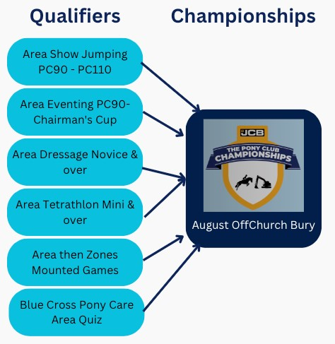

There are also non-qualifying classes at the JCB National Championships, including the Musical Ride.

2. Eastern Regional Championships

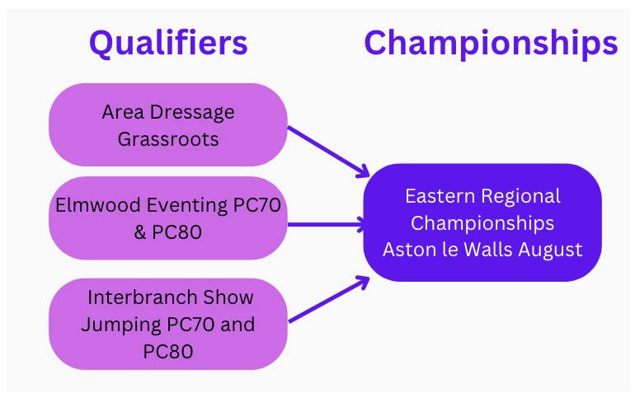

3. Area 12 Championships

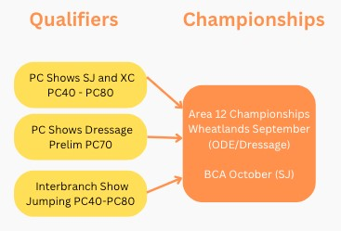

Further information
To register your interest in competing as part of an OBH North team at any level make contact with the relevant Discipline Manager, keep an eye on face book posts and team training opportunities on Horse Events.

There are a few broad points that are relevant for all:

- The Championships courses/tests are always more challenging so aim to qualify at the level that you are very comfortable at and are able to go higher. So, if you are normally competing at 80/90, for example, aim to qualify at 80.
- Once you have moved up levels, be prepared that you can’t go back down levels again as a combination.
- At Qualifiers and Champs, you must stay for the Prize Giving – so put aside the whole day and be prepared for some waiting.
- Etiquette is important – make sure you and your pony are correctly attired for the competition AND for the prize giving.
- If you have a genuine reason for not being able to come to our Area qualifiers, you can apply to compete and qualify out of area by applying to the DC (restrictions apply).

Please see the rule books for further details on all these points.

The following breaks down the information per discipline.

Show Jumping

More about the Qualifying  Competitions | How do I Qualify for Area 12 Championships at BCA on 27th October?  - 40-70cm - To qualify, the pony/horse & rider combination must have achieved a double clear round (no faults) at any Pony Club show at either 40, 50, 60, 70cms (depending on class entered.)  - Qualification events are those run by any PC Branch and do not have to be in Area 12.  - The Qualification Period is 1st October 2023 to end September 2024 for each class.  - 80cm - To qualify for the 80cms you must have qualified by jumping a double clear at Interbranch PC80 on 15th June 2024.  NOTE:  - For all heights, the combination must have received a Qualification Card from their DC/Team Managers and have registered on the Area 12 Championship website.  - Our DC/Team Managers will ensure all qualified members are registered and so have a chance of entering as a Team Member or/and an Individual.

● At the Championships, it is a 2-round competition with the fences in the 2nd round being 5cms higher so take this into consideration when training.
How do I qualify for Regional Championships at Aston Le Walls on 24th-25th August?
Regionals are PC70 and PC80. The Qualifying Interbranch Regional
Show Jumping Competition is held at Middlegrove Farm on 15th June
2024; a friendly show on grass which runs 40cms-80cms with the
PC70 and the PC80 being team and individual qualifiers for the Regional Championships at Aston Le Wals in August and/or Area 12 Champs at BCA on 27th Oct (as above).
How do I qualify for JCB Championships Showjumping in August at OffChurch Bury?
The qualifying show for teams and individuals is Area Show Jumping on 22nd June at Addington for those jumping 90cms, 1m and 1.10m.
How are Teams chosen? | Full details of team selection are set out on our branch website. Selection for the Qualifying Competitions will be made by the Discipline Managers in liaison with the Coaches and Chief Instructor Catherine Shine.  Members will be contacted in advance to make sure they can prepare appropriately and selected team members will be contacted in advance of the competitions.
What training should I be doing? | We provide frequent training rallies with a variety of instructors at different levels. We will provide training across all disciplines we cater for.  Entering local Pony Club competitions also really helps you prepare for the upcoming qualifiers as it allows you to gain the experience of arena craft, perfect a warmup routine and identify important areas that need to be worked on within your partnership with your pony.  Please note that many of the Championships run at a slightly higher height than the qualifying competitions, so please take this into account in your practice!
Eligibility | Area 12 Championships Eligibility – 40cm, 50cm, 60cm, 70cm & 80cm

- The pony or horse/rider combination must not have competed at any Pony Club Regional or Area Show Jumping competitions.
- In addition, the pony and horse/rider combination must not have been placed at any Show Jumping competition at a height more than 10cms above their Championship class height.
- As the season progresses, it is likely that some competitors will qualify at two or even three heights. These competitors will be required to enter the Championships at their highest qualifying height.
- Age restrictions apply for the 50cm and 70cms classes:
50cms - 12 yrs and under at 1st Jan 2024
70cms – 13 yrs and under at 1st Jan 2024
REGIONAL PC70 and PC80
PC80 Riders are NOT eligible if they have previously represented their Branch or Centre at PC90 level or above.
PC70 Riders must be aged 13 and under on 1st January of the current year. Riders are NOT eligible if they have previously completed at any PC80 or above Area or Regional competition for Show Jumping.

AREAS & CHAMPIONSHIPS SJ PC90, PC100 and PC110
Members must fulfil all the eligibility rules on the day of the Competition depending on the height entered.
Full eligibility rules can be found in the Pony Club Show Jumping Rule Book. Each Rider/Parent is responsible for ensuring they understand and comply with the Rule Book and are eligible for selection.
What is the dress code? | Black, Navy or tweed competition jacket, white shirt, PC tie and badge, white or beige jodhpurs. Long hair in a hairnet or tied back neatly.
If I qualify – what next? | - Qualifications 40cms to 80cms go to the Area 12 Championships at the BCA on 27th October 2024.  - Qualifications obtained at Interbranch for PC70 and PC80 go to the Regional Championships held in Aston Le Walls on August 24th-26th and/or the Area 12 Champs at BCA on 27th October.  - Area Qualifications for 90cms, 1m and 1.10m go to the National JCB Championships held 13th-17th August (exact date tbc) at Offchurch Bury, Warwick.
 | Please note: You must let us know if you are unable to commit to going to the Championships BEFORE we do entries as we will enter you either as an individual or in a non-qualifying team.

Eventing

More about the Qualifying  Competitions | Area Eventing Qualifier is running at Hambleden on Sunday 7th July with PC90, 100, 110 and the Chairman’s Cup, which is PC100+ run with a trot up and Show Jumping on last day. All these except the 110 qualify for the JCB Championships held at Offchurch Bury 9-17th Aug. The date and venue for the 110 Champs is yet to be released.  In the PC100, CC & 110 there is direct qualification if you receive fewer than 45 penalties in dressage, fewer than 16 faults in SJ and go clear in XC with fewer than 30 time penalties.  Regional Eventing Qualifier will be held at Elmwood Sunday 9th June with PC70 & 80, which qualifies for the Eastern Regional Championships at Aston le Walls 24-26th August.  Area 12 Championships.  Throughout the year there are many PC One Day Events and Hunter Trials. Completing one of these with a clear cross country qualifies you for the Area 12 Championships in September at Wheatlands, which will have classes from PC40-PC80
What  Training should I be doing? | You will need a very fit horse so make sure you do plenty of fast work, whether that be at the gallops or on good ground out hacking and plenty of hill work, along with your usual dressage, SJ and XC schooling
Eligibility | The eligibility criteria are different for all the classes, but generally you cannot compete in a class if you have evented more than 10cm bigger see the Eventing Rule Book
What is the dress code? | Dressage & SJ – white saddle pad  Tweed or black/navy jacket  Stock shirt & pony club stock/tie  Beige or white jods  XC – OBH North XC base layer & silk
If I qualify – what next? | 90,100,100+ Pony Club Championships Offchurch Bury, 13th-17th August (Eventing dates TBC)  70,80 Eastern Regional Championships Aston le Walls 24-26th August
40-80 Area 12 Championships, September date at Wheatlands

Please note: You must let us know if you are unable to commit to going to the Championships BEFORE we do entries as we will enter you either as an individual or in a non-qualifying team.
Who to contact | Alison Dippenaar obhnortheventing@outlook.com

Tetrathlon

More about the Qualifying Competitions | To qualify for the JCB Champs, you must attend an Area Tetrathlon in a Qualifying Class (no riding down). The Area 12 date is July 13th-14th at Horseheath (combining with Area 8).  The top Mini boy and girl will be nominated for the Steppingstones Mini Central England team, also held at Champs.  Qualifying Juniors, Intermediates and Opens will go on to the JCB  Champs as individuals and teams. Tet at JCB Champs runs from 9th11thAugust at Offchurch Bury (most will arrive on the evening of the 9th) and includes a legendary party on the Saturday night. This weekend pulls well above its weight for fun and is not to be missed.  Area Tet is open to all ages and also has non-qualifying classes (Beanies, Tadpoles and lower height Minis, Juniors, Inters and Open) so even if you are not of trying to qualify, come along – it’s a great event.  There aren’t Tet classes at the Area 12 Championships or at the Eastern Regional Championships.  There is also the Junior Regionals for top level Juniors at Moreton Morrell on 2-4th June via nomination. And Senior Regionals/Internationals for the most advanced Tetrathletes at 3rd4thAugust in Enniskillen, also via nomination.
How are Teams chosen? | Holly Arnott & Catherne Shine will choose the teams based on previous competition  experience. Must have been signed off for shooting and swimming, as well as for XC as the Champs courses are considerable. No limit to how many we can take to Areas – as long as spaces allow. Each individual must complete Areas with a minimum ride score of 800 even if the Team qualifies overall.
Eligibility | No eligibility limits as classes are run purely by age:  Minis 10-11 (PC80 - only top Area boy and girl will be nominated).  Juniors 12-14 (PC90)  Intermediate & Open 15+ (PC100\PC100+)  See Tet Rule Book
What is the dress code? | Branch tops for running and shooting, long trousers and trainers for shooting. FPC swim hats. OBH North XC base layer, hat silk and numnah (or plain white)
If I qualify – what next? | Book 9th-11th August and get your camping kit ready. There will be a themed party night and we will camp together as an Area – families often come all together and make it a core part of their summer holiday
For more information | Holly Arnott

Dressage

More about the Qualifying Competitions | Area 12 Championships  To qualify for the Area 12 Championships, the pony or horse/rider combination must have completed successfully (i.e. attained 65% or higher and/or been placed 1st, 2nd or 3rd in a class of 10 riders or more). Qualification events are those run by a PC Branch but do not have to be in Area 12.  The Qualification Period is 1st October 2023 to close of entries for each class.  The combination must have received a Qualification Card from their DC and have registered on the Area 12 PC Championship website.  More Info to follow when released.  Regional Champs & JCB Pony Club Champs - qualifying event for both is at the Area Qualifier at BCA 30th June.  This competition is for all riders from PC70 (Prelim), PC80 (Grassroots) up to the Novice, Intermediate and Open classes. You can compete as an individual and team member. We will put together teams to include all those wishing to compete.  This competition also features a Prix Caprilli class, which is for younger, less experienced partnerships and is a great steppingstone to Dressage.  All tests are available on the PC Website under Sport / Dressage / Dressage Tests.  PC70 and PC80  This is aimed at introductory levels, with simple and encouraging tests. If you qualify at BCA at these levels, you can compete at the Regional Championship at Aston Le Walls on 24th-26th August.  Novice, Intermediate and Open  Qualifiers at these levels compete at the JCB Championships 13th-17th August.
How are Teams chosen? | Team selection is based on experience, results and current competition form.  Please note: You must let us know if you are unable to commit to going to the Championships BEFORE we do entries as we will enter you either as an individual or in a non-qualifying team.
What Training should I be doing? | Training should be regular, with your own instructor weekly or fortnightly if possible and / or by attending the dressage rallies. The summer field dressage rallies are strongly recommended for those wishing to compete in this event.  There is only one test per level so if you are interested in competing (a slightly harder version will be ridden as the Championships test), get learning the test and practise it and the movements regularly where possible. There are many PC and unaffiliated dressage competitions on over the year in our area which are excellent opportunities to practise and some even allow you to do PC test in the 'Pick Your Own' classes.  Competition is strong, so get practising as soon as you can!
Eligibility | Please speak to Helen Mooney re eligibility or check the PC rule book / website.
What is the dress code? | Dress code for all dressage is black / navy / tweed show jacket, PC stock, pin and badge.  White or beige breeches, hat / silk to complement jacket, black or dark brown boots / half chaps.  White dressage pad, number bib / badges  Tack - please see PC rule book or ask ...plain black or brown tack, no martingales, snaffle / hanging snaffle or similar bit. No boots. Horses / ponies should be plaited.
If I qualify – what next? | The Regional Championships are at Aston Le Walls 24th-26th August.  The JCB Pony Club National Championships is 13th -17th August, at Offchurch Bury, actual date to be confirmed. Make sure you have those dates blocked in your diary.
For more information | Please contact Helen Mooney for any help or information.

Mounted Games

More about the Qualifying  Competitions | Area 12 mounted games is on the 19th May 2024. Friendly at the same venue on the 18th May. This is fun for all levels. For Junior, Senior and Pairs top 2-3 teams qualify for Zones on the 20th July. The top 8 teams from Zones go to the JCB National Champs in August.
How are Teams chosen? | Christine Hern will try to form a team to include everyone that would like to participate.
What  Training should I be doing? | Please let me know you are interested, attend some games rallies if you can (for lead rein and novice this is less essential).
Eligibility | Juniors 10 or under on 1st of Jan 2023.  Novice (lead rein, assisted or nervous, same age as juniors) Seniors 14 or under on 1st Jan.  Pairs 11 to 18 years old.
What is the dress code? | For training no shirt or tie is required. Competition clothing; shirt, pony club tie, sweatshirt, beige jods, navy or black hat velvet/silk. Hard hat with no fixed peak. Jodhpur boots and clips or chaps or long boots. Whole team can wear black jods in 2024.
If I qualify – what next? | We celebrate and aim our rally practice for the next set of races.
Who to contact for more information | Christine Hern

