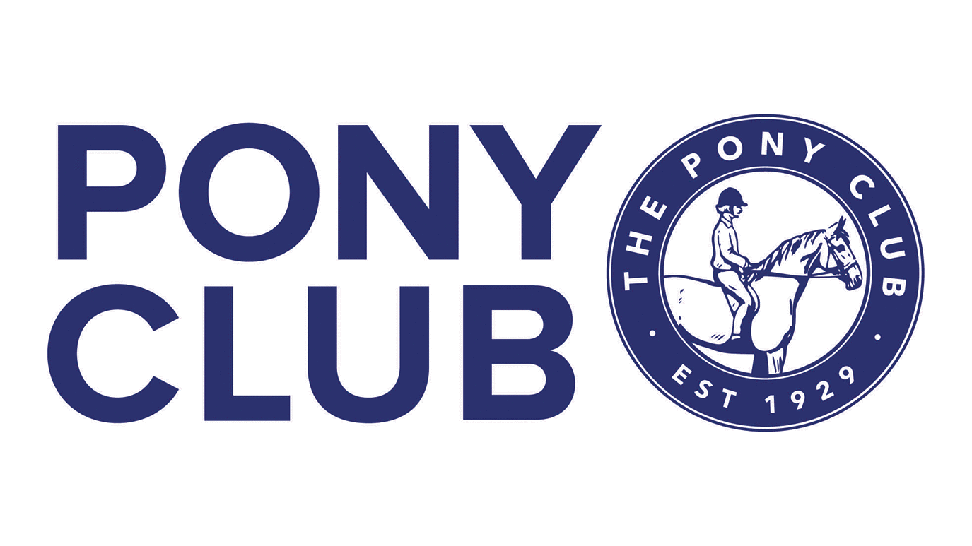
OXENHOLME BRANCH OF THE PONY CLUB
SHOW JUMPING COMPETITION

At Fleets Farm Gressingham LA2 8LN by Kind permission of Mr and Mrs Metcalfe

SUNDAY 30th March 2025

Pre-Entries only

OPC Members £7 per class – All Others £10 per class
Entries to be made online at https://oxenholmepc.entrymaster.online/
Ages as of 1st January 2024

Classes

1 Lead rein – max height 30cm
2 30cm – riders 10 years and under (may be assisted)
3 40cm – riders 10 years and under (may be assisted)

4-J 50cms under 16s on ponies
4-S 50cm anyone else

5-J Junior Todds QUALIFIER 60cm - under 16s on ponies (open to all but only OPC members to qualify)
5-S Senior Todds QUALIFIER 60cm - anyone else (open to all but only OPC members to qualify)

6-J 70cm under 16s on ponies
6-S 70cm anyone else

7-J Junior Todds QUALIFIER 80cm - under 16s on ponies (open to all but only OPC members to qualify)
7-S Senior Todds QUALIFIER 80cm - anyone else (open to all but only OPC members to qualify)

8-J 90cm under 16s on ponies
8-S 90cm anyone else

9 100cm open to all
10 105cm open to all

ENQUIRIES to:- Karen Barnes 07766 362173
oxenholme@pcuk.org

This competition is held under Pony Club rules and all competitors must abide by these rules.

Riding Hats
Please click the link below for full rules and hat standards
https://resources.pcuk.org/wp-content/uploads/2024/08/Hat-Rule.pdf

Back Protectors
Click the link below for full rules and standards
https://resources.pcuk.org/wp-content/uploads/2024/08/Body-Protector-Rule.pdf

HAIR SHOULD BE SECURELY TIED UP AND WORN IN A HAIR NET. NO JEWELLERY SHOULD BE WORN.

Pony Club members – to wear spurs you must have either passed your C+ test or the Spurs test.

In the event of cancellation by the organisers, full refunds will be given
No refunds given on withdrawn entries after the closing date

NOTICE TO ALL PERSONS ATTENDING THIS EVENT

It is most important that any incident involving:
- Accident, illness or injury to any rider, spectator or any other person present at the event
- Accident injury to any horse or other animal, whether competing at the event or not
- Damage to any property or vehicle
is reported to the organisers immediately.

HEALTH & SAFETY

The organiser of this event has taken reasonable precautions to ensure the health and safety of everyone present.
For these measures to be effective, everyone must take all reasonable precautions to avoid and prevent accidents occurring and must obey the instructions of all the Officials and Stewards.
The risk assessment for this event can be inspected on request.

DISCLAIMER

- Save for the death or personal injury caused by the negligence of the organisers, or anyone for whom they are in law responsible, neither the organisers of this event or The Pony Club nor any agent, employee or representative of these bodies, nor the landlord or his tenant, accepts any liability for any accident, loss, damage, injury or illness to horses, owners, riders, spectators, land, cars, their contents and accessories, or any other personal property whatsoever, whether caused by their negligence, breach of contract or in any other way whatsoever. Entries are only accepted on this basis.
- The organisers of this event have taken all reasonable precautions to ensure the health and safety of everyone present at this event. For these measures to be effective, everyone must take all reasonable precautions to avoid and prevent accidents. They must obey the instructions of the organisers and all officials and stewards.
- All non Pony Club competitors are not covered by The Pony Club insurance and must have their own third party cover. The Oxenholme Branch of The Pony Club and the organisers of this event are not legally responsible for non Members and their insurance will not cover you.

