JUNIOR CAMP 2024
KIT LIST
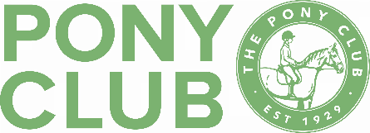
Rider
- Hat – coloured silk (preferably dark), hat tagged with pink hat tag
- Back protector to 2018 standard (blue label)
- Rally dress – shirt & tie, branch t-shirt or green polo shirt, beige/dark jodhpurs, black or brown long boots or short boots with chaps (no tassels), hairnet & gloves
- Waterproofs – wellies, jacket & trousers
- Change of riding clothes in case you get wet
- Show clothes for last day are optional (show jacket, shirt/stock, light jodhpurs)
- Non-riding clothes for lunchtime if required– hoodie, trainers, etc
- Lunch, snacks and a full water bottle
- Sun protection
- Medicines clearly labelled with name & dosage with details included on the medical form
- Camping chair for lunch/breaks
- Pony Club Manual of Horsemanship
Pony/Horse
- Saddle – plain saddlecloth (dark colours preferred), girth, stirrup leathers & stirrups
- Bridle – reins should be dark in colour and unknotted
- Brushing boots/tendon boots if you normally use them
- Headcollar & lead rope – correctly fitted & in good condition
- Rugs – sweat/fleece cooler, fly rug, rain sheet, exercise sheet as required
- Bucket, sponge & sweat scraper for washing down, shampoo, cooling/citronella wash, etc if you use them
- Tack cleaning equipment
- Full grooming kit including fly spray & hoof oil or equivalent
- Optional plaiting kit, rubber/silicon bands or quik-knots are fine
Stable
- Hay/haylage & haynet – enough for the day
- Hard feed for lunch if you think your pony will need it
- Water bucket & full water container, it’s a long walk from the tap with a full bucket!!
- Muck picking kit

PLEASE ENSURE ALL YOUR BELONGINGS
ARE CLEARLY NAMED

