VALE OF AYLESBURY HUNT PONY CLUB TEAM SELECTION POLICY 2025
THIS POLICY APPLIES TO THE FOLLOWING COMPETITONS:

- All Area PC70, PC80, Novice, Intermediate, Open Dressage and Prix Caprilli competitions and any associated Championships;
- All Area PC70, PC80, PC90, PC100, PC110 Show Jumping competitions and any associated Championships;
- All Area PC70, PC80, PC90, PC100, PC Chairman’s Cup and PC110 Eventing and any associated Championships;
- All PC invitation only Showjumping or Eventer Challenge competitions (Hickstead, Burghley, Gatcombe, Blenheim and any others)

- N.B. In respect of Blenheim Eventer Challenge, Windsor Pony Club Jumping and any similar event nominations, priority will be given to those who have not have not competed in these competitions on two previous occasions.

- VAHPC is keen to enter teams (and individuals) in as many competitions at every level as we can throughout the year. For all competitions, riders must be active members of the branch and out competing at the height/level they wish to be considered for on a regular basis.

- As a club we can enter teams, individuals or a combination of both. Teams must consist of three or four members. We will aim to field our strongest team(s) available and our preference is teams of four members. Scores for all competitors usually automatically count for the individual competition irrespective of whether they have been entered as part of a team or as an individual.
AREA ELIGIBILITY / AVAILABILITY FOR CONSIDERATION
All competitors must be members of the Pony Club both at the closing date for entries and at the date of the relevant competition.

New for 2025 (in italics)
Dressage
Combinations of Horse and Rider CAN compete at two adjacent levels of the same Sport at the Area Competition or at the Championships apart from at both Grassroots and Novice.
At the Championships, each level will have a separate section for riders/combinations that have competed at a higher level.
Commanders are permitted for the Preliminary PC70 Regional Qualifiers and Championships.

Show Jumping
Whilst Pony Club have made changes in their rule books so that Combinations of Horse and Rider CAN compete at two adjacent levels of the same Sport at the Area Competition and Championships, Including PC80 and PC90 this year, VAHPC recommends that rider/horse combinations compete at only one level as upto 4 rounds (PC70/80) and upto 6 rounds (PC90/100/110) incl potential jump offs is not considered sensible for the welfare of the horse. If members want to be considered for 2 levels priority for Teams may be given to members competing at one height only.

Eventing
No horse may compete at more than one level of Eventing at the Area or above (PC70, PC80, PC90, PC100.PC Chairmans Cup or PC110) in any one year nor may any horse be ridden more than once in any one year in any of the qualifying competitions or at the Eventing Championships.
Combination of Horse and Ride cannot compete at two different levels of the same Sport at the Area Competitions. Except any combination of horse and rider may qualify and compete at both the PC110 Championship, and the PC Chairman’s Cup Championships.

Schooling
Riders or horses who have “schooled” over the Area or Championship Cross Country courses during the previous two weeks are not eligible to compete. Competing over the course is permissible and does not render the competitor ineligible.

Eligibility for Team Selection

The DC or Team Manager is required to certify the eligibility of the horse and rider. Any breach may result in disqualification.

All horses and ponies must have genuinely participated at minimum of three Qualifying Rallies/Coaching/Training Sessions of this or their previous branch or centre since 1st July in the previous year, and one of these must be in the current year (preferably at a training session at the level wanted to compete at), with the current rider as a combination. Camp shall count as one Rally/Coaching/Training Session.

The following will also be considered as Qualifying Rallies/Coaching/Training:
- Proficiency Ridden Training (one level of ridden training in 2025 will count as one rally)
- Area 12 centrally organised Training Sessions
In the event that a member has a reasonable justification for not achieving the 3 rally count, they may be permitted into a team but only in the event that all those with their 3 rally count have been offered places first.

Full eligibility rules should be referenced in the associated Pony Club Discipline Rule Book. Each Rider/Parent is responsible for ensuring they understand and comply with the PC Discipline Rule Book and are eligible for selection.

LEVELS
The following is an indication of the various tests and heights for Area and Championships. Further information is given in the respective discipline rulebook.

SHOWJUMPING
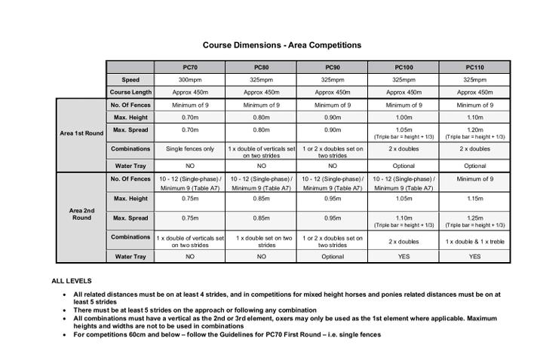
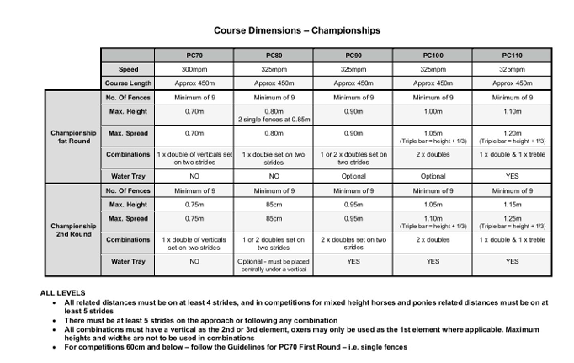

Notes: Heights stated are the maximum fences will be at for each round.
PC70 is for teams and individuals aged 13 and under on 1st January of the current year
PC70 Plus is and individual only competition for members aged 14 and over on 1st January of the current year

EVENTING | PC70 Regional Championships  PC70 Plus Regional Championships | PC80 Regional Championships (previously Regional) | PC90 (previously Novice) | PC100 (previously Intermediate) | PC Chairmans Cup (previously PC100+) | PC110 (previously Open)
Dressage Test – Areas | Preliminary PC70 Dressage Test 2022 | Grassroots PC80 Dressage Test 2018 | PC90 Eventing Test 2025 | PC100 Eventing Test 2015 | PC110 Eventing Test 2022 | PC110 Eventing Test 2022
Dressage Test – Championships | Preliminary PC70 Dressage Test 2022 | Grassroots PC80 Dressage Test 2024 | PC90 Eventing Championship Test 2015 | PC100 Eventing Championship Test 2025 | PC110 Eventing Championship Test 2015 | PC110 Eventing Championship Test 2015
Showjumping | Max height 75cm | Max height 85cm | Max height 95cm | Max height 105cm | Max height 110cm | Max height 115cm
Cross Country | Upto 25 Obstacles, Max height 70cm | 16-25 Obstacles, Max height 80cm | 18-25 Obstacles at areas, Max height 90cm  25-30 at champs | 18-25 Obstacles at areas, Max height 100cm  25-30 at champs | 20-27 Obstacles at areas, Max height 105cm  25-30 at champs | 20-28 Obstacles at areas, Max height 110cm  25-30 at champs
XC Speed | 435mpm  (Penalties only for going too fast) | 435mpm  (Penalties only for going too fast) | 450mpm | 475mpm | 500mpm | 520mpm
XC Course Length | Upto 1800m | 1600 to 2500m | 1600 to 2500m in Areas,  2500 to 3500m at champs | 1800 to 2800m in Areas,  2500 to 3500m at champs | 1800 to 3120m in Areas,  2500 to 3500m at champs | 2400 to 3120m in Areas,  2500 to 3500m at champs

Note: new tests for 2024 are marked in RED TEXT
Please see the PC Eventing Rule Book for full dimensions and specific information on spreads, drops, water etc

DRESSAGE | PC70 Regional Championships  PC70 Plus Regional Championships | PC80 Regional Championships (previously Regional) | Novice & Open Novice | Intermediate | Open
Area Tests | Preliminary PC70 Dressage Test 2022 | Grassroots PC80 Dressage Test 2018 | Novice Dressage Test 2020 | Intermediate Dressage Test 2024 | Open Dressage Test 2020
Championships Tests | Preliminary PC70 Dressage Test 2022 | Grassroots PC80 Dressage Championship Test 2024 | Novice Dressage Championship Test 2025 | Intermediate Dressage Championship Test 2023 | Open Dressage Championship Test 2018

Note: new tests for 2024 are marked in RED TEXT

COMPETITION DATES
We would expect those applying for consideration to be available for the relevant Championship date for their respective discipline (taking into account possible overnight stays). Priority is given at Team selection to those who can be available for both Area and Championship competitions. Wherever possible, if a member is still keen to compete at an Area competition (but is not available for the Championships and would otherwise have been selected), we will try to secure an individual place for them.

Dates for the Area and National events will be on our website and riders applying for consideration for respective competitions and associated Championship (should they qualify) should confirm availability at a date to be confirmed by each Team Manager.

Current dates advised are as follows:

DISCIPLINE AREA QUALIFYING COMPETITIONS | Date | Venue
PC70 & PC80 Showjumping | Saturday 14 June | Middlegrove Farm
PC90, PC100 & PC110 Showjumping | Sunday 22 June | Addington Equestrian
Area Dressage including Prix Caprilli | Sunday 29 June | Berkshire College of Agriculture
PC70, PC80, PC90, PC100 and PC Chairmans Cup  Note: PC110 qualify via the MERS route champs to be held at Wellington. | Sunday 6 July | Elmwood
CHAMPIONSHIPS
National Pony Club Championships | Friday 8 to Saturday 16 August | Offchurch Bury, Warwickshire, CV33 9AR
PC110 Eventing Championships | TBC (between Friday 22 & Monday 25 August) | Wellington
PC70 & PC80 Championships | Saturday 30 & Sunday 31 August | Aston Le Walls

SELECTORS AND SELECTION CRITERIA
For Area and Regional events, where the team is selected to represent the VAHPC, the selection will be made by:
  - District Commissioner or Joint District Commissioner’s
  - Associated discipline/level Team Manager(s)
  - Associated discipline/level Team Trainer

If any one of the Selectors is either the parent / legal guardian, a relation or privately trains any rider on a regular basis who is being considered for selection they must not take part in the selection decision involving that individual.

The Selectors reserve the right not to send a team or individual to any competition. The following criteria apply to those wishing to compete in a team or as an individual.

- Combinations should be actively and successfully competing within the discipline at the associated level, with visible results.
- Results from the previous September up until the time of selection will be taken into account.
- Selectors will consider all results which shall be submitted to Team Manager, Trainer and DC. Consideration will be given to consistency, soundness, results at or above the level being considered for selection and engagement with VAH. Selectors have absolute discretion to select combinations they deem best placed to secure the highest placing for VAH.
- Combinations should have attended the required Rallies/Coaching/Training Sessions and any organised team training sessions. Exceptions are at the discretion of the DC; where attendance may not be possible due to work or school commitments, illness or other reasons.
- In the event that a member has a reasonable justification for not achieving the 3 rally count, they may be permitted into a team but only in the event that all those with their 3 rally count have been offered places first.
- Riders need to register their interest in being considered for teams by completing the appropriate forms that will be available on the website and from Team Managers.
- It is a condition of selection that members will nominate someone who is prepared to assist at Area Competitions or on the Competition day at other VAH or Area 12 events during the year on a minimum of 2 occasions. Assistance will be needed at various events during the 2024 year.

RESERVES/REPLACEMENTS
Reserves/replacements for Championships will be selected primarily on results from the current year’s Area competitions. Where an Individual has qualified the Reserve will, in the first instance, be chosen from an alternative Team entry in order to maintain the Individual qualification place. Should we need to consider members who did not compete at Areas, this will be done as a last resort and the original selection criteria as above will be used.

Where a replacement is needed for an Area competition, this will be primarily based on those already selected. This will be at the complete discretion of the Team Manager, Team Trainer and DC to enable VAH to be best placed to have VAH teams able to secure qualification to the Championships. This may result in changes to previously advised team and/or individual entries. This may be due to issues outside VAH control, such as changes of circumstances affecting riders or horses. If this occurs members being moved between teams, to achieve the preferred number of 4 in a team. If this results in another team no longer being feasible those members would end up competing as individuals. Decisions on this will be made by the Team Manager, Team Trainer and DC.

CONFIDENTIALITY
It is vitally important for the integrity of the Selection Guidelines and those involved in its application both as riders, owners, selectors or other officials, that there is at all times a high degree of confidentiality relating to information which may have a bearing on selection.

TEAM SPIRIT
One of the great benefits and pleasures of Pony Club is the chance to be involved in a team. VAHPC expects riders and their supporters to have good attitude and participate in all the required activities within the Branch, either riding or helping. A high level of commitment to all the varied aspects for the preparation process is important.

We expect members (and parents) to support and help each other at all times as well as accepting advice from Team Trainers, Managers and other Officials in a constructive way.

We would like to remind all members to read the following code of conduct documents that are on the VAH and PCUK Websites:
- Pony Club Code of Conduct for Members
- Pony Club Code of Conduct for Parents and Guardians

ATTIRE
When competing at Area level or other Pony Club events VAHPC Team attire for both rider and pony should be worn. Please contact the appropriate Team Manager in good time if this may not be possible and VAHPC shall try and help facilitate.

If you are involved in prize giving, please wear your riding attire including hat unless directed to do otherwise by organiser.

TRAINING
Appropriate discipline training sessions will be provided which members should attend as frequently as possible. Dressage/Flatwork and Showjumping sessions for example will be applicable to those doing either pure single discipline or Eventing.

FITNESS
Horse and rider fitness is vitally important, not only to the success of competitor, but also to the safety and welfare of the horse and rider. Riders must notify the DC, Team Manager or Team Trainer of any change in their own health or fitness status, and/or their horse / pony or veterinary/medical management immediately, where such change could have an impact on performance.

FINANCE
Once selected, the member’s place is only confirmed on receipt of the relevant entry fee. No entry fees can be refunded without a vet or doctors certificate and there is usually a cut off date for this for each event.

VAH will provide a Team Trainer for any Area or Championship events where we have a Team competing. If this is the case, it is compulsory for all selected team and individual riders to take part in all course walks with the trainer. All combinations will be expected to warm up under the guidance of the trainer when on offer.

VAH may not provide a Team Trainer for events where we are only sending individuals. If this is the case members are either responsible for making their own arrangements using a suitable trainer or ask the DC to co-ordinate with another Area 12 Pony Club that is attending for the Member(s) to utilise their trainer and pay an equal share of the trainer costs whatever that may be.

Each member is responsible for the entry costs and stabling costs associated with both Area and Championship competitions. VAHPC will cover the trainer costs at Championships.

If a member is unable to put themselves forward for selection due to the financial constraints, they should discuss their position (in strict confidence) with the DC to see if VAHPC could subsidise some of the costs.

RULES
All selected riders agree to abide by the rules of the competition always. Should there be any query about rules or results on the day of the competition the rules state that the DC or the DC’s representative must take the query to the Officials.

ENQUIRIES
Any enquiries on selection should be directed to the DC or Assistant DC.

