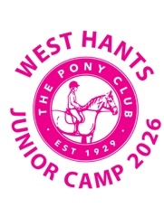**WEST HANTS PONY CLUB**

**JUNIOR CAMP 2026**

**4th & 5th July 2026**

**at Lower Rowe, Holt, Wimborne, Dorset  
/// Rollers.Salad.Adventure**

This is a non-residential 2 day camp for all members 10 and under (negotiation available)

* We will be covering full days of flatwork, jumping, xc, Polocrosse, games instruction, stable management, horse management and culminating in our final day competition where each child will compete at their level.
* Fully trained instructors, safeguarding and first aid officers will be in full attendance.
* Ponies will travel daily with the members
* All abilities will be catered for (lead rein children will require parents to stay to lead them)
* Full catering lunches will be provided for all
* Fun and friendship will be key for all.

**Cost:   £125**

All monies are non-refundable unless camp is cancelled (unless a doctor or vet's certificate can be provided)

Payment schedule:

Deposit on booking £25

31st March 2nd payment £25

30th April 3rd payment £25

31st May 4th payment £25

20th June – Final payment £25