The Pony Club Achievement Badges 
Fitness
Workbook
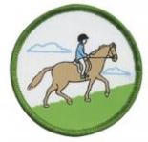
Which of these horses and ponies need to be fit? (circle your choices)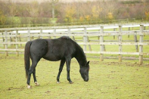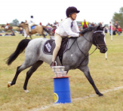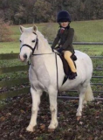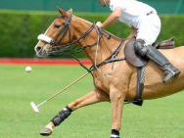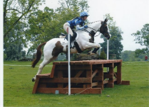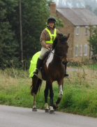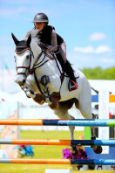
Which of the following general heath factors should be checked and considered prior to starting work with your horse?
Heart and respiratory function
Vaccinations 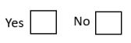
Foot care / shoeing
Teeth
Worming
Soundness
Which of the following statements do you agree with?
- An overweight horse may experience problems with fitness - An underweight horse may experience problems with fitness - A horse in hard work is less likely to need concentrated feed - Before competing a horse should be suitably fit for the discipline
- Walking is a good way to help with fitness
Is the following information TRUE or FALSE?
- Injures are more likely in horses that are not fit - Dressage horses need to be less fit than event horses - Each horse needs to be appropriately fit for the discipline and level for which they are competing
- A horse can only be deemed as fit if they gallop regularly
- Ponies need to be just as fit as horses if they are competing in the same discipline and at the same level
Match each of the scenarios to the most sensible feeding requirement.
Horse in light work
Horse in medium work
Horse in hard work Horse in no work
Grass or hay, and some concentrated feed required
Grass or hay, and no
concentrated feed required
Grass or hay, and very little or no concentrated feed required
Grass or hay, and an increased amount of concentrated feed required
Describe a simple fittening programme for one of the following:
• A pony going to compete in Novice Area Dressage, Show Jumping or Eventing
• A pony going for a days hunting
• A pony going to do a 25km endurance ride
_________________________________________________ _________________________________________________ _________________________________________________ _________________________________________________ _________________________________________________ _________________________________________________ _________________________________________________ _________________________________________________ _________________________________________________ _________________________________________________
With reference to fitness, use the space below to explain the problems that may be associated with the horse in this picture. _______________________________ _______________________________ _______________________________ _______________________________ _______________________________ _______________________________ _______________________________ _______________________________ _______________________________
With reference to fitness, use the space below to explain the problems that may be associated with the horse in this picture. _______________________________ _______________________________ _______________________________ _______________________________ _______________________________ _______________________________ _______________________________ _______________________________ _______________________________
Describe how you keep your own horse / pony fit and healthy to ensure that they are able to carry out the work required of them.
_____________________________________________ _____________________________________________ _____________________________________________ _____________________________________________ _____________________________________________ _____________________________________________ _____________________________________________ _____________________________________________ _____________________________________________ _____________________________________________

