The Pony Club Achievement Badges Handling and Grooming
Workbook
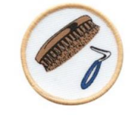
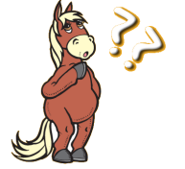
Identify which of the following statements are correct. - You should only handle a pony if you feel confident to do so 

- Ideally you should always lead a pony in a bridle, especially if you do not know the pony very well
- Small ponies are less unpredictable than big horses - It is advisable to tie a pony up before grooming them - If you are handling a pony then you don’t need to do up the chin strap on your riding hat

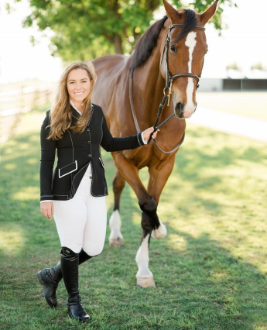
With reference to health and safety when handling a horse or pony, discuss any good points or bad points that you can identify in this picture.
Answer:_______________________________________________________________ _________________________________________________________________________
_________________________________________________________________________ _________________________________________________________________________ _________________________________________________________________________ _________________________________________________________________________ _________________________________________________________________________ _________________________________________________________________________
Are the following points good or bad when leading a pony? ? ?
/
lead rein correctly
Handling log sheet
Ask an adult to observe and confirm that you are able to safely and competently carry out each of the handling tasks below. Complete the log sheet as evidence.
Handling task | Date | Confirmation of safe and competent performance | Adult’s signature  and comments
Wear appropriate clothing and personal protective equipment for handling a pony
Lead a pony in hand
Trot up a pony in hand
Turn a pony correctly (away from handler)
Tie up a pony correctly using a quick release knot

List five reasons for grooming a pony.
1
2
3
4
5

Name each of these items of grooming kit.
Match each item of grooming kit to its correct function.
This needs to be used everyday to pick out your pony’s feet.
Dandy Brush
Metal Curry Comb Mane Comb
Hoof Pick
Sponge
Plastic Curry Comb Body Brush
Rubber Curry Comb
This is a nice soft brush and it is used to remove dust from your pony’s coat. This brush can also be used to brush your pony’s mane and tail.
This brush is used to remove dirt and dust from a body brush. DO NOT ever use this brush on your pony!!!
This brush is used to remove dry mud, sweat, and loose hair from your pony’s body. DO NOT use this brush on your pony’s legs or face.
This brush is used to remove dry mud, sweat, and loose hair from your pony’s body. This brush can also be used to give your pony a massage. DO NOT use this brush on your pony’s legs or face.
This brush is used to remove dry mud and dirt from your pony’s body and legs.
This is used to wash your pony. You should have a number of different ones for the different areas of your pony’s body.
This can be used to comb your pony’s mane.

