The Pony Club Achievement Badges Equine Behaviour
Workbook
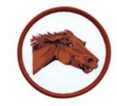
With reference to living as a herd in the wild, place the following horses into the correct pecking order.
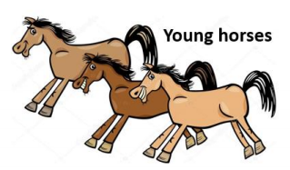
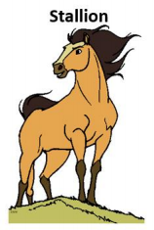
1. __________________
2. __________________
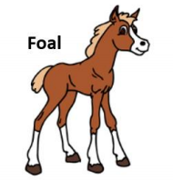
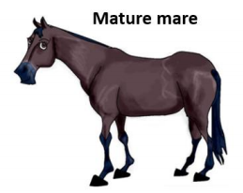
3. __________________
4. __________________
Match each of the ear positions to the correct description.
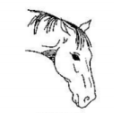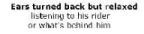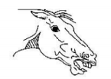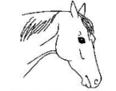
Identify the behaviour being demonstrated in each of the pictures below: Answer: ___________________
Answer: _________________
Answer: _________________
Answer: ______________________
Answer: ____________________
Answer: _________________
When might a pony make each of the following noises?
Noise  Neigh | When might a pony make this noise?
Squeal
Snort
Sigh
Scream

How might pony behaviour change according to each of the following weather conditions?
Answer: _________________ ________________________ ________________________
Answer: __________________ _________________________ _________________________
Answer:__________________ _________________________ _________________________
With reference to health and safety when handling, discuss the horses in each of these pictures.
Picture A _________________________________________________________________ ___________________________________________________________________________ ___________________________________________________________________________ ___________________________________________________________________________ Picture B __________________________________________________________________ ___________________________________________________________________________ ___________________________________________________________________________ ___________________________________________________________________________
Picture A Picture B
Which of the following behaviours are most likely to indicate that a pony could be in pain?
Rolling
Bucking
Unhappy or trying to bite
when being tacked up
Rearing
^{Napping} Eating
Circle the words below that could cause a pony to demonstrate unwanted behaviour/s . Colic Poisoning Poorly fitted tack Kissing spine Too much food
Gastric ulcers Hormone imbalance Dental disease
Bad weather Too much energy and
not enough exercise
Recap
See if you can identify any of the behaviours below in your own horse or pony. Circle the ones that you identify.

