The Pony Club Achievement Badges 
Points of the Horse
Workbook
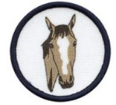
Name the missing points of the horse labeled 1 - 10.
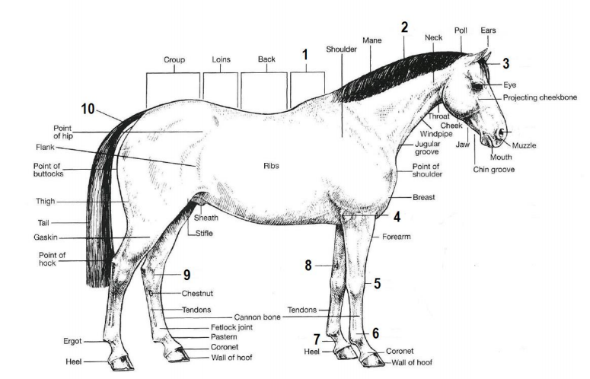
Numbers challenge - read each of the descriptions below and with reference to a horse identify the correct number.
1. The number of hocks.
Answer: __________
2. The number of nostrils.
Answer: __________
3. The number of thoracic vertebrae. Answer: __________
4. The number of ribs.
Answer: __________
5. The number of frogs.
Answer: __________
6. The number of coronet bands. Answer: __________
7. The number of stifles .
Answer: __________
8. The number of fetlocks.
Answer: __________
Now add all of your numbers together. What is the total?
Answer: _____________
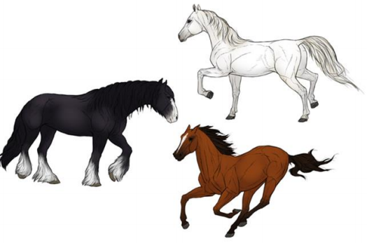
Name the colour of each of the horses below.
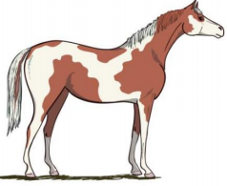
^{Horse 2}Horse 3
Horse 1
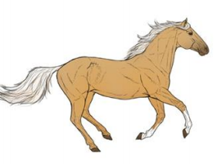
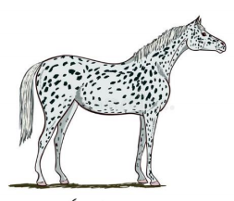
Horse 6
Horse 4
Horse 5
Horse 7
Horse 8
Read each of the descriptions below and identify the colour being described.
1. This horse is black and white.
Answer: ___________________
2. This horse has a white mane and tail, and a body that looks as though it is yellow in colour. Answer: ____________________
3. This horse is brown and white.
Answer: _____________________
4. This horse is often called white. This colour can sometimes be described as dapple. Answer: ____________________
5. This horse is spotty.
Answer: ____________________
Name each of the facial markings below.
Pony 1 Pony 2 Pony 3 Pony 4 Pony 5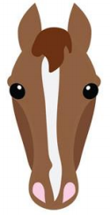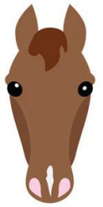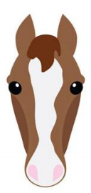
Identify the leg markings.
Which of these horses has socks? Answer: __________
Which of these horses has stockings? Answer: __________
Horse 1 Horse 2
1. Draw and colour in a picture of your horse / pony. 2. Label as many points of your horse / pony as you can.
Recap Task - Word search
Complete the word search.
Well done!

