
Accident reporting for training organisers/ coaches/officials

All accidents that occur at a Pony Club training or event must be recorded online under the new Risk Reduce online reporting platform
This is the link for the new risk reduce page to report accidents online Liberty Risk Reduce Forms. It can also be accessed by the main Pony Club Website Burton Hunt PC Website, Pony Club drop down, Accident Form – Branch Only, see below. It is worth noting that members wishing to claim on the Pony Club 3rd party insurance need to complete Members accident form – which is accessed below the members form
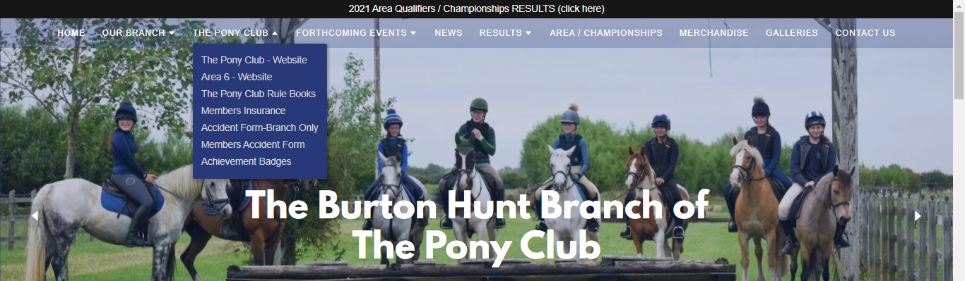
As an organiser you must still have a paper copy of the Howdens accident form so you can complete it at the time of the accident if you don’t have access to the internet so you have records to transfer later to Risk Reduce when you are home.
Once you have submitted the form this will automatically send a notification to the branch email for the DC to confirm but please advise the DC that you have completed an accident form online. If a member goes to hospital or does not complete the session please get an update from the parent on the childs condition, the accident report can then be updated with any further information. It is especially important where the child sustains a serious injury such as a broken bone as these must also be reported on RIDDOR by the DC. https://www.hse.gov.uk/riddor/report.htm
If the person only had an incident (landed on feet/slide down shoulder etc) where there was no injury, first aid not required and they continued to carry on riding then please complete form incident form and save in your folder. The parent must sign to say they were happy for the child to continue to ride.
Incident Log – Rallies and Trainings
Incident Report - Complete for minor incidents i.e. over vaults, little one slipping off due to instability at walk is an incident.
No injury/First aid not required

Date of event | Location/  Event | Person filling out form | Person/Horse who had the incident | State what happened & any action taken | Did they continue ? | Parents signature
- * Parents to sign to confirm they happy for child to continue training

