Bird | Photo | Key characteristics, including, size, colour, and song. | Environment | Diet
Kestrel | 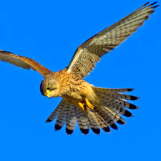 | Kestrels are typically seen hovering, their pointed wings held out. Males have a grey head and tail with a prominent black band, a gingery-brown back and a pale underside which is speckled with black. Females have a more uniform brown back and dark bands on the tail.  They are about the same size as a pigeon, with a wingspan of 76cm, and weight between 190-220g as an adult.  Kestrels have a shrill, urgent-sounding 'kee-kee-kee' call. | Kestrels can be found pretty much anywhere in the U.K. from moorland to farmland and grassland. | They eat mainly small mammals and birds as well as worms and insects.
Robin

Blackbird

Great-Tit

Bluetit

Chaffinch

Magpie

Wood Pigeon

Jay

Mallard Duck

Swan

Wren

Kingfisher

