There are different names/terms used to describe a grey horse. Three of these names are: flea bitten grey, iron or steel grey, and white grey.
Flea bitten grey is often used to describe a horse that has tiny brown or black speckles (dots) in their coat. On some flea bitten greys, these speckles can only be seen when they are clipped.
An iron or steel grey is used to describe a horse that is born a dark colour such as black and as it ages their coat slowly turns grey. The coat will have a mixture of dark hairs and white hairs giving the appearance of iron of steel colouring.
A white grey horse is simply a horse that is born with a white coat and continues to stay white throughout its life.
Looking at the pictures below, say what type of grey each horse is:
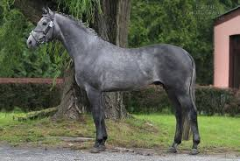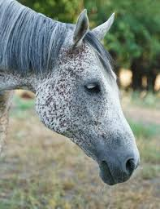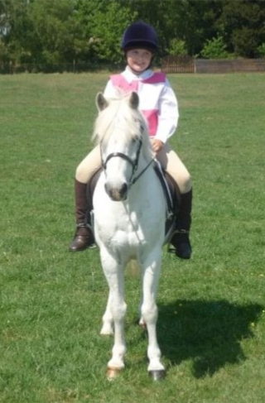

Like grey horses, chestnut horses can come in different shades. Do some research and fill in the table below, making sure to explain the differences:
Type: | Light chestnut | Liver chestnut | Flaxen chestnut
Photo:

Description:

Palomino ponies can vary in shades, from pale sandy colour to a rich golden coat. However, all palominos have a white mane and tail unlike a flaxen chestnut horse.
Look at the photos below, are both these ponies palomino and explain why you think this?

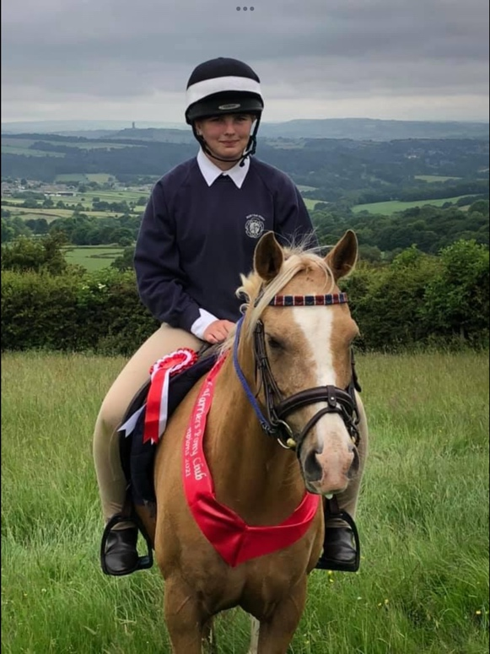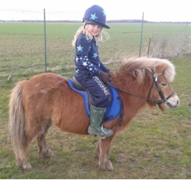

A roan pony has a coat that consists of a mixture of coloured (referred to as the base or basic colour) and white hairs. There are different names depending on the base colour of the hair. Search up the following types of roans and tell me what the base colour of:
Bay roan -
Strawberry roan -
Blue roan -

A horse with a spotty coat is often referred to as having an appaloosa coat. Different markings or spots have different names.
A snowflake marking is when a horse has a dark coat (such as black) and was white spots running throughout it.
A leopard spot marking is the opposite to a snowflake coat, with the horse having a white coat with dark spots running throughout it.
A spotted blanket marking is mainly a dark coloured coat with a white back or hind quarters with dark spots on it.
Look at the pictures below, state what kind of marking each horse has:
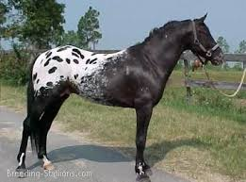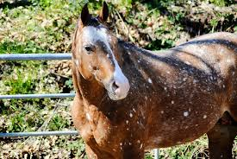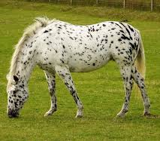

As well as socks and stocking a horse can also have a coronet or pastern leg markings. Describe what both these markings are:
Coronet marking -
Pastern marking -

When talking about markings, ‘points’ is the names given to the mane, tail, and lower legs.
Dun ponies have black points and a black line running down the spine called a dorsal or eel stripe.
What is the name of the line in the picture below?
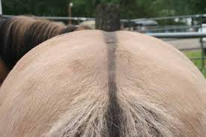

Does the pony below have black points?
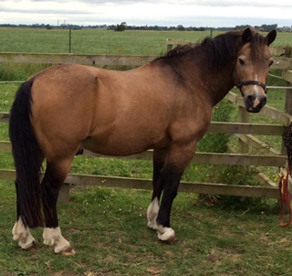

A prophet’s thumbmark (or thumbprint) marking is a dimple found on some ponies' neck or shoulder.

Research and explain the legend to why it is called a prophet’s thumbmark:

If a pony has a prophet’s thumbmark, does it mean they are a good horse?

