Look at the pictures of the ponies at the bottom of the sheet. What colour are the following ponies?
Angel -
Hugo -
Luci -
Millie -
Pudding -
Sherbet -

Face markings have different names depending on where they are on the pony’s face. Here is a diagram of the 4 main types of face markings.
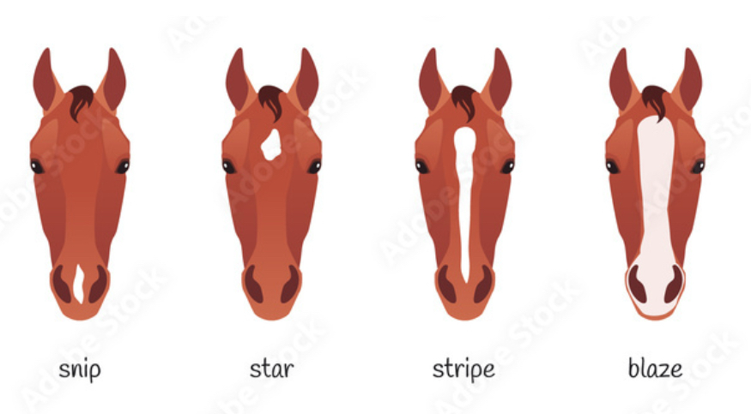
A snip is a marking that is only on the pony’s nose. This can be one small marking in the middle of their nose to their whole nose being white.
A star can be any shape marking that is on a pony’s forehead (between the eyes). This can be a small spot of white hair to a bigger patch that can sometimes look like a shape such as a diamond or star.
A stripe is a narrow stripe of white hair down the middle of the face. It does not have to reach the forehead or nose.
A Blaze is a broad stripe of white hair down the face. It is much wider than a stripe and the forehead and nose area.

Looking at the same pictures below, can you say what ponies have face marking and what they are?

Ponies can have markings on their legs. Leg markings have different names depending on where on the leg they finish.

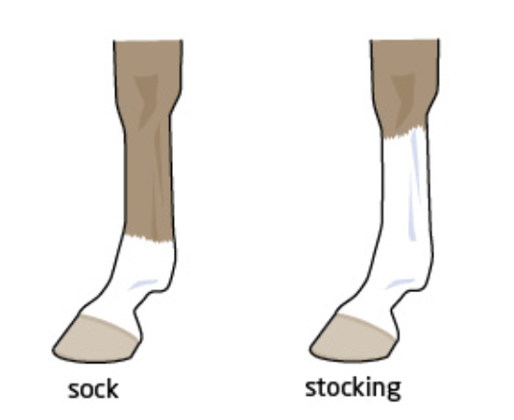
Socks go above the fetlock but do not go as high as the knee or hock.
Stockings go to the bottom knee or hock or higher.

Which ponies in the pictures below have socks?

Which ponies have stockings?

What is a single blue eye called on a pony?

A whorl is when the hair grows in the opposite direction to the rest of the coat.
Thinking about your pony, list where you expect to find whorls on a pony’s body.

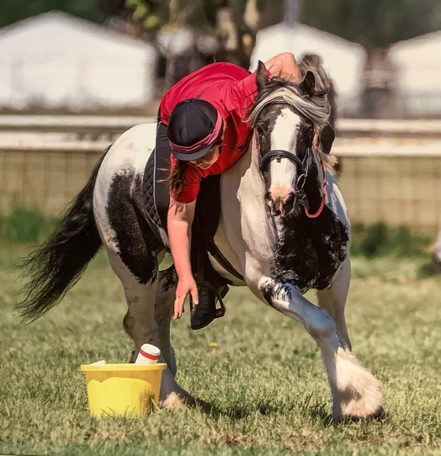 Pudding
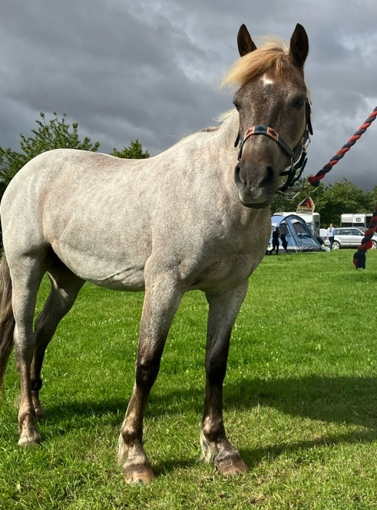 Coco

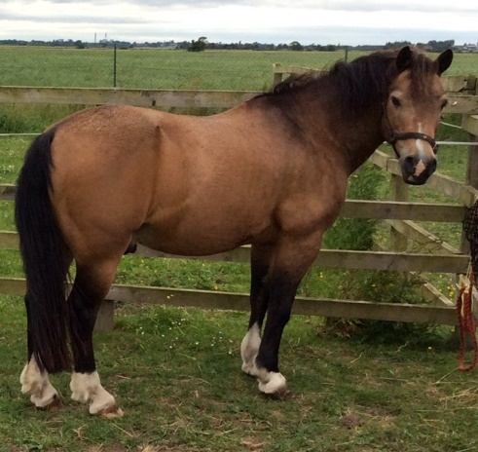 Pepper
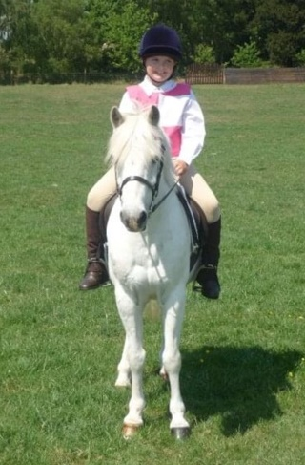 Angel
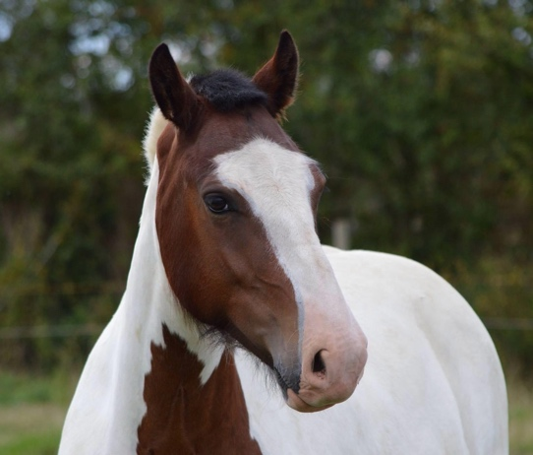 Hugo
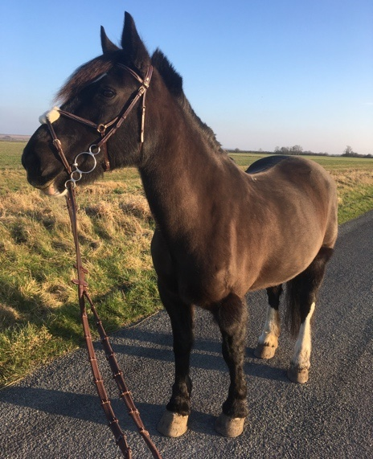 Luci

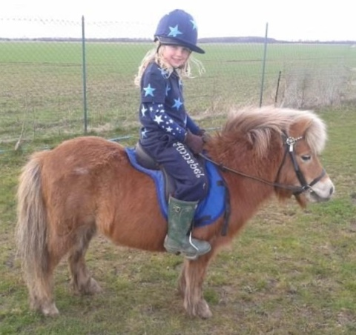 Millie
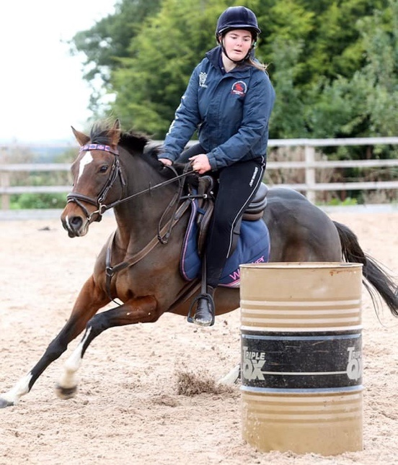 Pony
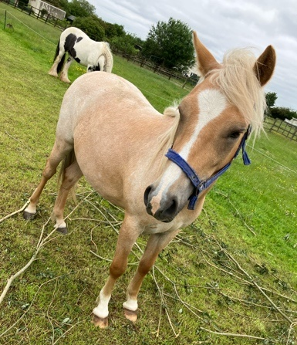 Tiger
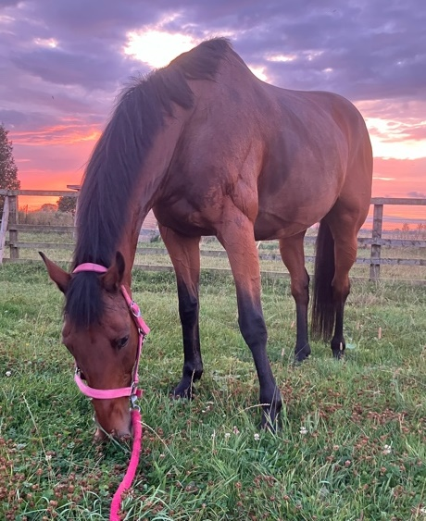 Sherbet

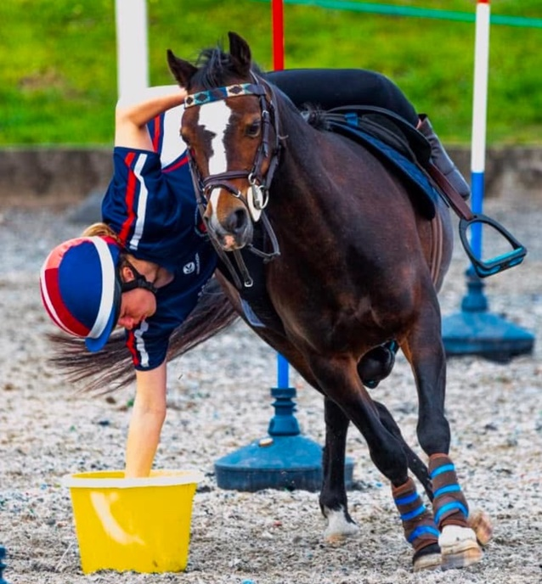 Noggin

