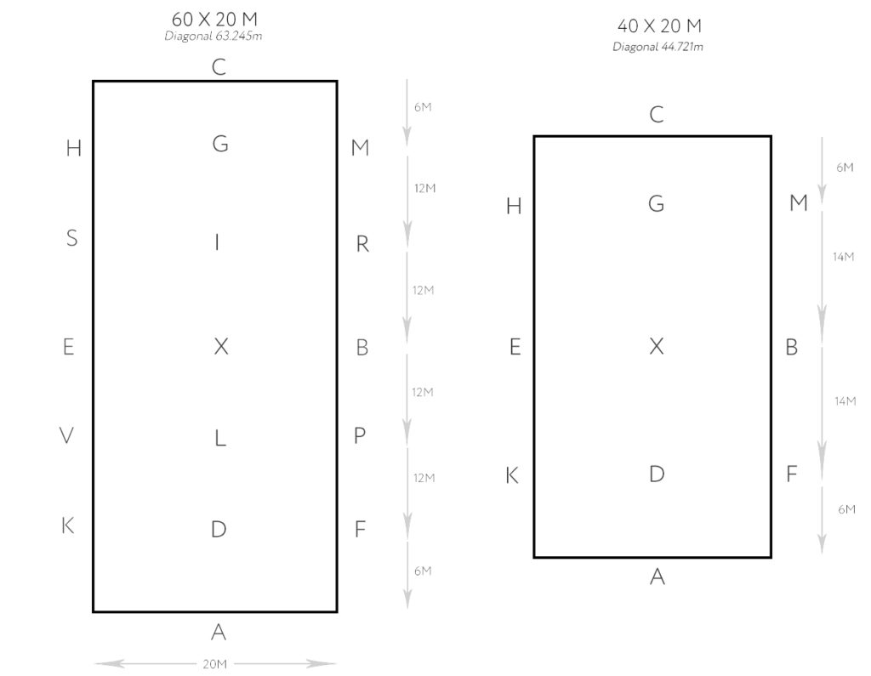
The diagrams above show the layout of both a 60m x 20m and 40m x 20m dressage arena. When setting up a dressage arena, the distance between letters will depend on which arena you are using.

- What is the distance between the corner of the arena and the letter E on a 40m x 20m arena?
- How long is the long side of a 40m x 20m arena?
- What is the distance between the letter H and the letter S on a 60m x 20m arena?
- How long is the long side of a 60m x 20m arena?
- What is the distance between the letter E and the letter K on a 40m x 20m arena?
- What tis the name of the invisible line that runs up the middle of the arena?
- What is the distance between the corner of the arena and the letter K on a 60m x 20m arena?
- What is the distance between the corner of the arena and the letter C on both arenas?
- Are all letters on a dressage arena visible?
- What is the distance between the corner of the arena and the letter V on a 60m x 20m arena?
- What is the name of the invisible line that is located halfway between the centre line and the outer track?
- What is the distance between the corner of the arena and the letter H on a 40m x 20m arena?

The letters of the dressage arena are not just random but relate to the position horses waited to be mounted in the German Royal Mews. However, not all the letters originate from there. Do some research and explain which letters come from the German Royal Mews and what they stand for and when the other letters were added.

