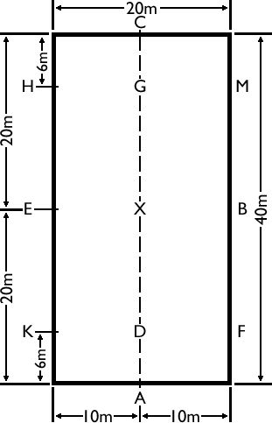
This is a diagram of a 20m x 40m dressage arena with the letters and measurements shown. As you can see the arena is a rectangle shape, with two short sides and two long sides. The short sides are 20 meters long from corner to corner and the long sides are 40 meters long from corner to corner.

What letters are on the short sides?
What letters are on the long sides?
What does X represent?
What is the line down the middle the of the arena called?
What is the distance between the corner of the arena and the letter B?

There are two commonly used different rhymes that can be used to remember the letters in the right order.
If you start at the letter A and go clockwise, the rhyme is: All King Edwards Horses Can Manage Big Fences.
If you start at the letter A and go Anti clockwise, the rhyme is: A Fat Black Moggy Cat Had Eight Kittens.
Can you create your own rhyme to remember the letter order?

