Mini Achievement – Social Licensing

Not everyone thinks riding ponies is ok, some people think it is cruel, we must be very careful to be kind and gentle to our ponies and understand that other people might not understand what we are doing.
We must not shout at, or hit our ponies, even if they make you feel frustrated. Other people might think you are being cruel and frightening your pony.
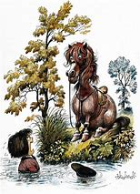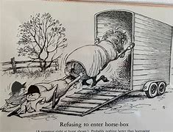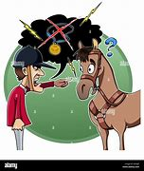

Can you think of 4 things your pony might do that could make you angry?

Instead of hitting or shouting at your pony, what could you do instead?

People who don’t ride may not fully understand that we use reins, leg aids, whips and spurs to communicate with our ponies whilst riding. They may think we are being cruel. Why might someone think we are being cruel? How can we make sure people don’t think we’re being mean to our ponies?
Reins-

Legs-

Whips-

Spurs-

The Pony Club have rules in place to protect our ponies from misuse of whips and spurs. Only certain types and lengths of whips and spurs can be used. From January 2025 all pony club members wishing to wear spurs at a pony club event must have either passed their spurs test or have done their C+ test.

People may take photographs of us riding our ponies.
To present riding in a good way, what can we do to show that we care about our ponies in a photograph?

What could make us look bad in a photograph?

Think about how you should respond in the following situations to show you understand how your pony thinks and that you care about them …

Your pony stops twice at the same jump, what should you do?
Hit your pony with your whip and kick with your spurs to get them over the jump?
Shout, so your pony knows you are angry with them and growl as you represent at the jump?
Ask someone to lower the fence so you can pop over it in a calm and confident manner, before putting it back up to try again?

You can’t get your pony passed the road works whilst out hacking, what should you do?
Get someone to chase him with a stick?
Dismount or ask a helper to lead him passed, speaking to him reassuringly as you do?
Kick firmly and pull on reins strongly when he tries to turn away?

It’s a hot day and you are at a show, you’ve been riding all morning and are ready for your lunch, do you…

Tie your pony up in the sun to relax and get your picnic out?
Try and stand your pony in the shade and make sure he has water and hay first?
Leave your pony tacked up as you haven’t got long before your next class?

Your pony repeatedly snatches for grass whilst out hacking, it’s hurting your fingers and becoming very annoying, do you…

Give him a really hard yank in the mouth, that will let him know what it feels like.
Wear gloves to protect your hands next time and keep your reins at a slightly shorter length to discourage snatching.
Whip him each time he does it, he’ll soon stop.

