Name: | Picture: | Key characteristics including size, colour, and diet. | What is their home called? | What environment would you find them in?
Example:  Water Vole | 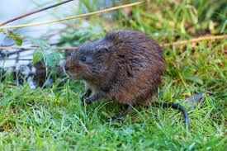 | They are about the same size as a Rat, and can grow to about 14-20cm long, not including their tail.  Their lifespan is about a year and half long.  Water voles have brown fur, with a blunt, round nose, small ears. They have furry tails that can grow up to 14cm long!  They can often be confused with the Brown rat, which has a pointy nose, long ears, and a long, scaly tail.  Water voles are herbivores meaning their diet consists of plants. They eat mainly plants found around water such as reeds and grass. They are also known to eat berries and seeds. | Water voles live in barrows found along the banks of water systems. | Along water systems such as streams and rivers, as well as in ponds and lakes. They can also be found in marshland or wet moorlands.
Dormouse

Fallow Deer

Fox

Grey Squirrel

Hare

Otter

Rabbit

Red Deer

Red Squirrel

Roe Deer

Stoat

Weasel

