There are many different breeds of working dog, they come in a variety of shapes and size from all over the world.
Fill out the table below, one has been done for you as an example. There is an empty row at the bottom of the table for you to fill in on a breed of your choice. Then answer the questions at the bottom of the work sheet.
Breed | Photo | Key characteristics, including size, colours. | Category of work | Country of origin
Irish Wolf Hound | 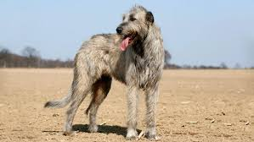 | On average they grow up to about 80-86cm tall and weight over 40kg as an adult.  The UK Kennel Club recognises grey, brindle, red, black, pure white, fawn, wheaten and steel grey as colours for an Irish wolf hound.  They have a long, wiry coat that helps protect them when hunting.  Personality wise, they are often gentle and friendly and like a lot of exercise. | Originally bred as livestock guard dog and hunting dog. They have also been used as a war (military) dog throughout history. | Ireland
Golden Retriever

Husky

St Bernard

Border Collie

Belgian Malinois

Cocker Spaniel

Yorkshire Terrier

Fox Hound

Blood Hound

Poodle

Rottweiler

Dalmation

There are many different types of jobs a dog can do; can you list 6 different jobs and breed of dog that is commonly associated with that job?

Why would you look for certain characteristics in a breed of dog that you were planning to use for work and why might this differ if you were looking for a family pet?

Was there anything surprising you found out while filling in the table?

