A Working dog is a dog that has been bred or trained to do a certain job. Some breeds of dog are trained to do different jobs. For example, a golden retriever can be trained as a gun dog or as a guide dog.
Fill in the table below, one dog has been done for you as an example. Then answer the questions at the bottom of the work sheet.
Breed of Dog | Photo | What jobs do they do? | What are the key characteristics of the breed?
Pembroke Welsh Corgi | 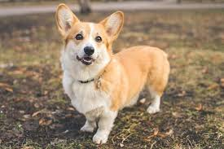 | They are a livestock herding dog. | They are a small breed of dog with short legs and a long body. They have medium length coat that is double coated helping them stay dry in bad weather. They often have a docked tail.  Colours: fawn + white, tricolour, stable + white, red + white.  Lifespan: up to 15 years old.
Labrador Retriever

German Shepard

Springer Spaniel

Jack Russel Terrier

Beagle

Name 2 breeds of dogs that might be used as a police dog?
Name 2 breeds of dogs that might be used for livestock herding?
Name 2 breeds of dogs that might be used as gun dogs?
Name 2 breeds of dogs that might be used as a hunting dog?
Name 2 breeds of dogs that might be used for a guide dog?

