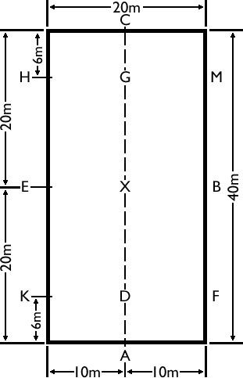
This is a diagram of a 20m x 40m dressage arena with the letters and measurements shown. As you can see the arena is a rectangular shape, with two short sides and two long sides. The short sides are 20 meters long from corner to corner and the long sides are 40 meters long from corner to corner. This badge is on movements you might be asked to do during training or in a dressage test.

What are long diagonal changes of rein?

What letters could you start a long diagonal change at?

What are short diagonal changes of rein?

Would a change of rein that begins at E and finishes at F be a short or long diagonal change of rein?

What is the centre line?

What could you look at to help you stay straight on the centre line?

Can you change the rein by crossing the arena from the letter E to the letter B? If so, what letter do you cross on the centre line?

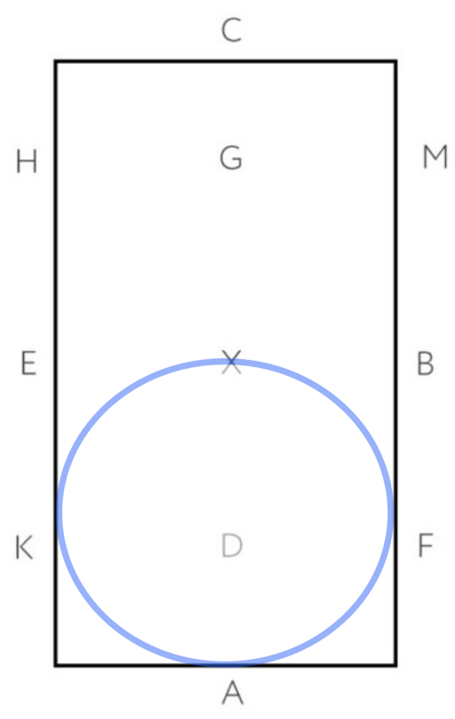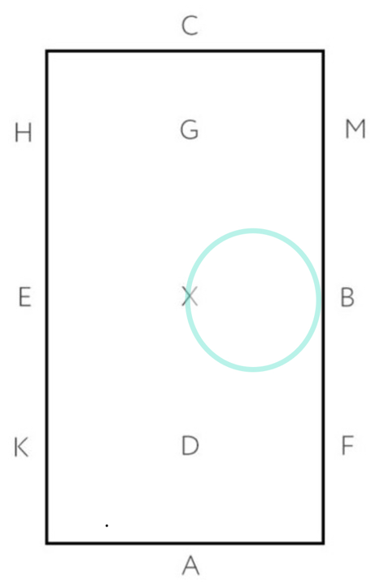

Look at the diagrams of the circles above, which one represents a 20-meter circle and why?

Which one shows a 10-meter circle and why?

Using the diagrams of the circles above to help with size, what letter would a half 20-meter circle finish at if it started at the letter B?

How many times would you touch the outer track when riding a 20-meter circle starting at the letter C?

What letters on the outer track could a half 10-meter circle finish at if you started it at the letter X?

Look at the diagram below, what movement is it showing?
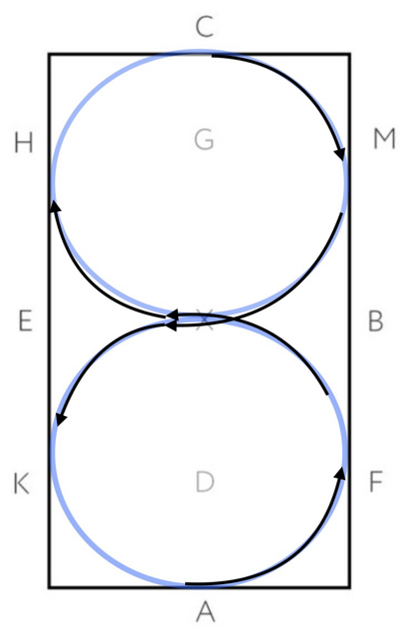

If you were asked to do a figure of 8, where would you change your trot or canter diagonal?

