There are many things in a stable yard that can start a fire or help it spread. Fire is a chemical reaction and needs 3 things to start it and continue to burn, these are: oxygen, fuel, and heat. Fuel can be any material that can burn. Heat is needed for the initial ignition of the fire. List three things that could be a fuel source for a stable fire.

List three things that could ignite a stable fire.

You will have done fire practice at school or work; this is to help prepare you in case of a fire. Why should you hold fire practices at a stable yard?

Why is it important to remain calm when you find a fire?

When you find a fire, you should call the fire and rescue crew immediately. What information do you need to give them and why?

Emergency crews now use What3words to help locate rural properties and locations. Explain how What3words works and why it is important to have it in case of a stable fire or another emergency.

Stable yards should have a fire evacuation plan for the horses, this is to help get as many horses out of the stables and to safety as possible. Describe how you would go about evacuating ponies during a stable fire?

Why might it be too dangerous to evacuate horses?

The smoke that is created by a fire can be dangerous to your health when evacuating the buildings. What dangers does smoke from a fire pose?

Look at the different signs below, what are these signs and why are they important in regards to fire safety?
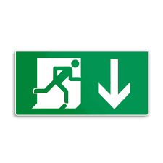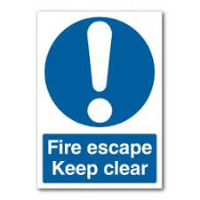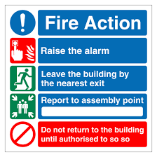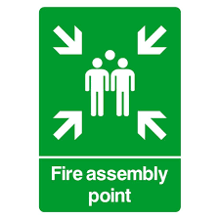

Sometimes the fire might be small enough for you to put out yourself safely before it spreads. What could you do to put out a small fire?

There are many different pieces of equipment you can have in a stable yard to help prevent and put out a fire. List 5 different pieces and explain what their job is.

There are 5 different types of fire extinguishers, each has a different colour label on them and has different substances inside them to be used to tackle different types of fires. Research the 5 fire extinguishers and fill in the table below.
Type | Colour | How do they work? | What fires should they be used on?
Water

Carbon Dioxide

Dry Powder

Foam

Wet Chemical

General yard safety and everyday tasks you do around the stable yard can help prevent a fire from starting or spreading. What tasks or yard safety rules can you think of that would help prevent a fire?

General yard safety can also help make it safer for you in case a fire does occur, and you have to evacuate horses quickly. What yard safety rules can you think of that can make a stable yard safer if a fire does break out?

It is important to do regular fire safety checks on the stables as well as any electrical equipment and firefighting equipment. Why is it important to have these regular fire safety checks and why should an up-to-date record of these checks be kept?

The materials used to make stables or barns can also affect how a fire is contained or spread. Why might you take the building material into consideration when thinking about fire safety of stables or outbuildings?

By law, all businesses and premises should have a fire marshal who is responsible for fire safety. They make sure safety checks and equipment are up to date, run regular fire drills, and ensure steps are being taken to prevent risks of a fire. Pony Club camps have a junior fire marshal which is usually a responsible adult, they have to do a fire risk assessment of the camp and make sure everyone is following safety measures. Create a list of things that a junior fire marshal might notice on their fire risk assessment at a pony club camp.

What jobs would you expect a junior fire marshal to do while the camp is running?

