There are many ways for a fire to start in a stable yard and they can spread quickly, becoming extremely dangerous to both people and ponies in a matter of minutes. Fire needs fuel (such as straw), oxygen, and heat (such as a match) to start and stay alight.
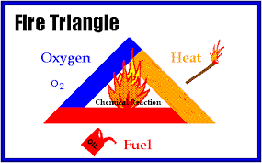

Can you think of 3 different ways that could a fire start in a stable yard.

It is important to know what to do if you find a fire, so you do not panic. You must tell an adult immediately and follow any instructions they give you. What sort of instructions would you expect to get?

What should happen to any horses that are in the stables if a fire is discovered?

Is it always safe to evacuate ponies from a stable fire?

There are several items that can be used on a stable yard to prevent, detect, or put out a fire before it gets out of control.
Look at the list of items below, how do they help prevent, detect, or stop a fire?
A fire extinguisher

A smoke alarm

A fire blanket

Waterproof outdoor electrical sockets

Bucket of water or sand

Most stables whether a livery yard or your own stable, will have safety measures in place to help prevent stable fires or to make it safer if a fire does occur. For example, you might not be allowed bonfires on the yard, or you store your hay in a different barn to your stables to prevent a fire from spreading.
Think of the stables you keep your pony at, are there any safety measures or rules in place that would help prevent case or fight a fire? Why do you think these rules are in place?

