A healthy and balanced diet is important to maintain health and fitness which lets us ride more effectively. If we do not keep a balanced diet, you might find your body has not got enough energy to stay active or that it takes longer to recover after exercise.
Please answer the questions with as much detail as possible.
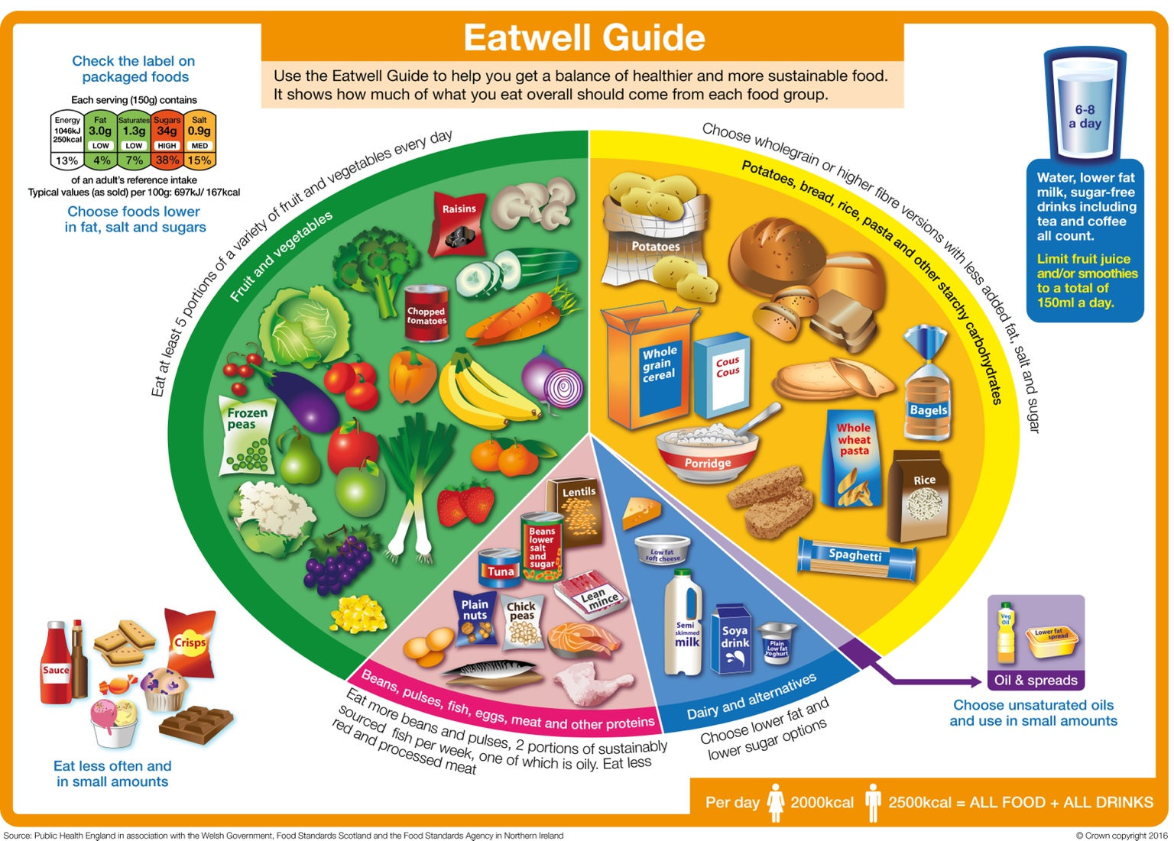

The eat well plate is a good guide to see what components makes up a balanced diet and how much of your daily diet they should be. Fill in the table below of what components make up a balanced diet.

Components | Why do we need them in our diet? | What foods are they found in?
Fibre

Carbohydrates

Vitamins

Proteins

Fats

Water

Minerals

What percentage of the following should you consume daily to have a healthy diet?
Carbohydrates
Protein
Fat

What is the difference between slow-release energy and quick-release energy? Give a few examples of food that they can be found in.

Meal planning for the week can help you keep a healthy diet as you can plan to have balanced meals to make sure you are getting enough of each component in your diet. Planning what meals to eat at breakfast, lunch, and tea can also help you keep your energy levels up throughout the day. For example, beans on toast provides carbohydrates, proteins, and fibre. Making it a good lunch meal as it provides slow-release energy to help get you through the rest of the day.
What meal do you like? List the components that this meal provides.

A person’s daily fluid requirements depend on lots of factors including their gender, age, exercise level, and the weather. Why might these play a role in how much fluids someone needs to have each day to maintain hydration?

Why is it important to stay hydrated especially during exercise?

What happens to your body when you are dehydrated and how can this affect your riding?

You lose fluid during exercise through quicker breathing and sweating. You can calculate the amount of fluids you lose during exercise through this simple equation: weight pre-exercise – weight post-exercise + fluid you drank during exercise = fluid loss. For example: you weighted 59.0kg before you exercised, after you finished exercising you weight 58.5kg. However, you drank 0.25kg of water during your exercise. Therefore, the amount of fluid you lost during exercise is 0.75kg. Why is it important to be able to work out how much fluid you lost during exercise?

Athletes will have a food plan for pre-exercise, during exercise, and post-exercise. This is to help them perform to the best of their abilities. As riders we are also athletes and therefore should consider a food plan especially on the day of a rally, competition, or at camp. During which you might do more exercise and need to adapt your diet to keep your body healthy. Fill in the table below about the various stages of a food plan.
Stage | Why is this stage important? | What food might you eat at this stage and why?
Pre-exercise

During exercise

Post-exercise

