FOUR BURROW PONY CLUB

Summer Camp 2024
St Leonards Equestrian Centre Polson, Launceston, PL15 9QR

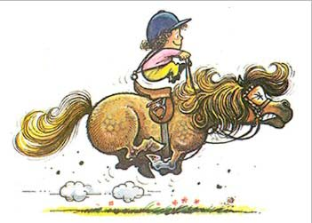

Useful Numbers

District Commissioner : Peter Murrish - 07971606339
Camp Coordinator : Charlotte Kevern - 07875603879
Camp Matron : Paula Trenerry - 07969897361
Camp Stable Manager - Charlotte Kevern 07875603879
Camp Catering Manager - Jayne Orpe 07845058758

Camp Time table

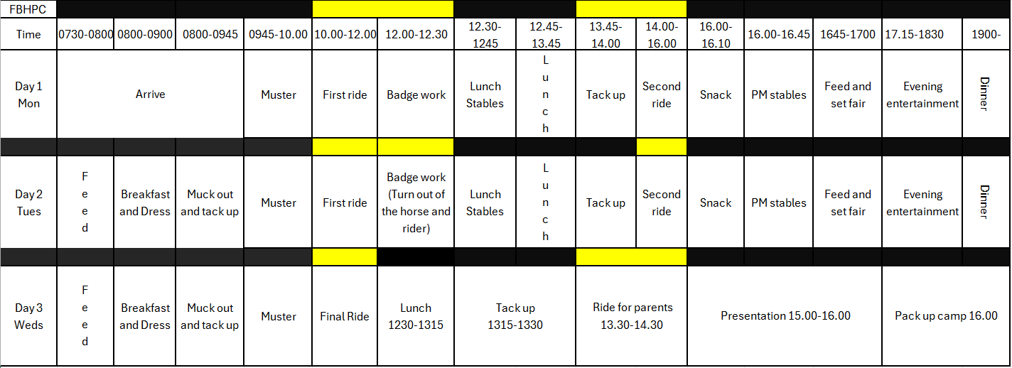

Information for Parents

Summer Camp
Please arrive on Monday morning from7.30am. The horses and ponies can then be settled, and all equipment unloaded. We would ask that all parents then leave by 9am

Trailers/lorries may be left in the field for the duration of camp. If leaving a lorry or caravan, please ensure all gas fuelled equipment has been disconnected before you leave.

Accommodation:
Please bring your child’s own tent/ accommodation for the duration of the camp, your children may wish to share accommodation, this will be accepted as long as good behaviour prevails.

Food

All food is provided please ensure you fill out all information form correctly to ensure that we can cater for all needs.
On arrival please bring a cake and or biscuits to the kitchen in an airtight named container.

Health:
Please complete the confidential medical and parental consent forms and return to charlottek@martinssltd.com these can be found on the branch website.
Parents are asked to remind their children not to worry, but to report all aches and pain, day or night to the Camp Matron. Please inform the DC and Camp Matron of any medical problems and medication your child has (including inhalers) before the start of camp. Any medication must be handed to Camp Matron.

Ponies:
Ponies must be over 4 years old and fit and well to attend camp, unless otherwise agreed with the DC. Partly trained, vicious or dangerous ponies cannot be accepted.

There will be Camp Organisers, First Aiders and Stable Managers at Camp at all times.

Kit List

PLEASE MAKE SURE EVERYTHING IS MARKED WITH YOUR CHILD’S NAME

PERSONAL:
- Plate, bowl, mug, cutlery, tea towel, and Named water bottle
- Wash bag and items including sanitary wear if needed.
- Torch, pillow, sleeping bag, camp bed/mattress with ground mat
- Nightwear
- Underwear, socks ( plus spares )
- Change of clothes and shoes for evenings.
- PC tie or stock and pin.
- Hair nets are compulsory for all long hair please remember to pack spares
- Gloves are advisable for all ridden work.
- White long sleeved shirts / base layers (enough for duration) please ensure you have a shirt and tie for the last day and presentation.
- Four Burrow Pony Club sweatshirts or rugby tops.
- 3 or more pairs of plain cream, beige, navy, black or brown jodhpurs.
- Jodhpur or riding boots and chaps if needed and cleaning kit.
- Gloves, Whip, PC badge, hair nets
- Body protector (Beta 2018) and medical arm band for cross country
- Yard boots or another suitable footwear for mucking out
- Waterproof jacket and trousers
- Sun cream and sun hat
- Swimwear there is a pool on site to be used at the discretion of the DC.
- Riding hat to current standard and tagged, (Please note tags will be available but if hat doesn’t meet current standards you will not be able to ride).

HORSES/PONIES:
Large box to keep equipment in outside of stable.
- Complete set of well-fitting tack including girth, spare bits and spare peacock leathers if used. Please check all stitching especially stirrup leathers. Stirrups should have 7mm clearance either side of boot.
- Numnahs/saddlecloths (plain colours)
- One strong head collar and lead rope
- Full grooming, plaiting kit.
- FLY REPELLENT
- Tack cleaning kit
- Sweat rug/fleece rug or stable rug if required
- Boots, bandages and studs if used
- 3 named buckets (1 for feed, 1 large for water, 1 for tack cleaning)
(Please note the ponies are working extremely had and a small bucket of water will not be enough)
- 2 x hay nets ensuring they are big enough to feed your pony adequately.
- Correct fork for the bedding you will use, 1 shovel, wheelbarrow and 1 yard brush,
- Horse/ pony passport

Veterinary
- If you have some basic first aid supplies, then do bring them but we will have an equine first aid kit.

Final day of camp
We will invite parents to camp to watch their child’s last session as a showcase of their achievements at camp. Parents will be invited from 13.00pm on the final day to watch the children ride at 13.30 and stay for the presentation after.
After that please assist your children to pack up all belongings leaving the stable and outside area clean and tidy.

CAMP RULES

- No personal mobile phones or any electronic devices are allowed at camp. Between the hours of 8AM and 6PM should an emergency occur mobile phones are to be used at the discretion of the Camp Matron.
- No persons should attend camp who have not been invited to be there.
- Hats – must have been tagged with the official pony club tag. Hats will be checked at the beginning of camp. Your child will not be allowed to ride if the hat is not up to standard (see Pony Club website for details).
- For cross country jockey skull caps with no fixed peak must be worn and body protector. If your child does not have these then they will not be able to take part in cross country.
- No Smoking and no alcohol
- No responsibility can be accepted for pony tack and belongings of any child at camp. All children must organise and look after their belongings. Please ensure everything is named beforehand.
- Behave politely and courteously to instructors, helpers, other campers and other people seen on the campus.
There is a pool on site which we are allowed to use, at the discretion of camp management, the pool is out of bounds at all other times.

Children who break the rules will be sent home.

