Inverness-shire branch the pony club

  - Feb 2025
Pony CLUB Tests
The Pony Club training structure encourages members to take tests which enable them to learn progressively about riding and the care of their ponies. Tests are taken with certain objectives in mind and assessed.
Recent member achievements
- Sophie, Ava and Caitlin passing their C test
- Kirsten passing her C+ care
- Lydia and Hollie passing tr D+ test
We would like to recommend the working notebooks and activity books for those studying towards their next test. These can be found at www.equineworkingnotebooks.com

Foreword from our DC
Hello Everybody,
Holly has offered to resurrect our Newsletter to help us share news and information with members and their parents. We had out parents meeting on Saturday so this issue will be a catch up on some of the items discussed.
First of all, who are our 2025 committee. This will be my last year on committee. After a lot of years as branch secretary, Joint DC and DC, I will be standing down at the end of 2025. Existing committee members Julie Ingram and Holly Philp have stepped up as Assistant DCs. Julie is taking over as Rally coordinator and Badge secretary, while Holly continues as Show secretary and takes on the role of Dismounted Competitions coordinator.
Ailis Kerr is now Health and Safety officer as well as being Mounted Games trainer, and has begun team training for 2025. We have offered to team up with Ross-shire, Moray and Nairn and Broomhill to see if we can put together mixed teams if we don’t have enough members from IPC.
Gillian McKnight and Jen Fraser continue in their existing roles. Gillian as Mounted Competition coordinator and Jen as our Media and Merchandise coordinator. Aimee Maclennan has taken on the role of Safeguarding Officer and Carrie Gill is now our branch Treasurer.
Following the parents meeting we are delighted to welcome Freyja on to the committee as our branch Fundraising coordinator. Susan also joins the committee and we look forward to her involvement. The club can’t run without help from parents so I am extremely grateful to all those who are willing to come forward and take on a committee role.
Finally, I want to say thank you to the Committee members standing down. Amanda Campbell, on committee since 2016, is mainly known as our treasurer, alongside being ADC and Joint DC with me. She has put a huge amount into the club of her own time, contributed legendary baking skills, organized many fundraisers and also sent plumbers and electricians from her family business to sort out the building when required. She will be greatly missed.
Rebecca MacLelland stood down as dismounted competition coordinator and rally organizer last year. Rebecca’s teams were very successful, reaching national finals in both Quiz (2024) and Horse and Pony Care (2023) – a true testament to the effort made and time put in by their trainer.
Nicki Macrae left the committee stepping down from Health and Safety Officer. As essential, behind the scenes role which she competently undertook, and an important contribution to the safe running of our club.
Contact details for our current Committee members can be found on the latest 2025 Fixture List which can be found on our facebook page.

Our branch is 60 years old!!
2024 saw our branch of the Pony Club turn 60 years old! To celebrate we held a BBQ party at Dunain Croy, and invited lots of past members, instructors and supporters along. The celebration was really well attended. A massive photo-wall has been created showing members over the years taking part in all sorts of pony club activities. Many past members who feature on the wall are now the parents of current members - there are even grandparents of current members that can be seen on the wall. These will stay up at Dunain Croy, so don’t worry if you didn’t manage to make it to the Autumn BBQ, you can have a good look next time you’re there!
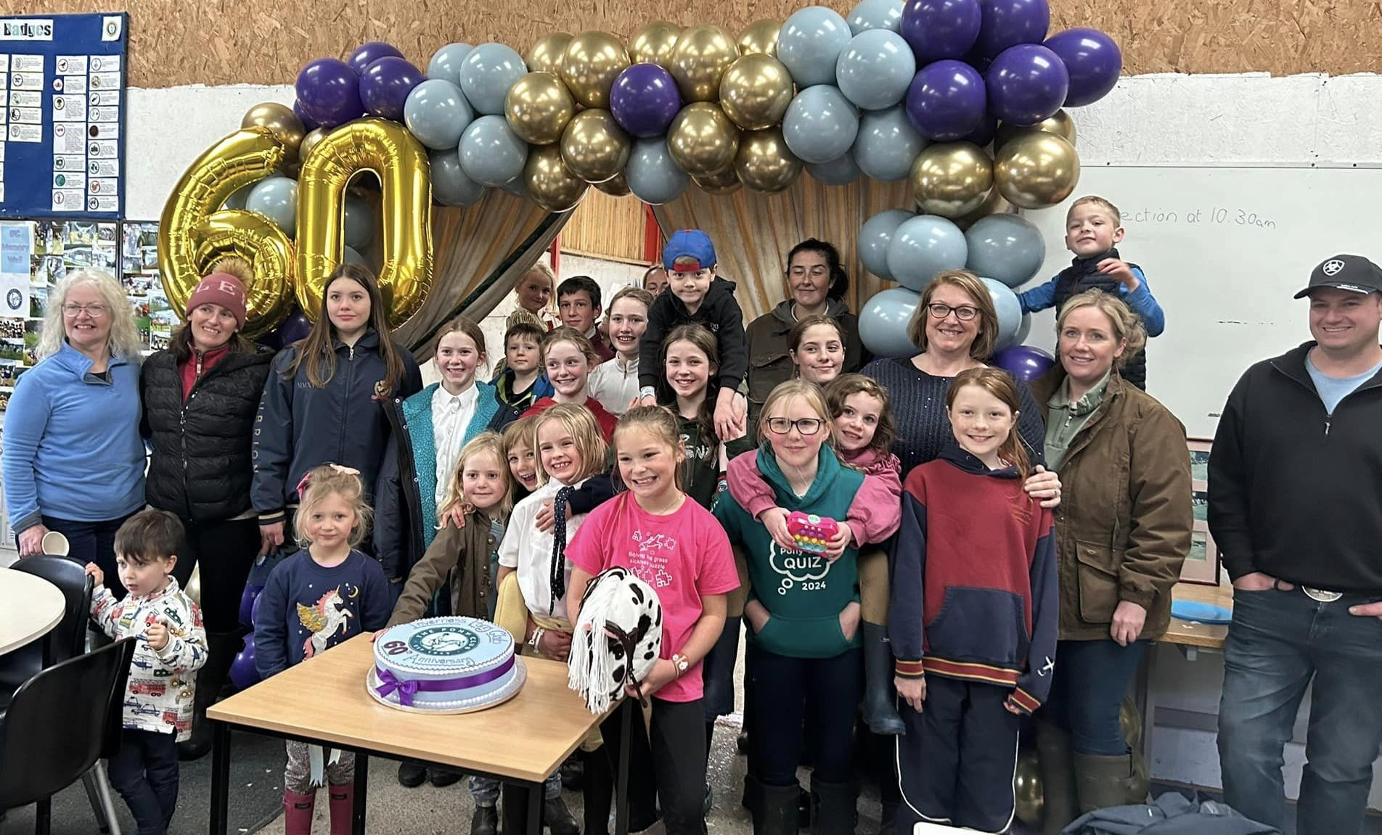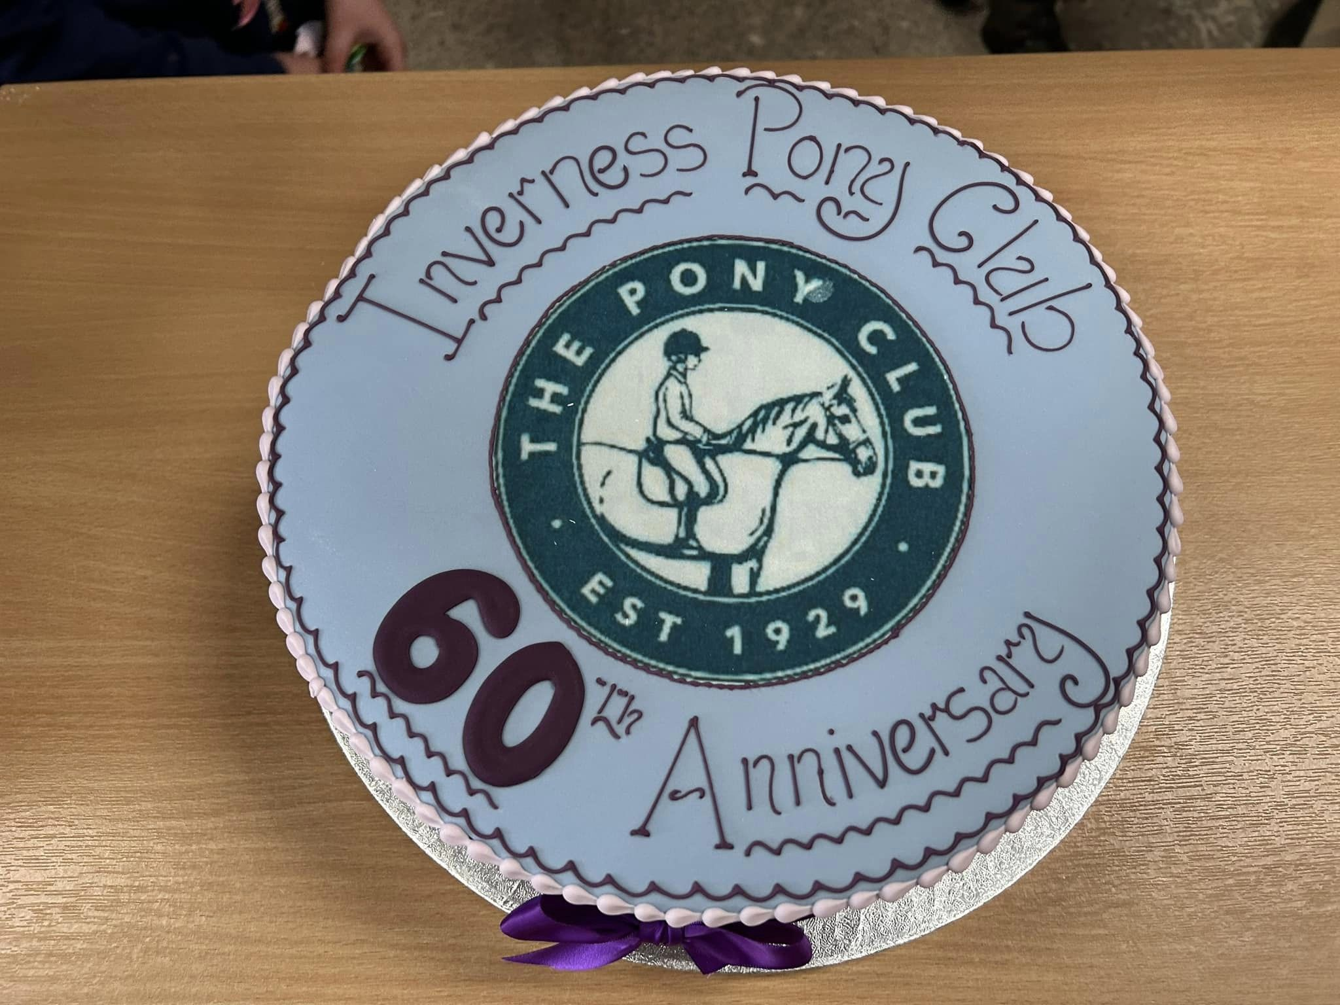
Figure 1 60th Birthday celebrations at DC

We hope that 2025 will see our branch continue to foster the values of the pony club, of ‘Togetherness, Empathy, Respect and Learning’. As a committee we want to support the value of Togetherness by encouraging our branch members to form friendships and to take part in team events. Gillian will be looking to put together teams for Grassroots/Caroline cup/North Cup later this year. Ailis will be training members towards area games. Holly has been working hard on quiz training where we have 4 teams representing our branch at area Quiz in March, and will then look towards Horse and Pony Care teams. If these are activities that you think that your child would enjoy and would like to know more about, please do get in touch if you require more information.

Togetherness, Empathy, Respect, Learning

Winter Show Jumping League
The Winter Showjumping League has now come to an end. After three successful events it was unfortunate to have to cancel our finale. The points have been collated and we look forward to announcing the placings and presenting awards at the first mounted rally of the year on March 15th.

rallies
As you all know, rallies are the backbone of the Pony Club. They are a great opportunity for members to both improve their riding skills and learn horse and pony care, to work towards stable management badgework, brush up on knowledge and care skills, and also provide the opportunity for the kids to catch up with their friends. These friendships are fundamental to the ethos of pony club and its great to see the kids getting together so please do try to attend rallies. We now move back to mounted rallies, beginning with our half day rally on the 15th March at Dunain Croy. We look forward to seeing you all there.

