
Middleton Hunt Pony Club
JUNIOR SERIES
SHOW JUMPING COMPETITION
Team & Individual
Sunday 26th May 2024
At BRANDRITH FARM, BULMER, YORK, YO60 7ET
By kind permission of Mr and Mrs Michael Fargher.

Open to Pony Club members only

RING 1 9am start Teams & individuals
Class 1 40cm – beginner clear round class – assisted and lead reins allowed. Single round no jump off. Rosettes awarded to clear rounds. Individual only

Class 2 50cm - triers class - Individual only (penalties will be awarded if assistance is required)
Area 3 Junior Series: Class 3,4 and 5 are qualifiers for the Final of the Area 3 Junior Series on 6th October 2024 at Bishop Burton.
The top 2 teams and 3 individuals in each class will qualify, qualification passes down the line if already qualified in a team or as an individual.
Class 3 60cm – 10 Years & under
(Individuals and teams Qualifier)
Class 4 70cm – 12 Years & under
(Individuals and teams Qualifier)
Class 5 80cm – 12 Years & under
(Individuals and teams Qualifier)
Class 6 80cm Open - Individual only

Class 7 90cm open - Individual only

Classes 2-7 will all be run single phase (one ring, one round with timed section)

All heights stated are the maximum height in the 1st part of the round, the jump off section is timed.
Rosettes to 6th place for teams & individuals.
Entry Fee – Class 1 - £11 all other Classes £14 per entry: Closing date for entries is 17th May 2024.
Please print your own numbers
Entries to be sent by email and post to emmabrader@aol.com Manor Farm, Broughton, Malton, YO17 6QJ. Payment to be made by BACS to: Middleton Hunt Pony Club, Sort Code 09 01 51, Account 41255307 (Santander Bank) Please use Ref: SJBUL + Competitor’s Surname (e.g. SJBUL Smith)

Rules:

Rules can be found at https://branches.pcuk.org/middleton/junior-series/

Area 3 Junior Series – to be run under the Pony Club Novice Show Jumping rules 2024 with certain exceptions please see Middleton Hunt Pony Club website for Rules. No spurs are allowed in classes 1 and 2 and in other classes with DC’s permission only. Class 1 and 2 – Properly fitted grass reins are permitted for safety reasons; All Classes – ages as stated on class description as PC age.

Health & Safety:
The organisers have taken every responsible precaution to ensure the Health and Safety of everyone present at this event. For these measures to be effective, members of the public and competitors alike must take all reasonable precautions to avoid and prevent accidents occurring and must comply with the organizers and all Officials and Stewards.

Times will be available on Middleton Hunt Pony Club website from 9pm on 22nd May and will be emailed to each DC. No entries accepted without payment. Full refunds will be given if the event is cancelled.

For class 1, rosettes awarded to clear rounds. All other classes, rosettes to 6th place for teams and individuals if sufficient entries received. Combination of horse/pony and rider may only jump once in each class. Horses/ponies may only compete in a maximum of 3 classes, but the same combination may NOT compete in 60cm, 70cm and 80cm.

No liability will be accepted by the organizers, or landowners or anyone acting on their behalf for loss, damage, accident, or illness to horse, rider, spectator or any other person or property whatsoever. All non- Pony Club competitors must hold their own public liability insurance cover.

IN CASE OF BAD WEATHER CONTACT Emma Lund on 07734 958539 or Trish Russell on 01904 468425.

We are very grateful to our sponsors THE BEDDING BARN for their generous support.

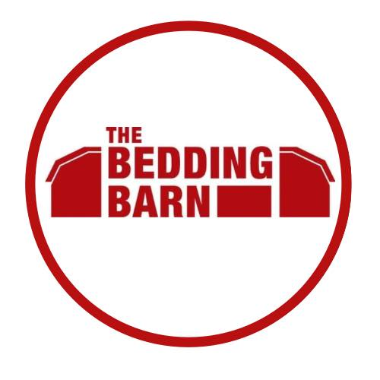

ENTRY FORM 26th May 2024

Entries for.............................................................. Branch of the Pony Club

Class: |  | Team:
Name of Rider: |  | Age | Pony/Horse Passport Name
INDIVIDUAL ENTRIES
Class | Name of Rider: | Age | Pony/Horse Passport Name

Total fee enclosed £.....…..

Team Trainer: ............................................... Tel. No: ........……...............
Contact details (in case of abandonment)

Name:………………………………………………………………………………………………………………….

Tel No:………………………………………………………………………………………………………………..

Email:……………………………………………………………………………………………………………………

Entries to: Emma Lund – emmabrader@aol.com or
Manor Farm, Broughton, Malton, YO17 6QJ
07734 958539

Entries by BACS transfer to:
Middleton Hunt Pony Club, (Santander Bank)
Sort Code 09 01 51 | Account 41255307
Please use Ref: SJBUL + Competitor’s Surname (e.g. SJBUL Smith)

