Oxenholme Pony Club
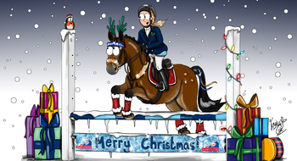

Christmas Show

MONDAY 30th December 2024

Myerscough College, Equestrian Indoor Arena, 10am

Classes are ages as of 1st January 2024 - Oxenholme Members Only
Entry Fee £6 per class
Pre-entries via Booking Form on our website
Entries close 27th December

Horse and Hound
Jump the course on your pony, then go over a shortened course on foot with a dog of your choice, best combined time wins.

Pairs
Pair up with another member of the same and jump a course that’s timed, best timed pair wins (both members to be in the same age section).

Accumulator
Accumulator is points per fence accumulated, highest score wins.

Section A - Lead rein / just off lead
Class 1 Horse and Hound
Class 2 Pairs
Class 3 Accumulator
Classes 1 -3 maybe split into lead rein and just off lead rein depending on entry numbers but will all jump together

Section B - Non-jumping classes (will start 15 minutes after class 3)
Class 4 Fancy dress – any age
Class 5 Young handler – any age (maybe split on age depending on entries)
Class 6 Best figure of eight (maybe split on age depending on entries)

Section C – 10 years and under
Class 7 Horse and Hound
Class 8 Pairs
Class 9 Accumulator

Section D – 14 years and under
Class 10 Horse and Hound
Class 11 Pairs
Class 12 Accumulator

Section E – 15 yeas and over
Class 13 Horse and Hound
Class 14 Pairs
Class 15 Accumulator

Section F – any age
Class 16 Parent and Child
Child rides first then jump off and switch to parent to ride, best time wins. Genuine parent and children only!!

*Hard hats & correct footwear must be worn but please wear Christmas Jumpers, tinsel etc (must be safe to jump in – no hoodies)

Pony Club rules apply

Any questions please call Karen on 07766 362173

Please clean up ALL HORSE POO – in the arenas and car park

CATERING WILL BE PROVIDED

