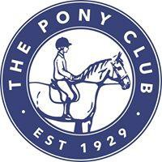

WELCOME TO THE

SOUTH NORFOLK BRANCH OF THE PONY CLUB

https://branches.pcuk.org/southnorfolk/

Welcome to the South Norfolk Branch of the Pony Club.
We would like to thank you for choosing to join our Branch and very much hope you will enjoy your time with us.

The South Norfolk Branch is one of the longest established Clubs within Area 8 (pcuk.org) . Area 8 is made up of branches in Norfolk, Suffolk, Essex, Cambridgeshire, East Hertfordshire and East Lincolnshire. We are an active branch with a enthusiastic membership from lead rein all the way through to Senior Members – everyone is welcome!

The aim of this document is to give you as much information as possible on how our Branch runs and what we are able to offer you throughout your time with us. If you can’t find something or have a question please contact us and we will help if at all possible.

There are lots of links within this document that will enable you to get a wider knowledge of the Pony Club.

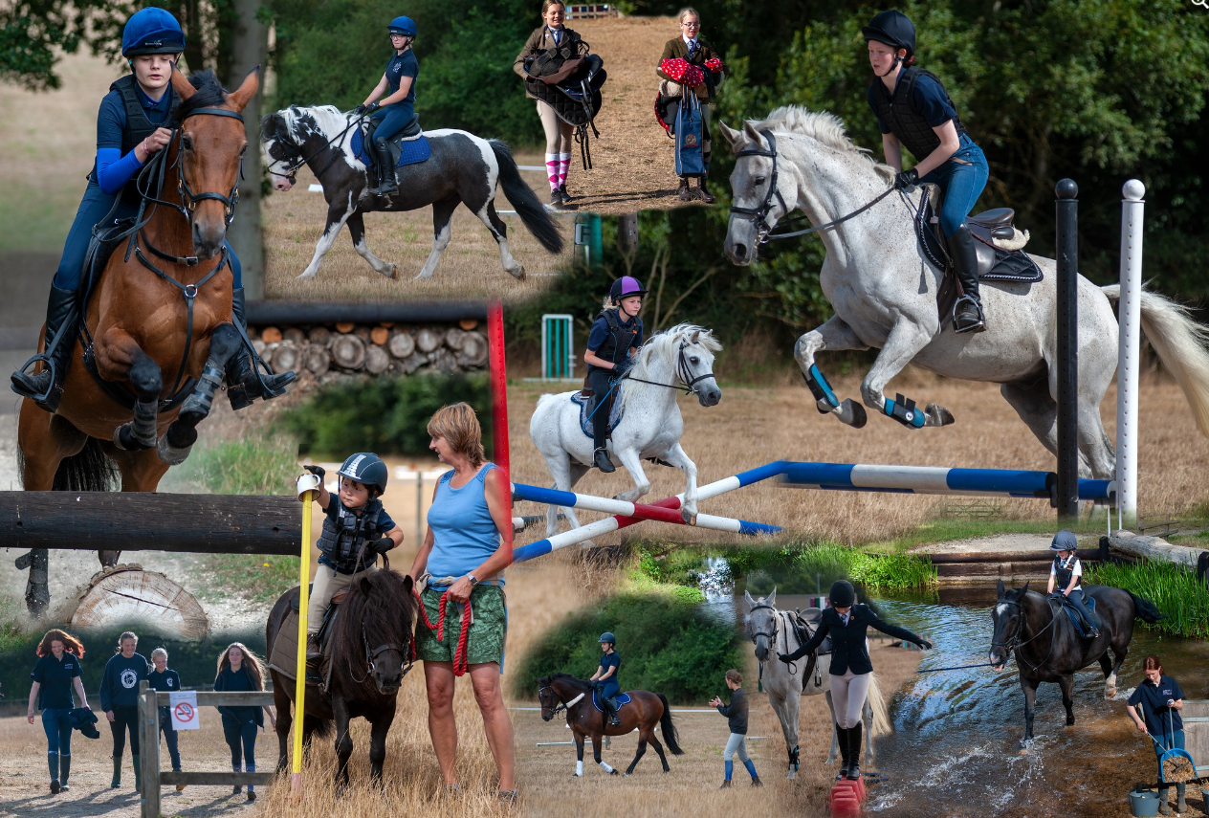

Contents

Useful Contact Information 3
South Norfolk Committee and Coaches 3
Rallies and Training 4
Rallies 4
Booking into Rallies and Training sessions 5
Attending Rallies/Training 5
Venues for Rallies and Training 6
Tack and Turnout at Rallies and Training Clothing 6
Hats 7
Body Protectors. 7
Spurs 7
Whips 7
Tack 8
Ponies and Horses 9
Parents - Health and Safety 9
Pony Club Testing Pathway 10
Camps 11
Team Competitions 11
Insurance 12
Vaccinations for Ponies attending Pony Club activities 12
Useful publications 12

Useful Contact Information

We have a Branch Facebook page intended for branch members only, together with coaches, instructors etc. – if you go to this site and request access you will be asked a couple of questions and providing you are a current member, will be given access. This site is used to share news, photos (where appropriate) and general information and works alongside Email and Whatsapp as a means to communicate to all members.

https://www.facebook.com/groups/southnorfolkponyclub
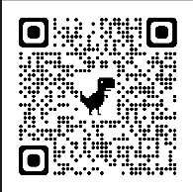
or use this QR code:

South Norfolk is part of Area 8 of the Pony Club and if you visit the website for Area 8 you will be able to find details of competitions and events being organised by other Branches within the Area. Area 8 (pcuk.org)

South Norfolk Committee and Coaches

We are entirely reliant upon our Committee and members to organise the activities we run as a Branch. Alongside all of the other requirements to ensure we uphold the very highest standards for our members – they are all volunteers who give up so much of their time for us, and as a club we are very grateful.

Full details can be found on the South Norfolk Website (https://branches.pcuk.org/southnorfolk/) but briefly:
District Commissioner: Aidan Taylor (m) 07493 609728
(e) dc.southnorfolk@pcuk.org
Treasurer: Ruth Grose (m) 07794750132
(e) treasurer.southnorfolk@pcuk.org
Secretary: Sue Taylor (m) 07904769994
(e) southnorfolk@pcuk.org
Membership and Health and Safety: Sue Taylor (m) 07904769994
(e) southnorfolk@pcuk.org
Child Protection Officer: Rebecca Weir (m) 07747 772039
(e) weirrebecca@googlemail.com
Junior Members Co-ordinators: Marion Gray (m) 07947 157655
(e) marion@hillfarmlivery.co.uk and Nicola Land (See below)
Rosettes, Trophies and Rally Co-ordinator: Nicola Land
(m) 07515 853706
Volunteer Co-ordinators: Lucy Sims (m) 07787 517558
Cassie Pace (m) 07721 936790
Committee Advisory: Helen Sida-Page
Coaches: We use a range of very experienced coaches (including but not limited to the excellent coaches below)
SARAH DREWETT | HOLDS FULL BHSI
 | HOLDS PONY CLUB A TEST
 | INTERNATIONAL COACH
EMMA LACEY | HOLDS COACHING AND SM BHSI
 | HOLDS PONY CLUB A TEST
 | A TEST ASSESSOR
HELEN SIDA-PAGE | HOLDS BHSII
 | AH ASSESSOR
 | NATIONAL CHAMPS HORSE AND PONY CARE ASSESSOR
MICHELE HURST | HOLDS BHSIT
 | B TEST ASSESSOR
TILLY DAVIES | PC COACH

Rallies and Training

Rallies

We hold a number of rallies throughout the year, during both term time and the school holidays which are open to everyone. We try to set the dates as early as possible and let members know via email and Facebook and our WhatsApp group. Rallies are typically monthly (but may vary dates).

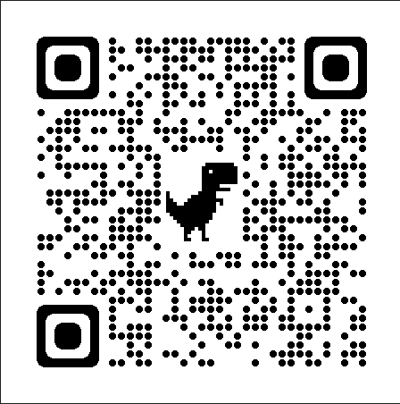
Members are put into age-related and ability groups and work with a fully qualified, accredited coach. A rally may be advertised for a specific discipline, flatwork perhaps, or as a more general rally, when members should expect to cover some flatwork and jumping, or a combination of skills over two ridden sessions, together with other areas of Horse Care or Badgework to improve all areas of horsemanship. Throughout the year we run a series of unmounted horse care training sessions on a Friday evening, looking to develop a number of areas of horsemanship from the comfort of a warm room!

Full details of each rally will be given on the Events page of the website - https://branches.pcuk.org/southnorfolk/events/ or use this QR Code

We also hold a number of themed rallies each year, at Easter, Halloween and Christmas – in addition to the ridden activities, lots of additional fun and games are always on offer at these rallies and are very well attended by young and old members alike!

As well as improving riding skills our rallies are social events where like-minded youngsters forge lasting friendships, they are not individual lessons unless we offer this as an option.

Training

In addition to rallies, for those wishing to represent the Branch in team competitions, we may hold additional training sessions which are discipline specific, dressage, showjumping, cross-country, where members will work with a coach towards a particular competition.

Booking into Rallies and Training sessions and other club activities

- We use emails and Facebook to keep members up to date with activities and try to give as much notice as possible of upcoming rallies and training sessions;

- All bookings are online: https://branches.pcuk.org/southnorfolk/events/, with payments made at the time of booking via Paypal. (This may be changing during 2023 – but further details will be made available at the time.

- PLEASE try to help us by booking on as early as possible.

- Once you book and pay, you will receive an email to confirm your booking and Paypal payment and an email is also sent to the rally/training organiser.

- If you have to withdraw from a rally/training please contact the rally/training organiser as soon as possible – contact details are shown on-line booking form. This advance communication is very helpful and greatly appreciated by organisers as it does organise the event properly.

- Rally / training times will be notified to you via text or email a few days beforehand.

- Please don’t assume you will be able to apply late and be given a space. You won’t be able to ride/ take part unless a suitable space becomes available. A lot of advance planning goes into our rallies/ training and coaches/ venues need booking in advance around the numbers / abilities of riders received by the application deadline.

Attending Rallies/Training

- Only those who have booked on and paid in the normal way may attend – we are unable to accommodate anyone just turning up unfortunately.

- Please arrive promptly and be mounted before the start time.

- Please remember arriving late disrupts the rest of the group, so please be on time – your group will have started without you.

- Once mounted and waiting for a rally or training to start please walk or stand quietly on your horse / pony. Do not gallop around venue fields or arenas.

- At the end of your rally or training please remember to thank your coach and to thank your organiser before you leave.

- Remember to remove horse droppings, hay, straw etc from parking areas before you leave, even if you are parked in a field please make sure that you clear up around your trailer/lorry. We are very fortunate to have the use of some lovely venues, and we ask everybody to please remember we are guests of our hosts.

Venues for Rallies and Training

In the winter months most of our ridden instruction is undertaken at: Easton College Equestrian Centre - Easton College, Bawburgh Road, Norwich, NR9 5DX where members are able to enjoy riding in the luxury of an indoor school, by kind permission of Easton College.

Once the weather improves, we move outdoors, to Bergh Apton Manor: The Manor, Threadneedle Street, Bergh Apton, Norfolk,NR15 1BL by very kind permission of Mr Kip Bartram

Summer Camp is held at Blackwater Farm, also known as Great Witchingham, by kind permission of David and Robert Sayer. We will also use World Horse Welfare at Snetterton, or other local venues as appropriate dependent on availability and the discipline we are training for.

Tack and Turnout at Rallies and Training Clothing

Mounted

- Under 10s are asked to wear an SNPC sweatshirt or polo shirt
- Members 10 years old and over may wear an SNPC polo shirt, Sweatshirt or other Dark Sweatshirt or polo shirt

SNPC clothing can be purchased on-line from GG Gear South Norfolk Pony Club (gggear.co.uk)

- Jodhpurs should be plain but can be either light or dark coloured;
- Brown or black jodhpur boots, matching half chaps (no fringes) or gaiters if desired, or long riding boots. No muckers!
- Pony Club badge and test felt should be worn for competitions.
- No jewellery except watches.
- Hair should be contained in a hair net or otherwise properly secured.
- Hats need to be tagged to meet current safety standards (see below)
- Hat covers should be plain black, brown or navy – no pompoms.
- Gloves to be black, brown, navy or cream.
- Shirts must cover the shoulders for cross country
- Body protectors are compulsory for cross country (see below for standards)

Unmounted
- SNPC Poloshirt/Sweatshirt, jodhpurs and suitable boots (no trainers or flip flops!).
- Hat
- Please remember to dress for the season i.e warm clothing for winter, waterproof jacket etc if it is wet.

Hats
Hats must be tagged by a Pony Club Official (DC or Chief Instructor within our Branch) to say that they meet the required standard before a member can take part in any rallies or competitions organised under Pony Club rules. Current Pony Club hat standard can be found on the main Pony Club website here:
https://pcuk.org/media/4qqlbarq/hat-tagging-guide-2023.pdf

Please note that from the 1st January 2023, the following hat standards will no longer be accepted, due to the age of hats made to these standards:
PAS O15 1998
SNELL 2001

Body Protectors.
These are compulsory for all cross country training and events. We strongly recommend that they are also worn for show jumping activities. Pony Club Body Protector standards can be found on the main Pony Club website here: https://pcuk.org/media/hh4h35mb/2023body-protector-rule.pdf

New members please ensure you ask to have your hat tagged at your first pony club rally. Also remember if you buy a new hat it needs to be fitted with a tag.

Fixed peak hats may not be worn for Cross Country/Show Jumping.

Spurs
Whilst members are no longer required to present their membership card for permission to wear spurs at Pony Club events and competitions, any misuse of spurs will be reported to the District Commissioner/Centre Proprietor, and Area Representative and riders who are reported will be recorded and monitored. Only blunt spurs, without rowels or sharp edges, and spurs that have a smooth rotating ball on the shank may be worn. If the spurs are curved, the curve must be downwards and the shank must point straight to the back and not exceed 4 cm in length. The measurement is taken from the heel of the boot to the end of the shank.

Whips
Please be aware that the specifications for whips for show jumping and cross-country have changed for all Pony Club competitions – in essence, you can only use the same whip as for British Show jumping. If you have one that you use for BS, then that is fine – no other type of whip is allowed.
* Riders may not hit their horse/ pony before the start of the course and may be eliminated for doing so at the Judge’s discretion.
* A whip, if carried, must be held in the hand by the handle with the handle at the top. The whip must be “padded” and comply with the current British Show jumping rule (BS Members Handbook, full wording is available to view online at www.britishshowjumping.co.uk).

The key points of that rule are as follows:
▶️The maximum length of the “Whip” is 70cm and must be no less than 45cm.
▶️The “Contact area”, is considered to be 2/5’s (two fifths) of the overall length of the “Whip” and must be covered with a “Pad”.
▶️There must be no “binding” within 17 centimetres of the end of the “Pad”.
▶️The “Pad” must be smooth, with no protrusion or raised surface, and be made of shock absorbing material throughout its circumference such that it gives a compression factor of at least 6mm.
▶️There is to be no wording, advertising or personalisation of any kind on the “Pad”.
Before buying any whip, please check with the retailer that it is BS compliant.

Tack and Turnout
- Saddle and Bridle should be black or brown and should be clean and in good condition - no loose stitching - and be a good fit.
- Plain numnahs (black, brown, navy, white) with no logos or coloured braiding/stitching.
- Martingales need rein stoppers and a stopper where the martingale meets the neck strap.
- If not using a martingale a neck strap is useful
- Stirrups must be the correct size for the rider’s foot, i.e. with a gap either side of the boot.
- Reins must not be so long that they hang in a loop near the rider’s foot.
- Bridging reins (e.g. Carol Mailer's) for show jumping only.
- All boots used on pony during riding activities should be plain black or white in colour.
- Grass reins and balance support reins are permitted at rallies and competitions jumping up to 50cm, or in the Walk and Trot Dressage Test subject to strict guidelines –
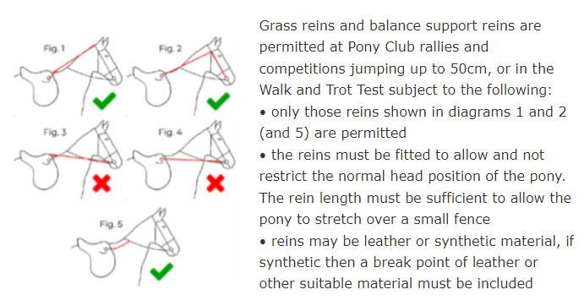

Please note whisker trimming is strongly discouraged within Pony Club.

Whilst guidance on the fitting of nosebands can be found here: Noseband tightness

Further information regarding dress for different disciplines i.e Dressage, Show Jumping, Eventing can be found in the relevant rule books, available to download from the Pony Club website here:
Rulebooks

Ponies and Horses
- Well groomed with no visible stable/field stains.
- Manes and tails should be brushed out and tidy.
- Eyes and nostrils should be clean.
- Hooves picked out.
- Ponies that may kick should have a red ribbon in their tail as a warning to other riders

Parents - Health and Safety

- When arriving at rallies or training sessions children remain your responsibility until their Coach arrives and takes charge of them. This also applies at the end of the session.
- A responsible adult must be present with your child at all times.
- Children not taking part in rally/training activities (whether members or not) remain the responsibility of their parents at all times.
- Coaches are being employed to instruct and look after the Pony Club members taking part in the activities. So unless specifically asked to do otherwise all parents and spectators at rallies, training and events are asked to maintain a safe distance away from the riders.
- We understand that you want to watch your child, but keeping everyone safe is a major concern, especially at cross country rallies - parents, please keep your spectating children out of harm's way and under your watchful eye – they are entirely your responsibility.

The Pony Club Code of Conduct for Parents and Guardians and the Pony Club Code of Conduct for Members can both be found on the Pony Club website here:
Code of conduct for Parents and Guardians
Code of Conduct for Members

We would ask that you take the time to read both these documents please.

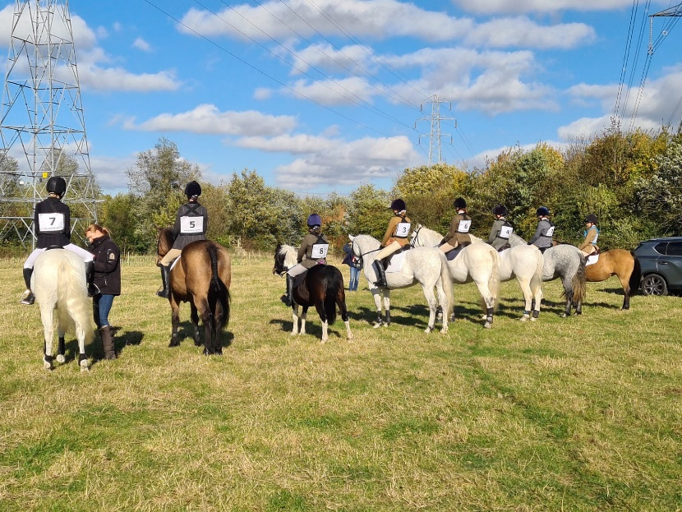

Pony Club Testing Pathway

Any queries regarding tests please contact Sarah Drewett.
All members can work through the Pony Club tests as follows:

E Test suitable for the younger riders
D Test 8 or 9 years old
Both E and D tests may be taken by members at Junior camp but other opportunities will be provided for those not attending Junior Camp

D+ Test 10 and over
C Test 11 or 12 years old*
*Riding & Road Safety Achievement Badge must be passed before C Test can be awarded
C+ Test 14 and over

Training courses for D+, C and C+ and Riding & Road Safety are organised throughout the year and are advertised via email, on our Branch website and on our Facebook page.

B Test (Horse & Pony Care and Riding) ** - 15 or over
Extensive training which can last over a year is usually recommended before this test is taken. Often a group of members wishing to do this training will group together and find a suitable timetable for training sessions either spread over a longer period of time or sometimes if it suits a group better then intensive training over a short period of time.
**Either BHS or Pony Club Riding and Road Safety Test must be passed before attempting either part of the B Test

There are usually groups of members working towards B Test – contact Sarah Drewett if you are interested in taking your B Test

Lungeing Test
Before taking the Lungeing Test, Candidates must have passed the B Test or B Standard Horse & Pony Care. It is necessary to pass the Lungeing Test before attempting the B+ or AH Test.

B+ Test
The B+ Test is a compulsory riding test taken after the Lungeing Test and before or after AH. It is a ‘stepping stone’ half way between B and A Test. Candidates will be required to ride their own horse and one other horse belonging to another member. It is a requirement that candidates allow their horse to be ridden by other candidates on the flat. Horses should be fit, suitable for other riders to use and go quietly in a double bridle.

Candidates should be able to: Ride horses in harmony and balance. • Be an effective rider on the flat, in show jumping and across country, showing balance and security of position (as described in Pony Club Publications). • Assess horses’ way of going on the flat and over show jumps and cross country fences up to 1 metre. • Discuss plans to develop horses’ training.

AH Test (Horse Care) –17 or over and hold the full B Test
The Pony Club ‘AH’ Test stands alone as the highest Test of Horsemastership available in The Pony Club. It is a pre-requisite for the ‘A’ Test Riding, replacing the Horsemastership section of that Test. It is recommended that where possible, candidates should take the two tests within a year of each other.

A Test (Riding) – must hold the B+ and AH Test
The A Test is the highest award of The Pony Club,and provides a comprehensive assessment of Horsemanship and Training of Young Horses. Candidates should have passed all previous Pony Club Tests, but must have passed B, B+, Lungeing and AH. These Tests will have provided a staircase of knowledge and progression to underpin the work and riding that will be observed. This progression will have been supported by further training and practice with different coaches and with varied horses, as well as undertaking a wide range of reading, to give the breadth of knowledge required for this Test.

The candidates should be able to: • Show a secure, correct, balanced seat on the flat and over fences. • Improve all horses they work, including young, awkward or refusing horses. • Be able to support the practical work shown with logical theory relevant to the individual horses. • Give the assessors confidence that a horse left with the candidate would improve in its way of going.

Please contact Sarah Drewett if you are interested in training for any of these.

Achievement Badges and Mini Achievement Badges

Training for badges usually takes place at our rallies throughout the year and at Junior Camp in the summer. For more details please contact Sarah Drewett.

Further details of efficiency tests and progressive tests and achievement badges are available on the Pony Club website.

Camps

Our Pony Club camps are the highlight of the year for many of our members and always enjoyed by those who attend. We are lucky to have great facilities at Bergh Apton and Blackwater to use for our camps allowing us to do a full range of activities.

Mini-, Junior Camp – for our very youngest members through to 10 years old.
This is run over two days in August as a non-residential adventure with ponies and children travelling in each day.

Senior Camp - for older members aged 10 and over, a week-long residential camp held in the summer holidays either last week of July or 1st Week of August.

Full details of camps will be emailed to members, and/or be advertised via our website and facebook page together with booking forms at the appropriate time.

[The above age “limits” are intended as a guide only – there are often circumstances where older or younger members can be accommodated and we invite members and their parents to discuss any particular requirements with the Camp organisers at the earliest opportunity – thank you.]

Team, Grassroots and Area Competitions

The South Norfolk is always very well represented at many of the various team competitions available in the Area, regularly qualifying for both the Grassroots and National Championships in a range of disciplines – however, we are best known for (and most proud of!) the fun we have along the way!

Information on the Pony Club disciplines is available on the main Pony Club website .

Information on the specific disciplines that this Branch competes at can be found on the South Norfolk Pony Club website.

At the start of the year we contact members with dates and information, asking for expressions of interest which helps enormously in the planning of training etc. – we fully understand that partnerships develop at different rates though, and we always welcome approaches from members later in the year wanting to come forward and represent the Branch in their chosen discipline.

Insurance

The Pony Club insurance policy is provided by Howden Insurance Brokers Limited.
All Members of The Pony Club are covered by our insurance policy . It is strongly recommended that you review the information on the Pony Club website regarding the policy.
.

Vaccinations for Ponies attending Pony Club activities

The Pony Club vaccination rule for 2023 can be found here: https://pcuk.org/media/eibpycgm/the-pony-club-equine-influenza-vaccination-rule-2023.pdf

Please be aware that stricter requirements can be requested at some venues so make sure that you always check before attending somewhere new for competitions etc.

Useful publications

- The Manual of Horsemanship is a very useful publication and it is recommended that all members purchase a copy.
- Discipline Rule Books – recommended for any members competing in teams or any Pony Club competitions (Updated each year).
- Pony Club Year Book - All information concerning the Pony Club
All publications are available to purchase from the Pony Club’s online supplier – www.Amazon.co.uk

