May  2024 |  | 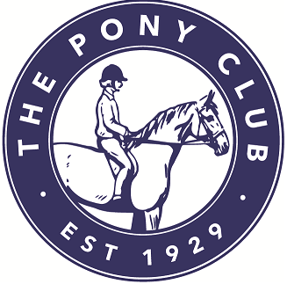 UNITED PACK BRANCH OF THE PONY CLUB
https://horsemonkey.com/equestrian_event/58319/May+UPPC+Programme

Booking will be closed on the closing dates below. It can be reopened if there are already some entries at close.

Date | Closing  date | Event | Coach | Venue | Time |  | Cost
Wednesday  1st May | 24/04/24 | General Rally | TBC | Bow House | 6.30 | £18
Sunday  5th May | 28/04/24 | Cake & Care | Beccy | Marked Ash | 2 - 4 | £10
Monday  6th May | 29/04/24 | Horse & Pony Care Practice | Beccy | Zoom | 6.30 | £5
Wednesday  8th May | 01/05/24 | General Rally | TBC | Bow House | 6.30 | £18
Sunday  12th May | 05/05/24 | Dressage Practice | Nicola | Lodge Farm | 1.30 | £10
Sunday  12th May | 05/05/24 | Games & Fun | Nicola | Lodge Farm | 3.00 | £10
Monday  13th May | 06/05/24 | General Rally | Nicola | Annscroft | 6.30 | £18
Wednesday  15th May | 08/05/24 | General Rally | TBC | Bow House | 6.30 | £18
Monday  20th May | 13/05/24 | Horse & Pony Care Practice | Beccy | Zoom | 6.30 | £5
Wednesday  22nd May | 15/05/24 | General Rally | TBC | Bow House | 6.30 | £18
Sunday  26th May | 19/05/24 | General Rally | TBC | Churchstoke SY15 6DU | 2.00 Minis  3.00 Jun/Sen | £12  £12
Monday  27th May | 20/05/24 | General Rally | Nicola | Annscroft | 6.30 | £18
Wednesday  29th May | 22/05/24 | ½ Day Rally | TBC | TBC | TBC | £25

