

Vale of Aylesbury Hunt
Senior Pony Club Camp 2024
Wednesday 24th July-Saturday 27th July 2024
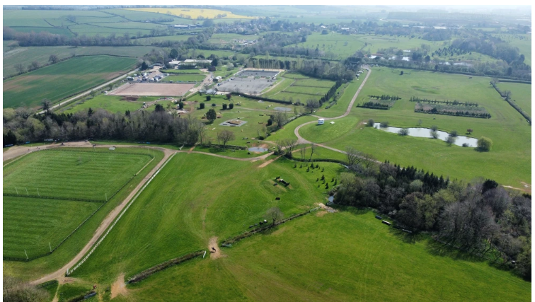
To be held at Aston Le Walls Equestrian Centre, Welsh Rd, Aston le Walls, Daventry, NN11 6RT

Hello Campers

We are really excited for our camp at Aston Le Walls this year and are looking forward to seeing you all there!

At Aston Le Walls we have the use of the full cross country course, plus two show jumping and two dressage arenas- all on a surface. The ponies will also stay in luxury in permanent stables.

We hope that this pack is helpful and should help get you prepared for the most exciting week of the year!
Have a read through and prepare any more questions that you may have and we can answer them at the camp Zoom meeting.

Best wishes

Kate and Clare
VAHPC Camp Co-Ordinators

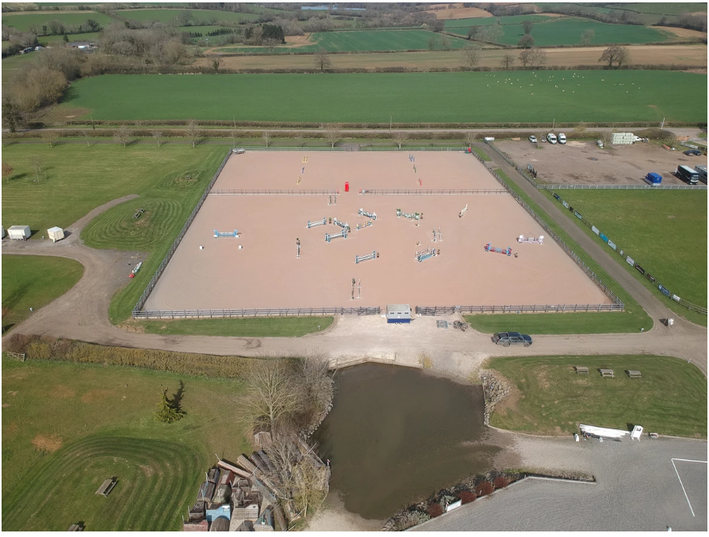

Do you qualify for Camp?

All members attending camp must be current VAHPC members and have attended at least three working rallies on the pony they intend to take to camp since August 2023. Ridden proficiency test training also can be counted as a rally. (Exceptions to this rule may be made by the DC /CI in extenuating circumstances, i.e. a pony going lame)

All attendees are expected to attend the Zoom camp meeting on Thursday 20th June 2024, with a parent or guardian.

All attendees must provide a parent helper to help during camp week for at least half a day, and/or to prepare meals in advance of camp. We were let down on a number of sessions at last year’s camps, so if you are on the rota to help we expect you to be there. If you cannot make it for whatever reason, you must find a replacement to cover.

Getting ready for Camp

Please start to prepare for camp now. In the best interests of our equine friends, we have reduced the riding sessions to two 1.5 hour sessions per day at this wonderful new venue. Your pony needs to be fit and so do you!

Check out the packing list on the VAH website and go through it with your parents, make sure you have everything you need for camp.

Please note that this year all campers must bring their own bedding, hay, mucking out equipment and water buckets for their horses.

Please start arranging your accommodation for camp. Although we encourage campers to share, if members would rather stay on their own then this is fine. We will be in touch shortly before camp to find out final accommodation details. Tents, lorries and trailers can all be used to sleep in.

Safety at Camp

Keeping you and your ponies safe is of paramount importance. Please be aware of your safety and that of other people at all times and in particular adhere to the following:

- Cars should be parked in the designated car park areas only.

- NO motorised vehicles are to be driven onto the riding fields whilst lessons are in progress (with the exception of those being used for first aid).

- Gates must be kept shut at all times.

- Riding Hats and suitable footwear must be worn at all times when you are on the pony lines and at the stables. This includes parents and certainly all children.

- Please make sure you are aware of the fire procedure and emergency meeting point.

- Please no medicines are to be left with the campers.
- NO Parents are allowed down to the stables during camp without permission from the camp committee.

- NO parents are allowed into camper’s accommodation during camp.

From a Safeguarding perspective, the Camp Team have responsibility for your child from 5pm on Wednesday evening until 4pm on the Saturday evening. Parents are responsible for their own children before and after these times. If children leave camp at any time, they must be signed out by their parent/nominated adult and signed back in again on return. During their absence from camp the child is the responsibility of the parent/nominated adult.

Mobile Phones

Phones are to be handed into us in the evening before bed and then returned to the children in the morning, so that we ensure that everyone gets a good night’s sleep. The children can have their phones during the day and it goes without saying that if the children need the phones to make a call etc. in the hours we have them, then of course they can. The camp committee will not be responsible for any damages or misuse of mobile devices, and we ask our senior campers to both act responsibly with any usage and to be mindful of the appropriateness of any such use. Please also note that instructors are not there to film footage for your Instagram stories either, so keep those videos for competition day when your parents are there to film you!

Please remember to bring an alarm clock!

Camp Meeting

The camp information evening is on Thursday 20th June 2024 via Zoom. Any member going to camp must attend this meeting with a parent/adult. The senior camp meeting will start at 7.30pm.

Arrival at Camp

Senior campers can arrive from 4.30pm on Wednesday to settle their ponies into their stables and to set-up their accommodation. There will be a member of the camp committee in the lorry park to direct you.

We ask that parents leave site by 6.00pm, so that we can do evening stables and prepare for dinner.

Parent Responsibilities

There will be a rota for parents to help during the camp week. Please make sure you have let the committee know when you are available to help.

Assistance is required with preparing evening meals in advance of camp. Recipes will be provided, so if you haven’t already offered but are able to assist then please let Kate or Clare know.

Senior camp is all about your child learning to be responsible for both themselves and their ponies, so we ask that parents keep away from stables throughout the week. The camp committee are there to support the children as needed.

Parents are also asked not to visit children’s accommodation throughout camp, and certainly not to tidy it. Accommodation will be messy, but it will still be messy at the end of camp whether you have tidied it or not. Dirty or clean laundry can be dropped off or collected from the club house.

If your child wishes to plait their pony at camp, please ensure they have practiced at home beforehand. This year camp committee will not be plaiting ponies for the children, as they will be encouraged to do it themselves. There will be helpers on-hand to advise, but plaiting is an important activity for the riders to learn.

Rider Responsibilities

Camp is great fun for you and your pony but it is also quite tiring sometimes. Making sure your pony is fit before camp is very important. Looking after your pony is your responsibility at camp but of course there is always help on hand if you need it. Looking after yourself at camp is also very important, make sure you eat properly, have enough to drink during the day and get a good night’s sleep!

Remember, you must wear your riding hat (tagged) at all times when you are in the stable area.

Studs must only be fitted by a helper that holds their B Test, a member of the camp committee or an instructor. When you need to use studs, you must ask for assistance.

We will endeavour to place you in a ride with riders and ponies of similar abilities and sometimes this means you will not be with your friends but don’t worry, there is plenty of time to be with them in your free time. Details of which ride you will be in will be shared at the camp Zoom meeting.

Each ride will be allocated an instructor for the duration of the week and you will find out who your instructor is on the first morning of camp.

Hopefully every day will be your best day at camp and it will always be fun, however please be mindful that on occasion one of your friends or a team mate might be having a bad day. The best fun is had when you all pull together and help each other.

The camp committee and in particular the camp mums and dads are there to help you and to keep you safe. We want you to have fun with your pony and with each other however please respect us when we say ‘no’ or ‘enough’ – we don’t say it very often but it is always for a good reason!

Camp Accommodation

Accommodation can only be shared share with members of the same sex. You may sleep on your own but the camp committee must be made aware in advance of this. Who you are sharing with and what you are sleeping in must be arranged BEFORE the camp meeting takes place please. It is your responsibility to sort this out but if you are struggling please contact Kate or Clare BEFORE the camp meeting.

Generators may NOT be used.

Dress Code whilst riding at Camp

Smart dress code. Boots should be polished. Half chaps and gaiters can be worn but must be in plain black or brown (Jodhpur clips should be worn with Jodhpur boots). Ponies should be sparkly clean with hooves oiled and so should your tack.
Riders should wear their long or short sleeved VAH tops and plain beige, blue or black jodhpurs only please. XC Colours may be worn for XC.

Hats must be tagged and for long hair, hairnets must be worn under hats please. NO EARRINGS.

For Cross Country a Jockey Skull Cap with no fixed peak is compulsory, as well as a Body Protector of the current 2018 standard.

All hats, hat covers and accessories should be in plain black or dark blue. Numnahs should be cream, white, black, brown or navy blue for all disciplines.

A snaffle bit is required for dressage.

Camp T-Shirts & Hoodies

These will be available online to order via the website Storkworkwear.co.uk.

Camp tops and hoodies are an optional purchase, but if purchased must be ordered by the END OF JUNE.

Hoodies are not to be ridden in, and are for social wear only.

During Camp

Your day will consist of two ridden sessions a day, one stable management session and tack cleaning. Lessons will include dressage, show jumping, grid work and cross-country.

Campers will be provided with three meals a day:

- A choice of cereals and toast for breakfast.
- Rolls, crisps and fruit for lunch.
- A home cooked meal in the evening for dinner.

Water, squash, and biscuits are readily available throughout the day.

On Saturday afternoon there will be a combined training competition which parents are welcome to arrive early to watch.

A typical day at camp looks like this:

7.00am Wake Up Call and register
7.15am Feed, water and hay ponies
8.00am Breakfast, Wash and Clean Teeth
8.30am Muck out and Groom Ponies
9.30am Tack Up and get ready to ride
10.00am Tack and Turnout at Stables
Riding or Stable Management
12.20ish Water and hay ponies
12.30pm Lunch
1.30pm Back to ponies to groom and tack up.
2.00pm Ready to ride.
Riding or Stable Management

3.30pm Put ponies away with hay and water for a well-earned rest.
3.45pm Drink and Biscuits.
4.00pm – 5.30pm Clean tack and relax.
6.00pm Check, skip out, hay, water and feed ponies
6.30pm Register and Tea

7.00pm – 9.00 pm Evening Activities
9.00pm Biscuits and Hot Chocolate then ready for bed.
10.00pm Lights Out and SLEEP!!!

Camp committee will do a late-night check of all ponies.

There will be a prize giving presentation after a combined training competition and before you go home on the Saturday. This will not take place until the camp site and stable area is clear and tidy and your stable has been checked by a member of the camp committee. After prize giving you are free to take your tired children and ponies home!

Useful Information

Camp Co-Ordinators & Camp Committee onsite

Kate Rolfe – katerolfe7@gmail.com 07736 979107

Clare Dunn – claredunn1980@gmail.com 07850 694040

Stable Manager – Marcedes Doughty

District Commissioner

Clive Johnson: vahpcdistrictcommissioner@gmail.com

VALE OF AYLESBURY HUNT PONY CLUB
RULES, PROVISIONS and CODE OF CONDUCT AGREEMENT FOR ENTRY TO SENIOR CAMP 2024

- A condition of attendance at camp is that parents/guardians and children all agree to adhere to the Rules, Provisions, and Code of Conduct for entry to senior and junior camp 2024.

- No responsibility can be accepted for the horse/pony and its tack, and personal belongings of any child at camp.

- For the duration of pony club camp the many campers including Day, Part Residential and Residential and their horse/pony are under the care of the organisers, the instructors and the stable managers who will endeavour to ensure the wellbeing of any child but cannot be held responsible for the same. All campers must accept and abide by directions and instructions given by those responsible for the running of camp.

- The normal insurance provisions negotiated on behalf of the Pony Club apply at camp.

- All children and parents must accept and abide by the directions and instructions given by those responsible for the running of camp.

- Smoking, the drinking of alcohol or the use of illegal drugs is not allowed in camp. Any camper found to be in possession of alcohol, cigarettes or illegal drugs will be sent home immediately, with their horse/pony, and not readmitted. There will be no exceptions. Campers who are consistently disruptive will also be sent home, at the discretion of the organisers.

- If the behaviour of a child at camp is such that the Organisers feel they may not continue at camp, then upon notification of this, the parent/guardian must remove the child and horse/pony immediately. Any expenses incurred in the removal of miscreants are the responsibility of their parents/guardians and no refund will be given.

- Any damage to another person’s property caused by a camper must be paid for in full and are the responsibility of the camper or their parents/guardians.

- Generally, there will be no refund of fees once a child has been registered for camp. However, in exceptional circumstances the Organisers may, at their absolute discretion, consider a partial refund.

- The Organisers reserve the right to exclude and send home any person or horse/pony attending camp that is injured, unfit or is in such a condition that it cannot be expected to complete camp without injury or hardship to itself or any pony that they consider to be a danger to others attending camp.

- All horses/ponies must be healthy and fit enough to stand a week of hard work at camp. Campers are responsible for their own horse/pony at all times and must endeavour to care for them to the highest possible standard. Always think of your horse/pony before yourself. The instructors and/or stable managers are on hand at all times to give help and advice.

- In the event of an accident or injury to child or horse/pony the organisers will immediately attempt to contact the parent or guardian. If this is not possible the organisers are authorised to take whatever steps are felt appropriate to secure the wellbeing of the camper and horse/pony. The parent/guardian will be responsible for any fees necessarily incurred.

- Numbers are limited and places will be awarded strictly on a first come first served basis. ALL required forms and documents must be received to constitute an application. The Organisers reserve the right to decline all late applications.

- Campers are not expected to leave the campsite without good reason. No-one may leave the campsite, even in the company of their parents or other adult, without notifying the duty organiser in the office and signing out. If you know you are going to have to be absent from camp for a time, please tell the organiser in advance. Otherwise everyone is expected to spend the full time at camp.

- Any complaints should be made immediately to the Organisers whose decision will be final. Any complaints about the Organisers should be made directly to the District Commissioner. Before you complain do remember that camp is run entirely by volunteers who not only give up their week, but a lot of time throughout the year to do everything they can to make camp a success. Nothing will ever be perfect, but we try our best! If you think you can do a better job, please feel free to run camp next year.

- The makeup of the rides, the daily programme, specific activities and other news will be posted on the notice board at the marquee. It is the responsibility of the campers to note these and to be in the right place at the right time. Please note that this board is for camp use only, any persons wishing to put advertisements etc up at camp should see the camp organisers who will be happy to put them on a separate board.

- Children will not be allowed in the stables area during the lunch break or of an evening after the horses/ponies have been bedded down for the night or before they are told they can do so of a morning. It is important that the horses/ponies have quiet time to rest.

- Children are not permitted to go to stables without a member of the camp committee.

- HEALTH & SAFETY DISCLAIMER: The Vale of Aylesbury Hunt Pony Club which term includes the Vale of Aylesbury Hunt Pony Club Officers and Committee, helpers, agents and employees and the owners of the land and buildings on which the Camp is taking place and anyone involved with the running of Camp (‘the Organisers’) do not accept any liability for any damage or injury caused by negligence or breach of contract or statutory duty in connection with the Camp. It is an expressed condition of every person entering the land on which the Camp is taking place that they agree, and if under the age of 18 their parents or accompanying adult also agree, that they do so voluntarily and entirely at their own risk to themselves, their animals and their property including vehicles.

- Photographic rights: The children and their parents/guardians hereby give permission for any photographic and/or film footage taken of persons or horses/ponies taking part in Pony Club events to be used in any published in any media whatsoever for editorial purposes, press information or advertising by or on behalf of the Pony Club and /or any official sponsors of the Pony Club. If parents do not give their permission, then they need to inform the Camp Committee in writing.

Senior Camp Packing List:
Item | Checked | Packed | Notes:
Pony:
Bedding |  |  | One or two bales of shavings or equivalent for use in stables.
Pitch/Shavings Fork
Hay- new requirement this year! |  |  | Enough to last your pony for camp.
2 x drinking buckets |  |  | The children need to carry water from the trough to the stable so please ensure they have at least one bucket suitable for a little person to do this and a larger bucket for pony to drink from.
Feed bucket
Head collar
2 x lead ropes
Waterproof box |  |  | For boots, feeds, equipment etc
Full Grooming Kit
Pony Shampoo
Plaiting Equipment
2 x haynets
Feed |  |  | Please make feeds up before you come to camp – plastic carrier bags are great for this.
Wheelbarrow |  |  | Essential for carrying tack and heavy items to and from the stables.
Muck bucket
Saddle
2 x Numnah |  |  | A White Dressage Sheet for Competition Day is optional. Plain navy, black or brown for other days please.
Girth
Bridle |  |  | Seniors will need a snaffle for dressage
Martingale / Breast Plate
Boots
Fly Rug / NZ |  |  | For ponies not stabled.
Fly Spray
Hoof Oil and Brush
Stable Door Plaque |  |  | Prize for the best decorated one!
Wash Down Bucket & Sponge
Cuddles
Passport
Jockey: |  |  | N.B. You will not be allowed to ride XC if your hat has a fixed peak!
Hat (with pc tag)
Back Protector |  |  | Made to the Beta 2018 Horserider Body and Shoulder Protector Standard Level 3.  Compulsory for XC. (shoulder protectors not compulsory).

Item | Checked | Packed | Notes:
Riding Boots and Gaiters/Chaps |  |  | Gaiters and chaps to be plain brown or black please.
Whip
Gloves
Pony Club Tie /stock
Pony Club Badge
Hairnet
Jacket
White Shirt with Collar |  |  | For the first day and competition day.
4 x Plain Jodhpurs, to include a beige pair. Other colours: navy, brown, black.
Long/short Sleeved VAH Tops for riding in.
Notebook and Pen
Tack Cleaning Equipment
Shoe cleaning equipment

Pony Club Manual
A smile ☺
Camper:
Bedding |  |  | It can get cold so an extra blanket or two may be needed.
Airbed (if camping)
Sleepwear
Underwear
Shorts and T Shirts
Joggers
Hoody |  |  | But not for riding in!
Trainers
Towel
Washbag
Tooth Brush and Tooth Paste

Phone and Charger
Torch
Lights for tent
Insect Repellent
Bite Cream
Any regular medication |  |  | Please declare this on the childs medical form and hand in to Kate or Clare.
Small amount of change for the tuck shop
Suitable boots for mucking out etc
Waterproof Coat |  |  | It can rain ☹
Sun Cream and Hat |  |  | It can get hot ☺
Tissues
Alarm Clock |  |  | You will be tired and won’t have your phones in the mornings!

