FLINT & DENBIGH HUNT BRANCH
Of the
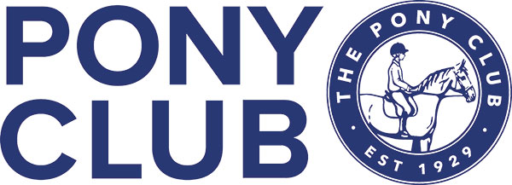

Winter League Team & Individual Dressage Competition
Sun 20th October 2024
At
The Equine Unit,
Coleg Cambria, Northop.
CH7 6AA
Entries Close Thurs 17th Oct 2024

Enquiries: secretary@fndponyclub.org.uk

Times Friday 18t^{h} Oct
Will be emailed out to all & put on Area 5 web page

FLINT & DENBIGH HUNT BRANCH OF THE PONY CLUB
Winter League Team & Individual
DRESSAGE COMPETITION
At
The Equine Unit,
Coleg Cambria, Northop.
CH7 6AA
Sun 20th October 2024
Entries Close Thursday 17th October 2024
Entry Fee £16 Walk Trot £12
Dressage Tests:

Class 1 Pony Club Walk Trot
Class 2 Pony Club Grassroots PC80 2018
Class 3 Pony Club Novice 2020
Class 4 Pony Club Intermediate 2024
Class 5 Pony Club Open 2020

Tests may be called. All trot work may be sitting or rising. All horses/ponies, apart from class 5 (double bridles may be used) must compete in a snaffle. All classes will be run according to Pony Club Area 5 Winter League Dressage rules 2024

Points will be awarded individually and for Teams as per Area 5 Winter League Dressage rules.

Members will be required to print their own numbers and use number bibs/bridle numbers.

Please enter online, using Entrymaster.

This Competition will be run under the Area 5 WL Dressage Rules 2024.
All Tack Rules are available on the PCUK website.

All accidents should be reported to the show secretary for inclusion in the accident book
If any horse/pony has been in contact with strangles or any other infectious disease, it should not attend the competition. Equine Influenza/Vaccine Compliance All horses/ponies vaccination should comply with rules for PCUK.
Details can be found at https://pcuk.org/media/eibpycgm/the-ponyclub-vaccination-rule-v22-1-1.pdf
Please ensure you have your horse/pony passport with you. Refunds, if cancellation of competition occurs In the event of cancellation, refunds will be made, minus any expenses/admin incurred by the hosting branch. This amount will be checked and approved by Area 5 representative before refund is made.

Health & Safety The organisers of this event have taken reasonable precautions to ensure the health and safety of everyone present.
For these measures to be effective, everyone must take all reasonable precautions to avoid and prevent accidents occurring and must obey the instructions of the organisers and all the officials and stewards.
Disclaimer of Legal Liability Save for the death or personal injury caused by the negligence of the organisers, or anyone for whom they are in law responsible, neither the organisers of this event or The Pony Club nor any agent, employee or representative of these bodies, nor the landlord or his tenant, accepts any liability for any accident, loss, damage, injury or illness to horses, owners, riders, spectators, land, cars, their contents and accessories, or any other person or property whatsoever.
Entries are only accepted on this basis.

