
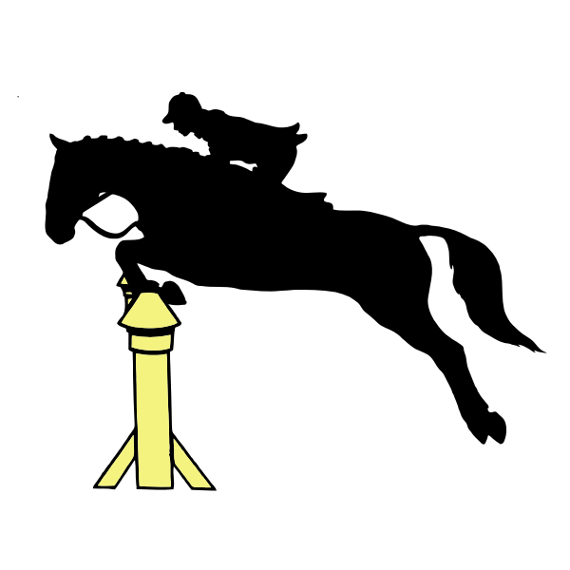
Unaffiliated Showjumping Competition
At Berriewood Equestrian
Hosted by the United Pack Pony Club
UPPC-DC@hotmail.com or 07811187048

10th November, 15th December, 12th January, 9th February, 9th March and
13th April
Classes are open to all ages, members and non members
All entries via Horse Monkey
Entries close 11pm on the Wednesday before, Late entries accepted until 5pm on the Friday before at an extra cost.
Times will be available from 9pm on Friday via Horse Monkey.
Classes will be single phase incorporating timed sections.
Rosettes for 1st to 6th place.

Class 1 Poles on the floor lead rein and assisted £10
Class 2 30cm lead rein and assisted £10
Class 3 40cm assisted only NO LEAD REINS £10
Class 4 50cm assist from outside the arena £12
Class 5 60cm £12
Class 6 70cm £12
Class 7 80cm £12
Class 8 90cm £12

Unload in the lorry park and go to the warm up. DO NOT GO TO MAIN OR DIY YARD.
Please take home all your waste and clear the lorry park before you leave.
Toilets are in the RDA room.

With thanks to Penny and Peter Cowdy and team for use of the facilities

UPPC Showjumping Winter League

There will be a winter league running throughout the competitions, with all horse/rider combinations going forward to collect points. If one rider has more than one horse/pony they will be counted as separate entries. The league will be split to Juniors 16 and under and Seniors 17 and over. Ages taken from the 1st of October 2024

Scoring 1st = 6 points
2nd = 5 points
3rd = 4 points
4th = 3 points
5th = 2 points
6th = 1 point

A score tally will be kept and on the conclusion of winter dates the winner will be announced. Incase of a tie we will look back at the points and the one with the most 1st places will win.

Rules

- The event will be run under pony club rules, tack and dress must conform to these rules.
- No entry accepted without correct fees.
- Entries online only.
- No more then 3 classes per horse.
- Entry fees will be refunded for withdrawals made before the closing date or if the UPPC cancels a class. In this case only the canceled class will be refunded and not any other class the rider has entered. Booking fee will be refunded if canceled by the UPPC. NO booking fee refund if competitor cancels.
- Entries are limited to first come basis.
- The organisers reserve the right to amend times of classes or cancel according to entries.
- Dogs not allowed on the site.
- Park considerately and tightly. Please clear up any droppings from around where you park, No horse/pony to be left unattended tied up outside.
- Hats must be worn at all times when mounted and must comply with the pony club standard and be tagged.
- Be safety conscious at all time. Take care with young/inexperienced children and ponies.

