
AREA 14 PRE SEASON EVENTING TRAINING CAMP
FANTASTIC COACHES IN AN AMAZING VENUE TO HELP PREPARE YOU FOR YOUR SEASON AHEAD
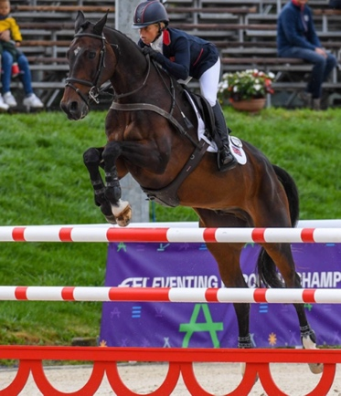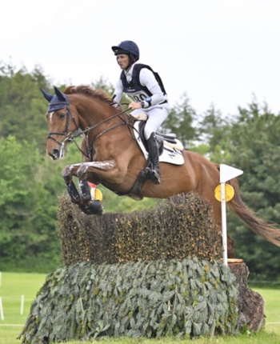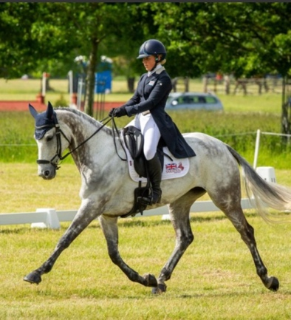
FOR THOSE COMPETING FROM 90CM TO 110CM (NOVICE)
SUNDAY 6TH – WEDNESDAY 9TH APRIL 2024
RAC SADDLE CLUB, BOVINGTON
SAVE THE DATE!!
BOOKING DETAILS TO FOLLOW

