
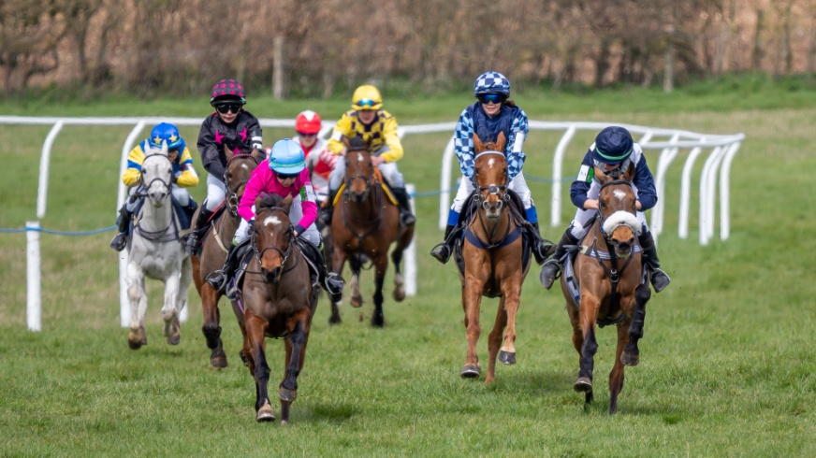
SOUTH DORSET & AREA 14 OF THE PONY CLUB

Pony Club Pony Racing Day
(Part of the Pony Club Racecourse Series)
at
THE SOUTH DORSET POINT TO POINT COURSE
MILBORNE ST ANDREW, NEAR BLANDFORD, DORSET BH20 7JF

By kind permisson of Mr M Miller
Saturday 15th February 2025
First Race 12pm (Noon)
All enquiries to Louly Thornycroft
Area14@pcuk.org
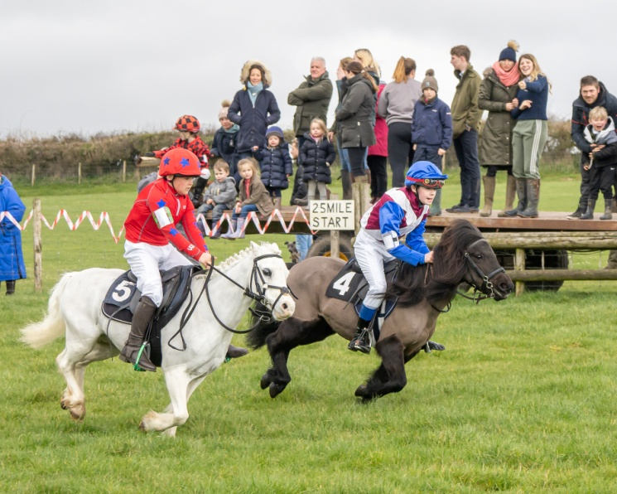
Photographs courtesy of Nigel Gidney Photography

