Open Dressage Competition
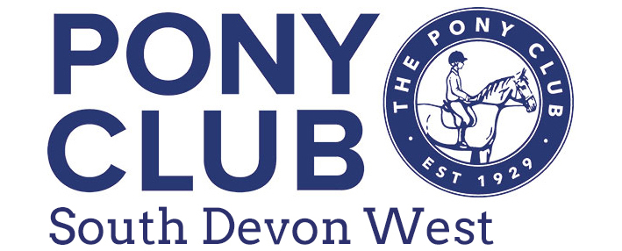
On 24th November 2024
At Crokers Farm, Ipplepen TQ12 5UD from 9am onwards
All tests are on a surface.

Class 1 – Pony Club Walk & Trot Dressage test 2022 – section a) lead rein b) assisted, can be beside rider but NOT hold pony. c) Open. Please state section on entry form. All sections are open to ALL AGES

Class 2 - Pony Club Walk Trot test 2013 - section a) lead rein b) assisted, can be beside rider but NOT hold pony c) Open. Please state section on entry form. All sections are open to ALL AGES.

Class 3 – Pony Club Introduction to Dressage Test 2019 – section a) 11 years and under b) 12 years and over. Please state section on entry form.

Class 4 – PC 70 Dressage Test 2022 - open

Class 5 – Grassroots PC80 Dressage Test 2018 – open

Class 6 – Novice Dressage Test 2020 – open

Class 7 – Intermediate Dressage Test 2024 – open

Class 8 – Open Dressage Test 2020 - open

All Pony Club tests can be downloaded from the Pony Club website for FREE!
Callers allowed in all classes.
Competition is run under Pony Club Dressage rules 2024.

Entry fee – £10.00 per class SDW Members £9.00 per class

Prizes – prize to highest placed SDW rider in each Test.
Rosettes awarded to 6th place. Class 1a 1b & 1c - rosettes to all.

Entries close – Wednesday 20th November

Entries email to SDWcompetition@gmail.com

Times will be given for each competitor and must be strictly adhered to. These will be posted on the South Devon West Pony Club Open Facebook page and website on Friday 22nd November

Rules

Entries are accepted and admission granted only subject to the following conditions and it is a condition of entry that these have been accepted by each competitor.
All classes will be run in accordance with Pony Club Dressage Rules 2024 and the Health & Safety Rule Book 2024. You can view the rules at www.pcuk.org .

Riders who have suffered concussion or head injury within 3 weeks before the competition will withdraw from the competition

Whip Rule….Use of the whip At all times, the whip must only be used for a good reason,
- as an aid to encourage the horse forward.
- At an appropriate time, namely when the horse is reluctant to go forward under normal aids of seat and legs.
- In the right place, namely down the shoulder or behind the leg but never overarm.
- With appropriate severity.
- No more than twice for any one incident. Excessive use of the whip anywhere on the showground will result in disqualification:
- Use of the whip to vent a competitor’s anger is always excessive.
- Use of a whip which causes injury eg. Broken skin or a weal, is always excessive.
- Use after elimination or retirement is always excessive.
- Use on a horse’s head, neck etc. is always excessive.
- Using the whip from the ground after a rider fall or dismount is always excessive.
- If the rider’s arm comes above the shoulder when using the whip, this is always excessive.
Spurs Spurs must only be used to enhance the normal leg aids and allow for better communication from rider to horse. Spurs must never be used to vent a competitor’s anger or to reprimand the horse. Use of the spurs which causes injury eg. blood, broken skin or a weal, is always classed as misuse. Misuse of the spurs anywhere on the showground will result in disqualification

Organisers of this event have taken reasonable precautions to ensure the health and safety of everyone present. For these measures to be effective, everyone must take all reasonable precautions to avoid and prevent accidents occurring and must obey the instructions of the organisers and all the officials and stewards.
Legal Liability Save for the death or personal injury caused by the negligence of the organisers, or anyone for whom they are in law responsible, neither the organisers of this event or The Pony Club nor any agent, employee or representative of these bodies, nor the landlord or his tenant, accepts any liability for any accident, loss, damage, injury or illness to horses, owners, riders, spectators, land, cars, their contents and accessories, or any other person or property whatsoever. Entries are only accepted on this basis

The Judge’s decision is final and any objections must be accompanied by £25 deposit which will be returned if upheld. Horse/Pony must be 4 years or over on day of show. All dogs must be kept on lead.
The Organisers reserve the right to refuse entry without stating a reason and to eliminate any competitor who in their opinion places themselves or others in danger or fails to observe the rules.

OPEN DRESSAGE COMPETITION
On 24th November 2024
At Crokers Farm, Ipplepen, TQ12 5UD

Class (don’t forget to put section where needed) | Rider Name | Horse Name & height

Address: ………………………………………………………………………………………………………………………………………………………………………. Tel No: ……………………………………………………………

Email: ……………………………………………………………………………………………………………………………………………………………………………………………………………………………………………………
If you are a Pony Club member please state club?...........................................................................................
Entries close – 20th November 2024 | Entry fee - £10 per class (SDW members £9.00 per class) via BACs (if not possible please contact) Entry only confirmed once payment received.
Payment by: BACS to South Devon West Pony Club –
Sort 60-21-48
Account 94642400
with reference “Dressage-your surname”.

No late or phone entries accepted. Entries: email to SDWcompetition@gmail.com

